Table of Contents

UNITED STATES
SECURITIES AND EXCHANGE COMMISSION
Washington, D.C. 20549
SCHEDULE 14A
Proxy Statement Pursuant to Section 14(a) of the
Securities Exchange Act of 1934 (Amendment No. )
☑ |  |  | Filed by the Registrant |  |  | ☐ |  |  | Filed by a party other than the Registrant

CHECK THE APPROPRIATE BOX:
☐ |  |  | Preliminary Proxy Statement
☐ |  |  | Confidential, for Use of the Commission Only (as permitted by Rule 14a-6(e)(2))
☑ |  |  | Definitive Proxy Statement
☐ |  |  | Definitive Additional Materials
☐ |  |  | Soliciting Material under §240.14a-12
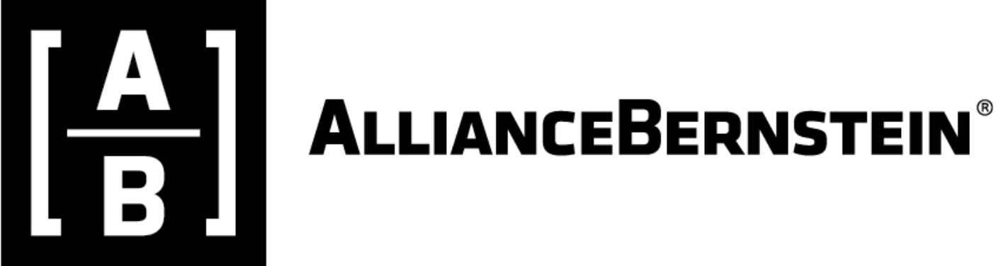
ALLIANCEBERNSTEIN HOLDING L.P.
(Name of Registrant as Specified In Its Charter)
(Name of Person(s) Filing Proxy Statement, if other than the Registrant)

PAYMENT OF FILING FEE (CHECK ALL BOXES THAT APPLY):
☑ |  |  | No fee required
☐ |  |  | Fee paid previously with preliminary materials
☐ |  |  | Fee computed on table in exhibit required by Item 25(b) per Exchange Act Rules 14a-6(i)(1) and 0-11

Table of Contents

Notice of 2026 Special Meeting of Unitholders
 |  |  | DATE AND TIME |  |  |  |  |  |  |  |  |  |  |  | MEETING LOCATION |  |  |  |  |  |  |  |  |  |  |  | WHO CAN VOTE
 |  |  | November 18, 2026;  9:30 a.m. (CST) |  |  |  |  |  |  |  |  |  |  |  | Virtual at https://meetnow.global/MTKW77S |  |  |  |  |  |  |  |  |  |  |  | Unitholders of record at the close of business on September 24, 2026
 |  |  | [Items of Business] |  |  |  |  |  | [Board Voting Recommendation]
 |  |  | [1.] |  |  | Consider and approve the AB 2026 Long Term Incentive Plan, an equity compensation plan |  |  | FOR |  |  | 
Unitholders may also transact such other business as may properly come before the Special Meeting.
November 18, 2026
Dear Fellow Unitholder:
I cordially invite you to attend AllianceBernstein Holding L.P.’s 2026 Special Meeting of Unitholders.
Your Vote is Important
We enclose our letter to Unitholders, our proxy statement and a proxy card. Your participation in the Special Meeting is very important, so please return the enclosed proxy card as promptly as possible. Alternatively, you may use the information found in the enclosed proxy card to either call in your vote (toll-free) or vote using the Internet.
Thank you for your support of AB.
Very truly yours,
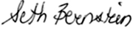
Seth Bernstein
Chief Executive Officer
Important Notice Regarding the Availability of Proxy Materials for the Special Meeting of Unitholders to be held on November 18, 2026:
The Notice of Special Meeting of Unitholders, Proxy Statement and our 2025 Form 10-K are available electronically at https://www.edocumentview.com/AB

2026 Proxy Statement and LTIP |  |  | i

Table of Contents
Table of Contents
Notice of 2026 Special Meeting of Unitholders |  |  | i
Proxy Summary |  |  | 1
Special Meeting Information |  |  | 1
Voting Information |  |  | 1
Important Notice Regarding the Availability of Proxy Materials for the Special Meeting |  |  | 4
Information Regarding our Company and AB Holding Units |  |  | 4
A Note About Our Company |  |  | 4
AB Holding Units |  |  | 5
Unitholders Have No Right to Direct the Business of AB Holding |  |  | 7
Change in Control |  |  | 7
Taxes |  |  | 7
Item 1—Company Proposal to Adopt AB 2026 Long Term Incentive Plan |  |  | 8
Summary of the 2026 Plan |  |  | 11
Executive Compensation |  |  | 17
Compensation Discussion and Analysis (“CD&A”) |  |  | 17
Compensation Philosophy and Goals |  |  | 17
Deliver Superior Investment Solutions to our Clients |  |  | 18
Our Compensation Practices are Structured to Help the Firm Realize its Growth Strategy |  |  | 19
Compensation Committee; Process for Determining Executive Compensation |  |  | 27
Compensation Consultant; Benchmarking Data |  |  | 28
Compensation Elements for NEOs |  |  | 29
Summary Compensation Table for 2025 |  |  | 36
Pay Versus Performance |  |  | 45
Security Ownership of Certain Beneficial Owners and Management and Related Stockholder Matters |  |  | 52
Securities Authorized for Issuance under Equity Compensation Plans |  |  | 52
Principal Security Holders |  |  | 52
Management |  |  | 53
Information Incorporated by Reference |  |  | 55
Appendix A - The 2026 Long Term Incentive Plan |  |  | A-56

ii |  |  | AllianceBernstein

Table of Contents

ALLIANCEBERNSTEIN HOLDING L.P.
Notice of 2026 Special Meeting of Unitholders
November 18, 2026; 9:30 a.m. (CST)
Proxy Statement
We are sending you this proxy statement in connection with the solicitation of proxies by our Board of Directors for our 2026 special meeting (“Special Meeting”) of Unitholders of AB Holding (the "Unitholders"). We are mailing this proxy statement and the accompanying form of proxy card to Unitholders on or about October 9, 2026. In this proxy statement, we refer to AllianceBernstein L.P. (“AllianceBernstein”) and AllianceBernstein Holding L.P. (“AB Holding”) collectively as “AB”, the “Company”, the “Partnerships”, “we”, “our” or “us” and the Board of Directors of AllianceBernstein Corporation (“General Partner”), the general partner of AllianceBernstein and AB Holding, as the “Board”. Where the context requires distinguishing between AB Holding and AllianceBernstein, we identify which of them is being discussed. Cross-references are in italics.
We are very pleased that this year’s Special Meeting will be a completely virtual meeting of Unitholders, which will be conducted solely online via live webcast. You will be able to attend and participate in the Special Meeting online, vote your AB Holding Units electronically and submit your questions prior to, and during the meeting, by visiting: https://meetnow.global/MTKW77S at the meeting date and time described in the accompanying proxy statement. There will be no physical location for the Special Meeting.

Special Meeting Information
 |  |  |  |  |  | Date and Location. We will hold the Special Meeting on Wednesday, November 18, 2026 at 9:30 a.m. (CST). This meeting will be held virtually.
 |  |  |  |  |  | Electronic Access. You may access the Special Meeting by webcast:  a.To attend the Special Meeting virtually, please visit https://meetnow.global/MTKW77S at least 15 minutes prior to the 9:30 a.m. (CST) scheduled start time of the Special Meeting to download and install any necessary audio software.

Voting Information
Record Date. The record date for the Special Meeting was September 24, 2026. You may vote all AB Holding Units that you owned as of the close of business on that date. Each AB Holding Unit entitles you to one vote on the matter to be voted on at the Special Meeting. On the record date, 92,144,084 AB Holding Units were outstanding. A majority of the AB Holding Units outstanding on the record date must be represented, by attendance of the virtual meeting or by proxy, to hold the Special Meeting.
Submitting Voting Instructions for AB Holding Units Held Through a Bank or Broker. If you hold AB Holding Units through a bank or broker, follow the voting instructions you receive from your account representative.
Our proposal to adopt the 2026 Long Term Incentive Plan (“2026 Plan”) is a “non-discretionary” item. Accordingly, absent specific voting instructions from beneficial owners on this proposal, New York Stock Exchange (“NYSE”) member brokers, may not vote on this proposal. If (1) you do not submit voting instructions and (2) your broker does not have discretion to vote your AB Holding Units, the broker will return the proxy card without voting (referred to as “Broker Non-Votes”). Under this circumstance, your AB Holding Units will not be counted in determining a quorum or the vote.
2026 Proxy Statement and LTIP |  |  | 1

Table of Contents
Proxy Summary
Submitting Voting Instructions for AB Holding Units Held in Your Name. If you hold AB Holding Units as a record holder (directly through Computershare), you may vote by submitting a proxy for your AB Holding Units by mail, telephone or Internet as described on the enclosed proxy card. If you submit your proxy via telephone or Internet, then charges from your telephone or Internet provider may apply. Submitting your proxy will not limit your right to vote virtually at the Special Meeting. A properly completed and submitted proxy will be voted in accordance with your instructions, unless you subsequently revoke your proxy. If you submit a signed proxy card without indicating your voting instructions, your AB Holding Units will be voted according to the Board’s recommendation and in favor of the proposal.
If you hold your AB Holding Units through Computershare and lose, misplace or otherwise need to obtain a proxy card, please contact our proxy tabulator, Computershare Shareholder Services (“Computershare”), at web.queries@computershare.com or by phone at (866) 737-9896. Additionally, you may write Computershare Investor Services at P.O. Box 43006, Providence, RI 02940-3006.
If you hold your AB Holding Units through a Bank or Broker and need to obtain a voting instruction form, please contact your account representative.
Revoking Your Proxy. You can revoke your proxy at any time before your AB Holding Units are voted by: (1) delivering a written revocation notice prior to the Special Meeting to Paul Emerson, Chief Compliance Officer, at AllianceBernstein Holding L.P., 501 Commerce St, 24th Floor, Nashville, Tennessee, 37203; (2) submitting a later proxy that we receive no later than the conclusion of voting at the Special Meeting; or (3) voting virtually at the Special Meeting. Attending the Special Meeting does not revoke your proxy unless you vote virtually at the Special Meeting.
AB Holding Units Held in Trust for the Benefit of Employee Incentive Compensation Plans. If you have been awarded AB Holding Units under an AB employee incentive compensation plan, including our firm’s Incentive Compensation Award Program (“ICAP”), you do not have rights as a Unitholder until the AB Holding Units awarded to you have vested and have been delivered to you. For additional information concerning our ICAP, see “Executive Compensation” below.
Until your AB Holding Units vest and are delivered to you, they are held in a grantor trust for which Charles Schwab & Co. (“Schwab”) acts as trustee. In accordance with our instructions, Schwab will vote the AB Holding Units held in the grantor trust pursuant to the Board’s recommendation and in favor of the proposal. As of September 24, 2026, 15,161,593 AB Holding Units, or 16.5% of the AB Holding Units outstanding as of that date, were held in the grantor trust or at the Depository Trust Company ("DTC") awaiting transfer to the grantor trust.
Vote Required to Adopt the Proposal. The approval of the 2026 Plan requires a majority of votes cast at the Special Meeting, and the Special Meeting cannot be held unless a quorum is present (i.e., a majority of the outstanding AB Holding Units must be represented, either virtually or by proxy). The required quorum present excludes AB Holding Units represented by Equitable Holdings, Inc., our parent, ("EQH") and its subsidiaries.
“Abstaining” and “Broker Non-Votes.” You may vote “abstain” on the proposal. AB Holding Units voting “abstain” will be counted as present at the Special Meeting and your abstention will have the effect of a vote against the proposal. In addition, failure to cast a vote or a broker non-vote can have the effect of a vote against the proposal if such failure or broker non-vote results in the total number of AB Holding Units present at the Meeting not representing over 50% of all AB Holding Units entitled to vote on the proposal.
Householding. The Securities and Exchange Commission’s rules regarding the delivery of proxy materials to Unitholders permit us to deliver a single copy of these documents to an address shared by two or more of our Unitholders. This method of delivery is called “householding,” and it can significantly reduce our printing and mailing costs. It also reduces the volume of mail you receive. This year, we are delivering only one set of proxy materials to multiple Unitholders sharing an address, unless we receive instructions to the contrary from one or more of the Unitholders. If you would like to receive more than one set of proxy materials, we will promptly send you additional copies upon written request to Paul Emerson, Chief Compliance Officer, at AllianceBernstein Holding L.P., 501 Commerce St, 24th Floor, Nashville, Tennessee, 37203 or by telephone at 615-622-0000. If you and other residents at your address have been receiving multiple copies of the proxy materials and desire to receive only a single copy of these materials, you may contact us at the above address or telephone number.
2 |  |  | AllianceBernstein

Table of Contents
Proxy Summary
Expenses Relating to this Proxy Solicitation. We will pay the expenses of the preparation of proxy materials and the solicitation of proxies for our Special Meeting. In addition to the solicitation of proxies by mail, solicitation may be made by our directors, officers and employees telephonically, electronically or by other means of communication and by Georgeson LLC (“Georgeson”), which we have hired to assist in the solicitation and distribution of proxies. We have agreed to pay Georgeson $20,000 (plus reasonable out-of-pocket costs and expenses) for their services.
Other Business. We do not know of any other matters that may be presented for action at the Special Meeting other than approval of the 2026 Plan as further described in this Proxy Statement.
Unitholder Proposals. Under applicable Delaware law and our partnership agreement, we are not required to hold an annual meeting of our Limited Partners and Unitholders. Ownership of AB Holding Units does not entitle Unitholders to make proposals at the Special Meeting. Our partnership agreement establishes a procedure for calling meetings whereby our General Partner may call a Special Meeting or the Limited Partners owning 50% or more of the outstanding units may request that the General Partner call a meeting. In any case, Limited Partners are not allowed to vote on matters that would cause the Limited Partners to be deemed to be taking part in the management and control of the business and affairs of the partnership. Doing so would jeopardize the Limited Partners’ limited liability under the Delaware Act or the law of any other state in which we are qualified to do business.

2026 Proxy Statement and LTIP |  |  | 3

Table of Contents
Important Notice Regarding the Availability of Proxy Materials for the Special Meeting
Our Proxy Statement, AB's Form 10-K for the year ended December 31, 2025 (“2025 Form 10-K”), as filed with the U.S. Securities and Exchange Commission (“Commission”) on February 12, 2026, Form 10-Q for the quarter ended March 31, 2026, as filed with the Commission on May 1, 2026, and Form 10-Q for the quarter ended June 30, 2026 (“2Q26 Form 10-Q”), as filed with the Commission on July 31, 2026, are available free of charge on our Internet site (www.alliancebernstein.com).

Information Regarding our Company and AB Holding Units

A Note About Our Company
We are organized as a two-tier limited partnership under the laws of the State of Delaware. Unlike U.S. corporations, which must solicit their shareholders annually for matters (such as the election of directors), limited partnerships solicit their Unitholders only under specific circumstances. As a result, we last solicited Unitholder approval in August 2017, for our current equity compensation plan, the 2017 Long Term Incentive Plan (the "2017 Plan"). Our two-tier structure differentiates us in additional ways, as discussed below in "Item 1—Company Proposal to Adopt AB 2026 Long Term Incentive Plan."
Equitable and Corebridge Merger
On March 26, 2026, EQH and Corebridge Financial, Inc. entered into a merger agreement to combine their businesses. Upon completion of the transaction, both companies will operate as wholly owned subsidiaries of a newly formed holding company ("HoldCo"), which we expect will be renamed Equitable Holdings, Inc. and listed on the NYSE. Corebridge and EQH stockholders are expected to own approximately 51% and 49% of HoldCo, respectively, and HoldCo's 14-member board will be evenly split between directors designated by each company. As of July 30, 2026, the stockholders of both companies voted to approve the previously announced merger between the two companies. No changes to AB's executive leadership, senior management, operating model, or ownership structure are expected as a result of the transaction.
The merger remains subject to customary closing conditions, including required regulatory approvals.
The transaction is also expected to enhance AB's long-term growth opportunities through an anticipated transfer of approximately $100 billion of assets under management over time, expanded management of insurance general account assets, and increased collaboration on retirement solutions, including AB's Lifetime Income platform.
Announced Leadership Changes
On September 25, 2026, AB filed Form 8-K with the Commission announcing Seth Bernstein’s retirement as CEO, effective March 31, 2027, and Onur Erzan’s appointment as President & CEO, effective April 1, 2027. The Form 8-K as filed with the Commission is available free of charge on our Internet site (www.alliancebernstein.com).

4 |  |  | AllianceBernstein

Table of Contents
Information Regarding our Company and AB Holding Units
AB Holding Units
AB Holding Units trade on the NYSE under the ticker symbol “AB” and are freely transferable subject to certain restrictions on transfer found in Rule 144 under the Securities Act of 1933, as amended (“Securities Act”), and Section 16 of the Securities Exchange Act of 1934, as amended (“Exchange Act”).
Cash Distributions and AB Holding Unit Prices
AB Holding is required to distribute all of its Available Cash Flow, as defined in the Amended and Restated Agreement of Limited Partnership of AB Holding (“AB Holding Partnership Agreement”), to its Unitholders pro rata in accordance with their percentage interests in AB Holding. Available Cash Flow is defined as the cash distributions AB Holding receives from AB minus such amounts as the General Partner determines, in its sole discretion, should be retained by AB Holding for use in its business (such as the payment of taxes) or plus such amounts as the General Partner determines, in its sole discretion, should be released from previously retained cash flow. AllianceBernstein Corporation (an indirect wholly-owned subsidiary of EQH, "General Partner") is the general partner of both AB Holding and AB. AllianceBernstein Corporation owns 100,000 general partnership units in AB Holding and a 1.0% general partnership interest in AB.
On July 28, 2026, the General Partner declared a distribution of $0.82 per unit, representing a distribution of Available Cash Flow for the three months ended June 30, 2026. Each general partnership Unit in AB Holding is entitled to receive distributions equal to those received by each AB Holding Unit. The distribution was paid on August 27, 2026 to holders of record at the close of business on August 12, 2026.
Total cash distributions per AB Holding Unit paid to Unitholders during 2025, 2024 and 2023 were $3.47, $2.98 and $2.62, respectively.
AllianceBernstein (AB) is required to distribute all of its Available Cash Flow, as defined in the AB Partnership Agreement, to its Unitholders and to the General Partner. Available Cash Flow can be summarized as the cash flow received by AB from operations minus such amounts as the General Partner determines, in its sole discretion, should be retained by AB for use in its business, or plus such amounts as the General Partner determines, in its sole discretion, should be released from previously retained cash flow. Available Cash Flow typically is the adjusted net income per Unit for the quarter multiplied by the number of general and limited partnership interests at the end of the quarter. Management anticipates that Available Cash Flow will continue to be based on adjusted net income per Unit. If management determines, with the concurrence of the Board of Directors, that certain adjustments to Available Cash Flow are necessary or unnecessary, such adjustments will be made in future periods.
On July 28, 2026, the General Partner declared a distribution of $0.91 per AB Unit, representing a distribution of Available Cash Flow for the three months ended June 30, 2026. The General Partner, as a result of its 1% general partnership interest, is entitled to receive 1% of each distribution. The distribution was paid on August 27, 2026 to holders of record on August 12, 2026.
Total cash distributions per AB Unit paid to the General Partner and Unitholders during 2025, 2024 and 2023 were $3.81, $3.30 and $2.92, respectively.
2026 Proxy Statement and LTIP |  |  | 5

Table of Contents
Information Regarding our Company and AB Holding Units
The tables set forth below provide the distributions of Available Cash Flow made by AB and AB Holding during 2025 and 2024 and the high and low sale prices of an AB Holding Unit reflected on the NYSE composite transaction tape during 2025 and 2024:
 |  |  | Quarters Ended 2025
 |  |  | Mar. 31 |  |  | Jun. 30 |  |  | Sep. 30 |  |  | Dec. 31 |  |  | Total
Cash distributions per AB Unit(1) |  |  | $ | 0.88 |  | $ | 0.84 |  | $ | 0.94 |  | $ | 1.05 |  | $ | 3.71
Cash distributions per AB Holding Unit(1) |  |  | $ | 0.80 |  | $ | 0.76 |  | $ | 0.86 |  | $ | 0.96 |  | $ | 3.38
AB Holding Unit prices:
High |  |  | $ | 40.73 |  | $ | 41.77 |  | $ | 42.88 |  | $ | 42.80
Low |  |  | $ | 35.00 |  | $ | 33.00 |  | $ | 37.76 |  | $ | 37.26
 |  |  | Quarters Ended 2024
 |  |  | Mar. 31 |  |  | Jun. 30 |  |  | Sep. 30 |  |  | Dec. 31 |  |  | Total
Cash distributions per AB Unit(1) |  |  | $ | 0.81 |  | $ | 0.79 |  | $ | 0.85 |  | $ | 1.15 |  | $ | 3.60
Cash distributions per AB Holding Unit(1) |  |  | $ | 0.73 |  | $ | 0.71 |  | $ | 0.77 |  | $ | 1.05 |  | $ | 3.26
AB Holding Unit prices:
High |  |  | $ | 34.75 |  | $ | 34.98 |  | $ | 35.39 |  | $ | 38.69
Low |  |  | $ | 30.37 |  | $ | 32.34 |  | $ | 31.87 |  | $ | 34.59
(1)Declared and paid during the following quarter.

6 |  |  | AllianceBernstein

Table of Contents
Information Regarding our Company and AB Holding Units
Unitholders Have No Right to Direct the Business of AB Holding
The activities of AB are managed and controlled by the General Partner. The General Partner has agreed that it will conduct no active business other than managing AB, although it may make certain investments for its own account. Neither AB Holding Unitholders nor AllianceBernstein Unitholders have any rights to manage or control AB Holding or AllianceBernstein, or to elect directors of the General Partner.

Change in Control
Because the General Partner controls the activities of AB Holding and is a wholly-owned subsidiary of EQH (our parent company), any change in control of AB Holding requires a transfer by EQH of its interest in the General Partner. Accordingly, any change in control of AB Holding would require EQH's consent.

Taxes
AB Holding has elected under Section 7704(g) of the Internal Revenue Code (“Code”) to be taxed as a “grandfathered” publicly-traded partnership (“PTP”) for federal income tax purposes, subject to a 3.5% federal tax on its partnership gross income from the active conduct of a trade or business. AB Holding is also subject to the 4.0% New York City unincorporated business tax (“UBT”), net of credits for UBT paid by AB. To maintain its PTP status, management ensures that AB Holding does not directly or indirectly (through AB) enter into a substantial new line of business. A new line of business includes any business that is not closely related to AB’s historical business of providing diversified investment management and related services to its clients. A new line of business is “substantial” if it generates more than 15% of that partnership’s gross income or uses more than 15% of the partnership’s total assets (by value).
AB, a private limited partnership, is not subject to federal or state corporate income taxes. However, AB is subject to a 4.0% UBT. Our domestic corporate subsidiaries are subject to federal, state and local income taxes, and generally are included in the filing of a consolidated federal income tax return. Separate state and local income tax returns also are filed. Foreign corporate subsidiaries generally are subject to taxes in the foreign jurisdiction where they are located. An increase in our business activities outside the U.S., or changes in foreign tax laws or rates, could also raise our effective tax rate.
In order to preserve AB’s status as a private partnership for federal income tax purposes, AB Units must not be considered publicly traded. The AB Partnership Agreement provides that all transfers of AB Units must be approved by the General Partner. The General Partner approves only those transfers permitted pursuant to one or more of the safe harbors contained in the relevant U.S. Treasury regulations. If AB Units were considered readily tradable, AB’s net income would be subject to federal and state corporate income tax, significantly reducing its quarterly distribution to AB Holding. Furthermore, should AB enter into a substantial new line of business, AB Holding, by virtue of its ownership of AB, would lose its status as a grandfathered PTP and would become subject to corporate income tax, which would reduce materially AB Holding’s net income and its quarterly distributions to AB Holding Unitholders. In addition, legislative proposals, if enacted when proposed, could materially affect us. However, we cannot predict whether, or in what form, new tax legislation will be proposed, or what effect it might have on us.

2026 Proxy Statement and LTIP |  |  | 7

Table of Contents

Item 1—Company Proposal to Adopt AB 2026 Long Term Incentive Plan
In August 2017, the Board unanimously adopted the 2017 Plan, subject to approval of AB Holding Unitholders. The 2017 Plan was approved by AB Holding Unitholders in September 2017.
Under the 2017 Plan, 60 million AB Holding Units were authorized for grant, all of which may be repurchased through open market or private purchases and up to 30 million of which may be newly issued. The 2017 Plan became effective September 30, 2017 and has a 10-year term.
As of the record date September 24, 2026, approximately 19,494,934 AB Holding Units remained available for grant under the 2017 Plan. We awarded 4.7 million restricted AB Holding Units in 2025 (which included 4.2 million restricted AB Holding Units in December for the 2025 year-end awards as well as 0.5 million additional restricted AB Holding Units granted earlier during the year relating to the 2024 year-end awards).
In determining the number of AB Holding Units to be reserved for issuance under the 2026 Plan, the Board considered a number of factors, including the effectiveness of the Partnerships’ existing compensation policies and practices and the importance of maintaining an equity incentive program to attract, retain and reward our employees and directors. The Board believes the number of AB Holding Units for which we are seeking authorization, 60 million, of which up to 30 million may be newly issued AB Holding Units, strikes an appropriate balance between enabling us to continue our policy of equity ownership by employees and directors as an incentive to contribute to our continued success and managing any dilutive effects of awards under the 2026 Plan. Further, the Board believes that 60 million AB Holding Units should provide sufficient authorized capacity for our equity-based compensation needs through the full 10-year term of the 2026 Plan, outside of any unexpected significant market volatility.
In September 2026, the Board unanimously adopted the 2026 Plan, subject to approval of AB Holding Unitholders. We are seeking Unitholder approval of the 2026 Plan, a new equity compensation plan authorizing awards of up to 60 million AB Holding Units, all of which may be repurchased through open market or private purchases and up to 30 million of which may be newly issued, in each case subject to adjustment upon specified events as provided in the 2026 Plan. If approved, the 2026 Plan will become effective November 30, 2026 and, like the 2017 Plan, will have a 10-year term. The 2026 Plan is discussed in greater detail below.
OUR BOARD UNANIMOUSLY RECOMMENDS THAT YOU VOTE “FOR” ADOPTION OF OUR PROPOSED 2026 PLAN. Our Board believes that this proposal is in the best interests of our Unitholders and supports this proposal for the following reasons:
Consistent with industry best practice, a significant portion of the compensation we pay to our employees is denominated in Company equity (i.e., restricted AB Holding Units that vest over three years). We believe this approach aligns our employees' long-term interests with those of our Unitholders and helps retain employees. While the number of AB Holding Units currently available for grant under the 2017 Plan remains sufficient to fund our anticipated 2026 incentive compensation awards, and the 2017 Plan does not expire until September 2027, we believe it is prudent to seek Unitholder approval of the 2026 Plan now. This approach allows sufficient lead time to secure approval of a successor plan in advance of the 2017 Plan's expiration, thereby maintaining our integral equity-based approach to compensation on an uninterrupted basis.
A substantial portion of long-term incentive compensation is denominated in restricted AB Holding Units, which directly aligns our executives' and other key employees' long-term interests with those of our Unitholders, and indirectly with those of our clients, as strong client performance generally drives growth in assets under management and the firm's financial performance. "Restricted" Units are generally subject to three-year vesting schedules and may not be sold or transferred until vested and delivered. For additional information regarding our approach to compensation, see "Executive Compensation – Compensation Discussion and Analysis" below.
8 |  |  | AllianceBernstein

Table of Contents
Item 1—Company Proposal to Adopt AB 2026 Long Term Incentive Plan
Maintaining our compensation philosophy requires an equity compensation plan under which we may grant restricted AB Holding Units. Accordingly, we are seeking Unitholder approval of the 2026 Plan as required by applicable regulations.
If the 2026 Plan is not approved, we may lose an important tool for recruiting, retaining and motivating our employees, which could place us at a competitive disadvantage in attracting and retaining talent.
We operate in an intensely competitive environment, and our success depends significantly on our ability to recruit, develop and retain talented employees and a strong senior management team, whose intellectual capital is collectively among our firm's most important assets. Approval of the 2026 Plan would allow us to maintain a competitive compensation program that includes equity awards, which we believe is essential to supporting our Company's long-term performance.
If the 2026 Plan is not approved, our Company may need to compensate employees to a greater extent in cash rather than equity, which would be inconsistent with industry best practices and could fail to align our employees' long-term interests with those of our Unitholders. This shift could also constrain our (i) financial resources, (ii) reduce our financial flexibility, and (iii) affect our ability to pay quarterly distributions to Unitholders.
Approval of the 2026 Plan would allow us to continue granting restricted AB Holding Unit awards as a meaningful component of employee compensation, consistent with industry best practice, and to maintain competitive levels of total compensation necessary to attract and retain key talent. We believe this equity-based approach best aligns the long-term interests of our employees with those of our Unitholders.
The terms of the 2026 Plan, our annual equity awards, and our compensation philosophy reflect our long-standing approach of aligning employees' interests with those of our Unitholders by directly linking employee compensation to the Company's long-term performance and value creation.
The provisions of the 2026 Plan include the following:
•Vesting: The 2026 Plan requires restricted AB Holding Unit awards to vest over a minimum of three years and prohibits the vesting of more than 50% in year one, unless under certain exceptions set forth in the 2026 Plan. Restricted AB Holding Unit awards have generally vested over three years, and we anticipate that future awards will continue to have the same vesting period. We may modify our vesting practices in response to competitive market conditions or other factors, including the issuance of awards with performance-based vesting conditions.
•No Re-pricing: The 2026 Plan prohibits re-pricing of options.
•Exercise Price: The 2026 Plan prohibits granting awards of options with an exercise price less than the fair market value of an AB Holding Unit on the award date.
•No Evergreen Provision: The 2026 Plan does not include an “evergreen” provision (i.e., a provision for automatic increases in the amount of equity issuable under a plan, based on a pre-established formula).
Changes from the 2017 Plan include the following:
•Modernization: Added explicit provisions allowing delivery of documents by the Company and acceptance of awards by participants by electronic means, and requiring participant consent to data use related to plan administration.
•Clawback: Added language making it clear that all awards and other benefits under the 2026 Plan are subject to the terms of any clawback, recoupment or forfeiture policy maintained by Company or its Affiliates, as such may be amended.
•Amendment authority: Clarified language for the Company’s ability to amend awards as necessary to comply with applicable law.
Our Board believes that the 2017 Plan has been effective in achieving our goal of aligning our employees’ interests with the interests of our Unitholders, and the material terms of the 2026 Plan are substantially similar to the terms of the 2017 Plan. Additionally, since 2017, employee ownership of AB Holding Units has decreased from 34.9% as of June 30, 2017, to 29.9% as of June 30, 2026, primarily reflecting the appreciation in the AB Holding Unit price over this period, which resulted in fewer AB Holding Units being issued to employees. As of June 30, 2017, there were 93,503,142 AB Holding Units outstanding. By June 30, 2026, that number had declined by approximately 0.5% to 93,075,219.
2026 Proxy Statement and LTIP |  |  | 9

Table of Contents
Item 1—Company Proposal to Adopt AB 2026 Long Term Incentive Plan
For additional information regarding the 2026 Plan, see “Summary of the 2026 Plan” below and the copy of the 2026 Plan attached below as Appendix A.
We discuss below the potential dilution that may result from the 2026 Plan. Of the 60 million AB Holding Units for which we seek approval, all may be reacquired through open market or private purchases. As we have done over the past nine years, we expect to repurchase a sufficient number of AB Holding Units to support all or a majority of awards under the 2026 Plan, although this will depend, among other things, on our business generating sufficient available cash for these repurchases. Under these circumstances, AB Holding Unit awards under the 2026 Plan would not have a material dilutive effect.
To the extent potential dilution should be considered, we believe the appropriate metric for our Unitholders to judge our proposed equity compensation plan is the potential dilution of Unitholders’ indirect economic interests in AllianceBernstein that would result, taking into consideration a number of key factors. We calculate that the maximum potential dilutive effect at the AllianceBernstein level of existing equity awards under the 2017 Plan and future awards available for grant, including the maximum 30 million newly-issued AB Holding Units under the 2026 Plan for which we seek your approval, is approximately 9.4%. Please consider the information we have provided below, which sets forth the factors we considered when calculating the potential dilutive effect of the 2026 Plan:
•AB Holding Units and AllianceBernstein Units represent interests in the same underlying business on a one-to-one basis. AB Holding’s only activities consist of owning AllianceBernstein Units and engaging in related activities, and its principal source of income and cash flow is attributable to its investment in AllianceBernstein Units.
Your ownership of AB Holding Units (equity interests in our “upper tier” partnership) represents an indirect interest in AllianceBernstein, through which we conduct our diversified investment research and management business. The economic difference between AB Holding Units and AllianceBernstein Units is the 3.5% tax on gross partnership income to which AB Holding Units are subject, which results in AB Holding Unitholders receiving lower quarterly distributions than those received by AllianceBernstein Unitholders. Aside from this difference, the two interests are economically identical. Another significant difference between AB Holding Units and AllianceBernstein Units is the fact that, while AB Holding Units trade publicly on the NYSE, AllianceBernstein Units do not trade publicly and are subject to significant restrictions on transfer. As discussed above in “Information Regarding Our Company and AB Holding Units”, the quarterly distributions you receive on your AB Holding Units are derived from the portions of adjusted diluted net earnings per Unit that are distributed to AB Holding by AllianceBernstein each quarter.
Accordingly, it is appropriate to consider the economics of our entire business (i.e., to use the number of AllianceBernstein Units outstanding) in any dilution calculation. AllianceBernstein Corporation (an indirectly wholly owned subsidiary of EQH, "General Partner") is the General Partner of both AllianceBernstein Holding L.P. and AB. AllianceBernstein Corporation owns 100,000 general partnership units in AB Holding and a 1% general partnership interest in AB. As of the record date of September 24, 2026, including limited partnership units outstanding as well as the General Partner's 1.0% interest, there were 293,364,438 AllianceBernstein Units outstanding, of which AB Holding owned 92,144,084, or 31.1%, EQH owned 199,306,025, or 68.3%, and other investors owned 1,914,329, or 0.6%.
•Only the 30 million newly-issued AB Holding Units would be dilutive in nature. As noted above, if approved, the 2026 Plan would permit us to award up to 30 million newly issued AB Holding Units within the aggregate 60 million AB Holding Units for which we are seeking Unitholder approval. The 30 million newly issued AB Holding Units available for grant under the 2026 Plan would be dilutive if utilized and should be included in any dilution calculation. However, to the extent we award reacquired AB Holding Units (generally through open market purchases), we are simply re-using AB Holding Units that are already outstanding, and such awards would not result in dilution. Set forth below is an example of how this might operate. We have used round numbers for convenience; our actual awards under the 2017 Plan in 2025 totaled 4.7 million AB Holding Units. The units presented below are expressed in millions:
10 |  |  | AllianceBernstein

Table of Contents
Item 1—Company Proposal to Adopt AB 2026 Long Term Incentive Plan
 |  |  | Year 1 |  |  | Year 2 |  |  | Year 3 |  |  | Year 4 |  |  | Year 5 |  |  | Year 6 |  |  | Year 7 |  |  | Year 8 |  |  | Year 9 |  |  | Year 10
AllianceBernstein Units Outstanding at the Beginning of the Year |  |  | 268.9 |  |  | 271.9 |  |  | 274.9 |  |  | 277.9 |  |  | 280.9 |  |  | 283.9 |  |  | 286.9 |  |  | 289.9 |  |  | 292.9 |  |  | 295.9
Total 2026 Plan Awards (newly-issued and reacquired AB Holding Units) |  |  | 6.00 |  |  | 6.00 |  |  | 6.00 |  |  | 6.00 |  |  | 6.00 |  |  | 6.00 |  |  | 6.00 |  |  | 6.00 |  |  | 6.00 |  |  | 6.00
AB Holding Units Reacquired and Used to Make Awards |  |  | (3.00) |  |  | (3.00) |  |  | (3.00) |  |  | (3.00) |  |  | (3.00) |  |  | (3.00) |  |  | (3.00) |  |  | (3.00) |  |  | (3.00) |  |  | (3.00)
AllianceBernstein Units Outstanding at Year End |  |  | 271.9 |  |  | 274.9 |  |  | 277.9 |  |  | 280.9 |  |  | 283.9 |  |  | 286.9 |  |  | 289.9 |  |  | 292.9 |  |  | 295.9 |  |  | 298.9
Although in the above example we would have awarded all 60 million AB Holding Units that would be available under the 2026 Plan, the number of AllianceBernstein Units outstanding would increase by only 30 million (i.e., from 268.9 million to 298.9 million). Accordingly, only newly-issued AB Holding Units should be considered when calculating dilution.
•In calculating the maximum potential dilution from the 2026 Plan, we have excluded AB Holding Units available for grant under the 2017 Plan. We have drafted the 2026 Plan to provide that any awards granted under the 2017 Plan after the effective date of the 2026 Plan will reduce the number of AB Holding Units available for grant under the 2026 Plan. Accordingly, we do not believe it would be appropriate to count as “overhang” the AB Holding Units that remain available for grant under the 2017 Plan, except for any AB Holding Units that we may award between September 24, 2026 (the record date for the Special Meeting) and November 30, 2026 (the effective date of the 2026 Plan). The 500,000 AB Holding Units, representing any grants under the 2017 Plan prior to the effective date of the 2026 Plan, are included for illustrative purposes and do not represent actual future commitments. As of September 24, 2026, there were 19,494,934 AB Holding Units available for grant under the 2017 Plan, all of which (except for the 500,000 AB Holding Units described in the previous sentence) should be excluded from any dilution calculation.
Numerator calculation:
AB Holding Units available for grant |  |  | 60,000,000
AB Holding Units that must be reacquired in order to be awarded |  |  | (30,000,000)
AB Holding Units we may award under the 2017 Plan prior to the effective date of the 2026 Plan |  |  | 500,000
Numerator |  |  | 30,500,000
Denominator calculation:
Numerator |  |  | 30,500,000
AllianceBernstein Units outstanding |  |  | 293,364,438
Denominator |  |  | 323,864,438
Dilution |  |  | 9.4 |  | %
OUR BOARD UNANIMOUSLY RECOMMENDS THAT YOU VOTE “FOR” ADOPTION OF OUR PROPOSED 2026 PLAN.

Summary of the 2026 Plan
The following is a general description of the material features of the 2026 Plan. This description is qualified in its entirety by reference to the full text of the 2026 Plan, a copy of which is attached to this proxy statement as Appendix A.
Purpose. The purpose of the 2026 Plan is to promote the interest of our Company by:
•attracting and retaining talented officers, employees and directors;
•motivating such officers, employees and directors by means of performance-related incentives to achieve longer-range business and operational goals;
2026 Proxy Statement and LTIP |  |  | 11

Table of Contents
Item 1—Company Proposal to Adopt AB 2026 Long Term Incentive Plan
•enabling such officers, employees and directors to participate in the long-term growth and financial success of our Company; and
•aligning the interests of such officers, employees and directors with those of AB Holding Unitholders.
Eligibility. Awards under the 2026 Plan may be granted to any employee of AllianceBernstein or any of its affiliates (as such term is defined in the 2026 Plan as referenced in Appendix A), and any member of the Board who is (i) “independent” within the meaning of Section 303A.02 of the NYSE Listed Company Manual or other applicable law or applicable stock exchange rules, as determined by the Board in its business judgment, or (ii) a former executive, a former employee or a former consultant of an affiliate of AB Holding (for this purpose only, “affiliate” includes any company or other entity that directly, or indirectly through one or more intermediaries, controls, is controlled by or is under common control with, AllianceBernstein). As of June 30, 2026, approximately 4,400 employees, 5 officers and 6 non-management directors would be eligible to participate in the 2026 Plan if it were currently in place.
Administration. The 2026 Plan will be administered by the Compensation Committee of the Board (“Compensation Committee”). The Compensation Committee generally will have full power and authority to, among other things, designate award recipients (except for awards to members of the Board, which must be approved by the Board), determine the type, amount, terms and conditions of awards, and delegate to one or more officers or managers of the General Partner the authority, subject to the terms and limitations as the Compensation Committee will determine, to grant awards, to the extent permitted by applicable law.
AB Holding Units Available for Grant under the 2026 Plan. Subject to adjustment as described below, the number of AB Holding Units with respect to which awards may be granted under the 2026 Plan will be 60 million, less one AB Holding Unit for every AB Holding Unit that was subject to an award (including options) granted under the 2017 Plan after the effective date of the 2026 Plan. Additionally, all 60 million AB Holding Units that may become subject to awards (including options) may be Units reacquired by AllianceBernstein on the open market or otherwise, while only half of these 60 million AB Holding Units (i.e., 30 million AB Holding Units) may be newly-issued. To the extent that an AB Holding Unit awarded under the 2017 Plan reduces Units available under the 2026 Plan, it will reduce the same type of AB Holding Unit. For example, a newly-issued AB Holding Unit awarded under the 2017 Plan would reduce the number of newly-issued AB Holding Units available under the 2026 Plan. If any award, whether granted under the 2026 Plan (other than any substitute award) or granted after the effective date of the 2026 Plan under the 2017 Plan is forfeited, is terminated or is canceled without the delivery of AB Holding Units, or is exercised for or settled in cash, then the AB Holding Units covered by such award, to the extent of any such forfeiture, termination, cancellation or cash exercise or settlement, as applicable, will again become available for awards under the 2026 Plan. In determining the number of AB Holding Units available for awards, if AB Holding Units otherwise deliverable in respect of awards granted either under the 2026 Plan (other than substitute awards) or after the effective date of the 2026 Plan under the 2017 Plan are in any such case withheld for payment of withholding taxes, the number of AB Holding Units so withheld will be available for awards under the 2026 Plan.
Also, the AB Holding Units available for awards under the 2026 Plan will also be available to exchange for AllianceBernstein Units on a one-for-one basis if, and to the extent to which, we issue AllianceBernstein Units to our employees under our employee incentive compensation programs. Any AB Holding Units that are so exchanged will be counted against the AB Holding Unit limit under the 2026 Plan.
Adjustments. If any distribution, recapitalization, reorganization, spinoff, merger, consolidation, combination, repurchase, or exchange of limited partnership interests or other securities of the Partnerships, issuance of warrants or other rights to purchase limited partnership interests or other securities of the Partnerships, any incorporation (or other change in form) of the Partnerships, or other similar transaction or event affects the AB Holding Units such that an adjustment is appropriate to prevent dilution or enlargement of the benefits or potential benefits intended to be made available under the 2026 Plan, then the Compensation Committee will equitably adjust, as applicable:
•the number of AB Holding Units or other securities of the Partnerships (or the number and kind of other securities or property) with respect to which awards may be granted under the 2026 Plan;
•the number of AB Holding Units or other securities of the Partnerships (or the number and kind of other securities or property) subject to outstanding awards;
12 |  |  | AllianceBernstein

Table of Contents
Item 1—Company Proposal to Adopt AB 2026 Long Term Incentive Plan
•the exercise or purchase price with respect to any award; and
•if deemed appropriate, make provision for a cash payment to the holder of an outstanding award.
In the event of incorporation (or other change in form) of the Partnerships, the Compensation Committee will make such adjustments as it deems appropriate and equitable with respect to options for the optionee to purchase stock in the resulting corporation in place of the options.
Acquisition Events. In the event of:
•the consummation of any merger or consolidation of either Partnership in which such Partnership is not the continuing or surviving entity;
•any transaction that results in the acquisition of all or substantially all of the outstanding AB Holding Units by a single person or entity or by a group of persons and/or entities acting in concert; or
•the sale or transfer of all or substantially all of either Partnership’s assets,
The outstanding awards held by each participant will be subject to the agreement with respect to such acquisition event. Such agreement may, subject to the terms of the applicable award agreements and in accordance with Code Section 409A, provide for:
•the continuation or assumption of the awards by either Partnership (or the successor or surviving entity);
•the substitution for such awards by the successor or surviving entity with equity-based awards with substantially the same terms and economic value;
•the acceleration prior to the closing of such acquisition event of the vesting and exercisability of any such awards that are options or other AB Holding Unit-based awards, and the expiration of such awards to the extent not timely exercised by a participant prior to the closing or such other earlier time determined by the Compensation Committee, after reasonable advance written notice to the participant; and/or
•the cancellation of all or any portion of the awards in exchange for a cash payment on such terms and conditions as determined by the Compensation Committee, the amount of which payment may be zero in the case of any option that is “out-of-the-money” (i.e., that has an exercise price that exceeds the fair value of the AB Holding Units subject to such option).
Term. The 2026 Plan will expire on November 30, 2036, 10 years after the effective date of the 2026 Plan, and no awards under the 2026 Plan will be made after such date.
Amendment and Termination of the 2026 Plan. The Board or the Compensation Committee may amend, alter, suspend, discontinue or terminate the 2026 Plan or any portion thereof at any time; provided, however, that no such amendment, alteration, suspension, discontinuation or termination will be made without the approval of AB Holding Unitholders:
•to increase the aggregate number of AB Holding Units that may be issued under the 2026 Plan (except under limited circumstances as described in the 2026 Plan);
•change the maximum term of any option;
•extend the period during which new awards may be granted under the 2026 Plan;
•expand the types of awards available under the 2026 Plan;
•materially expand the class of officers, employees or directors eligible to participate in the 2026 Plan;
•alter any 2026 Plan language regarding re-pricing; or
•if such approval is necessary to comply with any tax or regulatory requirement for which or with which the Compensation Committee deems it necessary or desirable to qualify or comply.
In addition, the Compensation Committee may amend the 2026 Plan in such manner as may be necessary or advisable so as to have the 2026 Plan conform with local rules and regulations in any jurisdiction outside the United States.
2026 Proxy Statement and LTIP |  |  | 13

Table of Contents
Item 1—Company Proposal to Adopt AB 2026 Long Term Incentive Plan
Amendment of Awards. The Compensation Committee may waive any conditions or rights under, amend any terms of, or alter, suspend, discontinue, cancel or terminate, any award, prospectively or retroactively. However, any such waiver, amendment, alteration, suspension, discontinuance, cancellation or termination that would adversely affect the rights of any participant or any holder or beneficiary of an award will not to that extent be effective without the consent of such participant, holder or beneficiary, provided however, all awards, proceeds, amounts and benefits delivered or realized in connection therewith are subject to the terms and conditions of any clawback, recoupment, or forfeiture policy maintained by the Partnerships or any of their affiliates, as may be amended from time to time, and no consent of any Plan participant, holder or beneficiary is required for any amendment, alteration, cancellation or other action taken to comply with applicable law and applicable stock exchange listing standards.
Awards Generally
Form of Awards. The 2026 Plan permits the following types of awards:
•restricted AB Holding Units or phantom restricted AB Holding Units (a “phantom” award is a contractual right to receive AB Holding Units at a later date or upon a specified event);
•options to buy AB Holding Units; and
•other AB Holding Unit-based awards (including, without limitation, AB Holding Unit appreciation rights and performance awards).
•General. Subject to the terms of the 2026 Plan, the Compensation Committee generally will have the sole and complete authority to determine the recipients (other than non-management directors) to whom restricted AB Holding Units and phantom restricted AB Holding Units will be granted, the number of such AB Holding Units to be granted to each recipient, the duration of the period during which, and the conditions under which, the AB Holding Units vest, are distributed and may be forfeited to us, and the other terms and conditions of such awards, including whether to accelerate the vesting of an award in connection with an acquisition event, a qualifying termination of employment or any other event or circumstance that the Compensation Committee determines to be appropriate.
•Vesting. Except for restrictions applicable to non-routine awards (e.g., awards for recruitment, severance or retirement) and substitute awards, restrictions applicable to awards of restricted AB Holding Units and/or phantom restricted AB Holding Units that are purely service-based will lapse over a period of not less than three years (whether such lapse occurs ratably or otherwise, so long as such restrictions lapse by no more than 50% in the first year), except upon a termination due to death, “disability” or “retirement” (as such terms are defined in the applicable award agreement), or to the extent provided in connection with an acquisition event described above, unless (i) the grant of an award (or acceleration of the lapse of restrictions applicable to an outstanding award) is authorized by the Compensation Committee or the Board and (ii) the cumulative number of AB Holding Units subject to such awards does not exceed 5% of the number of AB Holding Units available for grant under the 2026 Plan. In addition, service after termination may also be included for purposes of vesting where such service credit is conditioned on compliance with restrictive covenants or a standard of conduct involving an appropriate consideration of risk.
•Transfer Restrictions. Restricted AB Holding Units and phantom restricted AB Holding Units generally may not be sold, assigned, transferred, pledged or otherwise encumbered, except as provided in the 2026 Plan or the applicable award agreement.
•Payment. Any phantom restricted AB Holding Unit will have a value equal to the fair market value of an AB Holding Unit. Phantom restricted AB Holding Units will be paid in AB Holding Units, other securities, cash or other property, as determined in the sole discretion of the Compensation Committee, upon the lapse of the applicable restrictions, or otherwise in accordance with the applicable award agreement.
•Termination of Employment. Except as otherwise provided in the applicable award agreement or as determined by the Compensation Committee at grant or (if no rights of the participant are adversely affected) thereafter, subject to the terms of the 2026 Plan, upon termination of a participant’s employment or service for any reason during the relevant restriction period, all awards of restricted AB Holding Units and phantom restricted AB Holding Units still subject to restriction will vest, be settled or be forfeited in accordance with the terms and conditions established by the Compensation Committee at grant or (if no rights of the participant are adversely affected) thereafter.
14 |  |  | AllianceBernstein

Table of Contents
Item 1—Company Proposal to Adopt AB 2026 Long Term Incentive Plan
•General. Subject to the terms of the 2026 Plan, the Compensation Committee will generally have sole and complete authority to determine the recipients of option awards (other than non-management directors) and, with respect to each option, the number of AB Holding Units to be covered by such option, the exercise price of such option and the conditions and limitations applicable to the exercise of such option, including whether to accelerate the vesting of an option award in connection with an acquisition event, a qualifying termination of employment or any other event or circumstance that the Compensation Committee determines to be appropriate. The Compensation Committee may impose such conditions with respect to the exercise of options, including without limitation, any relating to the application of federal or state securities laws, as it may deem necessary or advisable.
•Exercise. The exercise price of an option will be not less than the closing price of an AB Holding Unit on the date the option is granted. The rate at which an option will become initially exercisable will be specified in the applicable award agreement. The right to exercise an option will be cumulative, so that to the extent that an option is not exercised when it becomes initially exercisable, it will be exercisable at any time thereafter until the expiration of the term of the option.
•Maximum Term. No option will be exercisable after ten (10) years from the date of grant.
•Prohibition on Re-Pricing. Other than in connection with an event described above under “Adjustments” or “Acquisition Events”, in the absence of approval by AB Holding Unitholders, neither the Board nor the Compensation Committee will be permitted to:
•lower the exercise price per AB Holding Unit of an option after it is granted;
•cancel an option when the exercise price per AB Holding Unit exceeds the fair market value of the underlying AB Holding Units in exchange for cash or another award (other than in connection with substitute awards); or
•take any other action with respect to an option that may be treated as a re-pricing under the rules and regulations of the NYSE or other applicable stock exchange upon which the AB Holding Units are then listed.
•Distributions and Distribution Equivalents. Subject to the terms of the 2026 Plan and compliance with Section 409A of the Code, the terms of any award other than an option may provide, if so determined by the Compensation Committee in its sole discretion, for the payment of cash, AB Holding Units or other property in respect of AB Holding Unitholder distributions relating to the number of AB Holding Units subject to such award.
Certain U.S. Federal Income Tax Consequences
The following discussion of the principal U.S. federal income tax consequences of certain awards under the 2026 Plan is based on statutory authority and judicial and administrative interpretations as of the date of this proxy statement, which are subject to change at any time (possibly with retroactive effect). This discussion does not address federal gift and estate tax, employment tax, social security tax or foreign, state and local tax issues which may arise in connection with awards under the 2026 Plan. Since these rules are technical and complex, the discussion below represents only a general summary. Accordingly, any interested party should consult his or her own personal tax advisor.
Restricted AB Holding Unit Awards to Employees. An employee participant will not realize taxable income at the time of the grant of an award of restricted AB Holding Units unless the participant elects under Code Section 83(b), within thirty days after receipt of the AB Holding Units, to recognize ordinary income in an amount equal to the fair market value of the AB Holding Units at the time of receipt, less any amount paid for the AB Holding Units. A participant who makes such election will not be allowed a deduction for the value of any AB Holding Units subsequently forfeited. A participant who does not make such election generally will recognize ordinary income on the date that the restrictions applicable to the AB Holding Units lapse in an amount equal to the fair market value of the AB Holding Units on such date, less any amount paid for the AB Holding Units. At the time that the participant recognizes ordinary income, AllianceBernstein generally will be entitled to a deduction in the same amount.
Phantom Restricted AB Holding Units. A participant will not realize taxable income at the time of the grant of an award of phantom restricted AB Holding Units. Upon settlement of the AB Holding Units, the participant will recognize ordinary income equal to the fair market value of the AB Holding Units, and AllianceBernstein generally will be entitled to a deduction in the same amount.
2026 Proxy Statement and LTIP |  |  | 15

Table of Contents
Item 1—Company Proposal to Adopt AB 2026 Long Term Incentive Plan
Subsequent Sale. When a participant sells AB Holding Units following lapse of the restrictions applicable to restricted AB Holding Units or exercise of an option to purchase AB Holding Units, the difference, if any, between the amount realized from such sale and the tax basis of the AB Holding Units generally will result in capital gain or loss to the participant. Such capital gain or loss will be short-term or long-term, depending on whether the participant held the AB Holding Units for more than one year before selling them.
Certain Other Tax Issues
In addition, officers of AllianceBernstein and directors of the General Partner subject to liability under Section 16(b) of the Exchange Act may be subject to special rules regarding the income tax consequences concerning their awards.
Recent AB Holding Unit Price
On September 24, 2026 (the record date for the Special Meeting), the closing trading price on the New York Stock Exchange for an AB Holding Unit was $35.41.
New Plan Benefits
The 2026 Plan does not have set benefits or amounts, and no grants or awards have been made by the Compensation Committee to date under the 2026 Plan subject to Unitholder approval. Because awards under the 2026 Plan are discretionary, the benefits or amounts that will be received by or allocated to all current executive officers as a group, all directors who are not executive officers as a group, and all employees who are not executive officers as a group under the 2026 Plan are not presently determinable. If the 2026 Plan is approved by our Unitholders, the additional AB Holding Units available for issuance under the 2026 Plan will be registered pursuant to a registration statement on Form S-8 promptly after such Unitholder approval is obtained.

16 |  |  | AllianceBernstein

Table of Contents

Executive Compensation
The information provided in “Executive Compensation” is an excerpt from AB’s 2025 Form 10-K, as filed with the Commission on February 12, 2026. See above in this proxy statement for relevant changes relating to our CEO.

Compensation Discussion and Analysis (“CD&A”)
In this CD&A, we provide an overview and analysis of our executive compensation philosophy, address the principal elements used to compensate our executive officers and explain how our executive compensation program aligns with AB’s strategic objectives. Additionally, we discuss 2025 incentive compensation recommendations and decisions made by our Compensation Committee for our named executive officers (“NEOs”). This CD&A should be read together with the compensation tables that follow this section. Our NEOs for 2025(1)(2) are:
 |  |  |  |  |  | 
Seth Bernstein  Chief Executive Officer (“CEO“) |  |  | Thomas Simeone  Chief Financial Officer (“CFO“) |  |  | Onur Erzan  President
 |  |  | 
Karl Sprules  Chief Operating Officer ("COO") |  |  | Mark Manley  General Counsel and Corporate Secretary
(1)Effective March 12, 2025, AB mutually agreed to a separation with Ms. Jackie Marks from her position as Chief Financial Officer. We have included information concerning Ms. Marks in this CD&A and the compensatory tables that follow in accordance with applicable SEC rules and regulations.
(2)Effective January 5, 2026, Mr. Erzan was appointed President. Mr. Bernstein continues as Chief Executive Officer.

Compensation Philosophy and Goals
Our employees are collectively the most important asset of our firm. We invest in our people – we hire highly talented individuals, develop them, recognize them for giving their best thinking to the firm and our clients, and reward them to motivate and retain them while aligning their interests with the interests of our Unitholders and clients.
Furthermore, our compensation practices are structured to help the firm realize its long-term growth strategy to Deliver, Diversify and Expand, Responsibly, with Equitable (the “Growth Strategy”), which includes firm-wide initiatives to:
•Deliver superior investment solutions to our clients;
•Develop high-quality differentiated services; and
2026 Proxy Statement and LTIP |  |  | 17

Table of Contents
Executive Compensation
•Maintain strong incremental margins.
We also are focused on ensuring that our compensation practices are competitive with industry peers and within the geographies that we operate and provide sufficient opportunities for wealth creation for all our top performing senior staff, including our NEOs, which we believe will enable us to meet the following key compensation goals:
•motivate and retain highly qualified executive talent;
•reward current-year performance;
•incentivize future contribution;
•recognize distinct outstanding individual performance that foster our firm’s primary objective of helping our clients reach their financial goals; and
•align our executives’ long-term interests with those of our Unitholders and clients.

Deliver Superior Investment Solutions to our Clients:
Investment Performance
The firm’s investment teams remain focused on consistently delivering differentiated return streams to our clients. We believe that, over time, the ability to produce idiosyncratic returns that cannot be easily replicated will be central to sustaining our competitive advantage. In 2025, our fixed income performance strengthened across all time periods, with 86% of fixed income assets outperforming for the one-year and three-year periods and 67% outperforming for the five-year period ended December 31, 2025. Equity performance remained challenged, with 21% of equity assets outperforming for the one-year period, 37% for the three-year period and 51% for the five-year period. (This performance data reflects the percentage of active fixed income and equity assets in Institutional Services that outperformed their respective benchmarks, gross of fees, and of active fixed income and equity assets in Retail advisor and I share class funds ranked in the top half of their Morningstar category; if no advisor class exists, we used A share class. Performance for private client services included as available.)
Net Flows
Scaling our proven investment services remains a key focus of our firm. In 2025, we experienced $11.3 billion in total net outflows, compared to $2.2 billion in net outflows in 2024. Within our actively managed platform, net outflows totaled $9.4 billion, driven by $22.5 billion of net redemptions in actively managed equities. These outflows were partially offset by $2.5 billion of net inflows in active fixed income and $10.6 billion of net inflows in alternatives/multi-asset solutions. Across our passively managed platform, we recorded $1.9 billion of net outflows, reflecting modest outflows in both passive equity and passive fixed income, partially offset by inflows in passive alternatives/multi-asset solutions.
By channel, institutional net outflows were $4.6 billion in 2025. Institutional gross sales increased to $26.7 billion, while redemptions and terminations totaled $12.6 billion. Retail recorded $9.1 billion of net outflows, with gross sales of $90.2 billion and redemptions of $87.5 billion. Within Private Wealth Management, the channel generated $2.4 billion of net inflows, marking its fifth consecutive year of positive net flows, supported by $23.1 billion of gross sales and $20.7 billion of redemptions.

18 |  |  | AllianceBernstein

Table of Contents
Executive Compensation
Our Compensation Practices are Structured to Help the Firm Realize its Growth Strategy
Deliver superior investment solutions to clients
Develop, commercialize and scale our suite of services
Expanding our Coverage
We continued to expand the availability of our services through expanding our active ETF platform to 24 products, reaching $14 billion in AUM. Our SMA platform also reached $62 billion in AUM led by our market-leading Muni capabilities.
Diversifying our Platform
Our private markets AUM reached $82 billion, up 18% versus prior year.
Enhancing our Margins
Our full-year margins reached 33.7% in 2025, up 140 basis points versus prior-year.
Growing Organically
Our strategically important private wealth platform grew 2% organically in 2025, with net new asset growth reaching 6%.
Fixed Income and Equity Performance
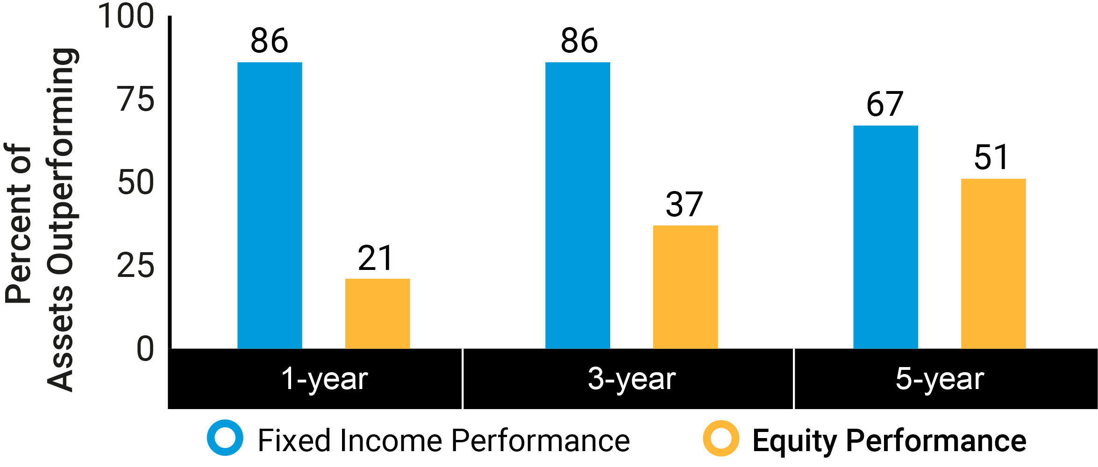
Maintain strong incremental margins(1)
AB Adjusted Operating Margin
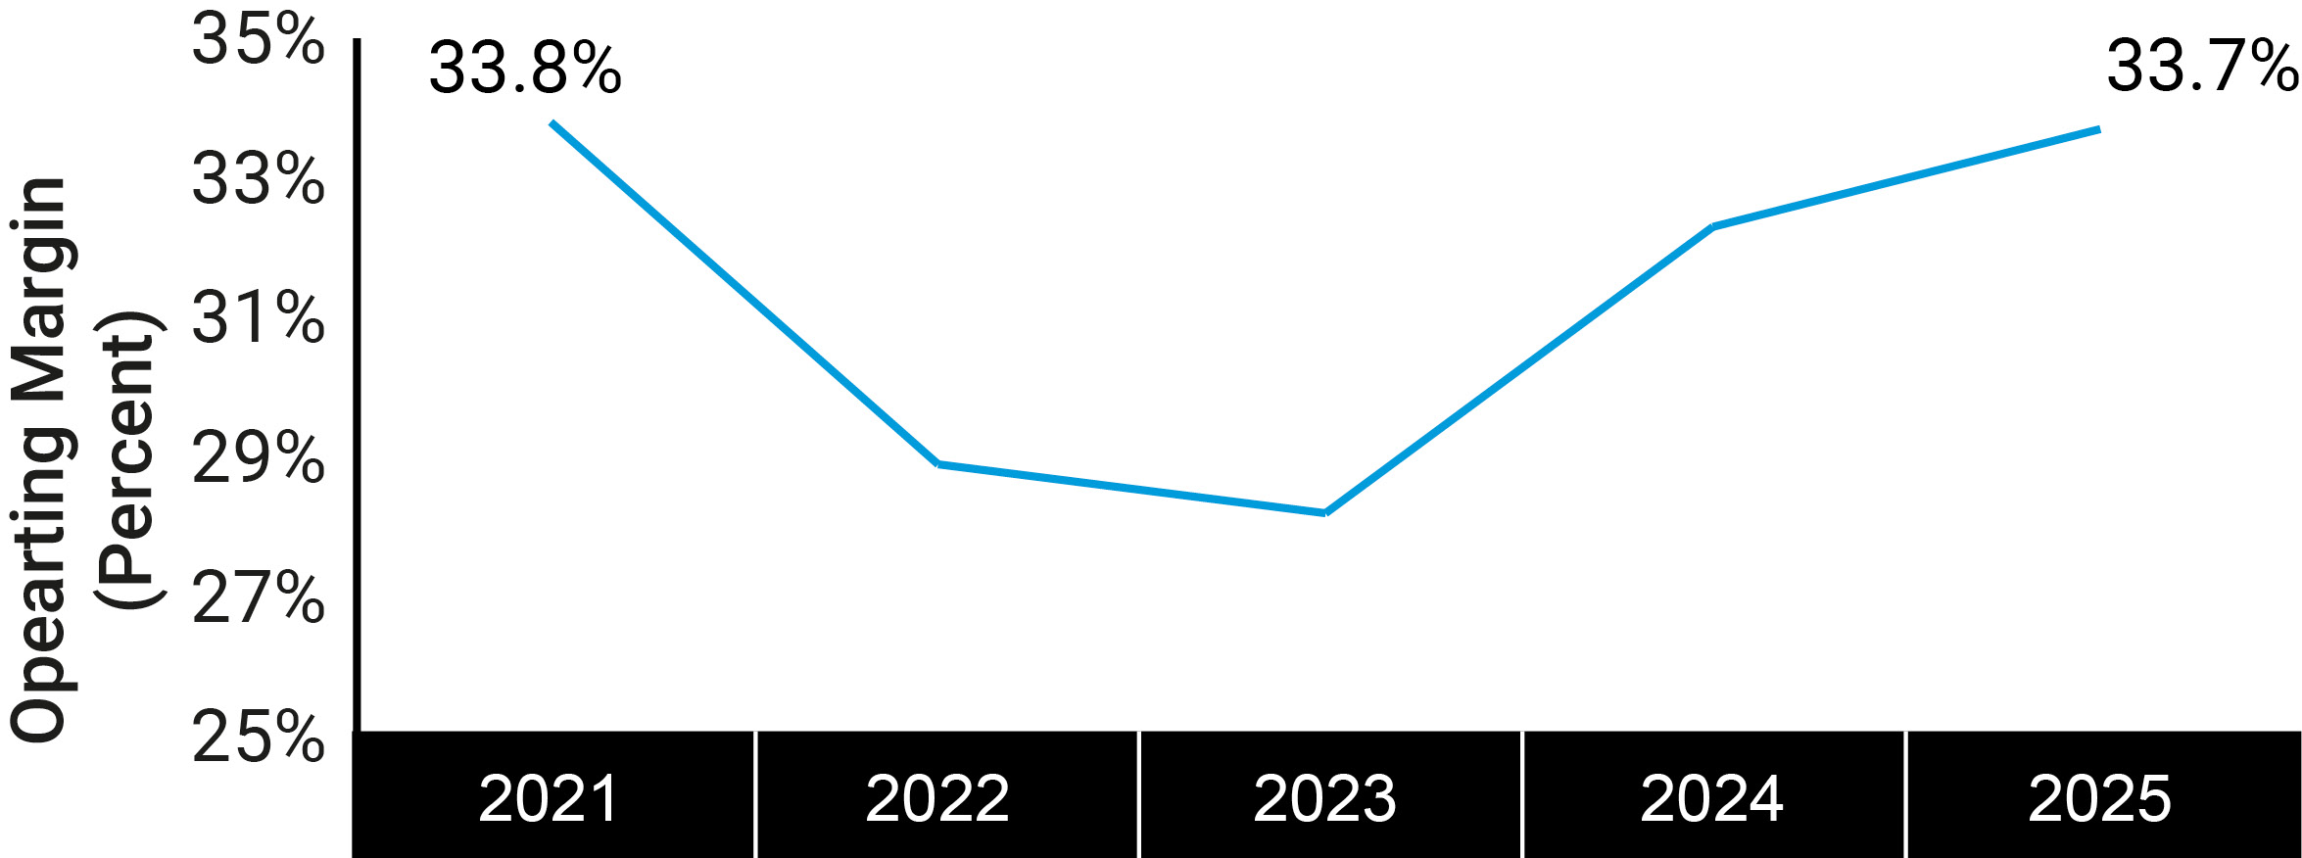
Total Unitholder Return
(2021 - 2025; assumes dividend reinvestment)
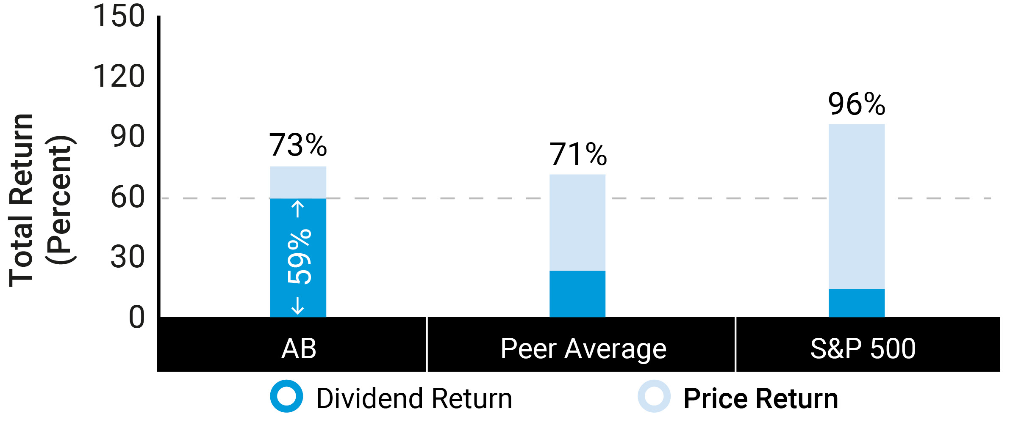
Overview
Record Firmwide Sales |  |  | Alternatives / MAS |  |  | Private Wealth |  |  | Institutional Pipeline AUM
$140B |  |  | $11.4B |  |  | 2% & 6% |  |  | $20B
in gross sales in 2025 |  |  | net inflows in alternatives/multi-asset |  |  | Private Wealth 2% annualized organic growth and 6% net new asset growth |  |  | of institutional pipeline AUM at year-end
(1)We provide additional information regarding our adjusted operating margin in MD&A above in Item 7.
2026 Proxy Statement and LTIP |  |  | 19

Table of Contents
Executive Compensation
Overview of 2025 Incentive Compensation Program
When reflecting on 2025 performance and pay, each of our NEOs received a portion of their year-end incentive compensation in the form of an annual cash bonus and a portion in the form a of long-term incentive compensation award. The split between annual cash bonus and long-term incentive compensation varied depending on the NEO's total compensation, with lower-paid executives receiving a greater percentage of their incentive compensation as cash bonuses than more highly-paid executives. (For additional information about these compensatory elements, see “Compensation Elements for NEOs” below.)
In 2025, we utilized performance scorecards for senior leaders of the firm, including our NEOs. These scorecards require our senior leaders to develop and maintain a broad leadership mindset with priorities, such as accelerating strategic initiatives and our firm's alternatives platform, that are aligned with firm-wide goals of creating long-term value for all of our stakeholders. The scorecard for each NEO reflected our Growth Strategy and included actual results relative to target metrics across the following measures:
•Financial performance, including peer results, adjusted operating margin, adjusted net revenue growth and operating efficiency targets (see our discussion of “Management Operating Metrics” in Item 7 of AB's 2025 Form 10-K for a reconciliation between our results pursuant to U.S. GAAP and our adjusted results);
•Investment performance, by delivering competitive returns across services and time periods;
•Strategic, aligned with our strategy of delivering core investment solutions, while developing high-quality differentiated services, in faster-growing geographies, responsibly, in partnership with Equitable;
•Organizational, including organizational effectiveness and efficiency, leadership impact, succession planning, developing talent, innovating and automating, and real estate utilization; and
•Cultural, including purpose, employee engagement, retention and safety.
The scorecards support management and the Compensation Committee in assessing each executive's performance relative to business, operational and cultural goals established at the beginning of the year and reviewed in the context of the current-year financial performance of the firm. The amount of incentive compensation paid to our NEOs continues to be determined on a discretionary basis by the Compensation Committee. (For additional information, see "Compensation Committee; Process for Determining Executive Compensation" below in this CD&A.)
Mr. Bernstein, with the Compensation Committee, continue to believe that the appropriate metric to consider in determining the amount of incentive compensation paid to all employees, including our NEOs, in respect of 2025 performance is the ratio of adjusted employee compensation and benefits expense to adjusted net revenues, which terms are described immediately below:
•Adjusted employee compensation and benefits expense is our total employee compensation and benefits expense minus other employment costs such as recruitment, training, temporary help and meals, and excludes the impact of mark-to-market vesting expense, as well as dividends and interest expense, associated with employee long-term incentive compensation-related investments. Also, we adjust for certain performance-based fees passed through to our investment professionals.
•Adjusted net revenues (see our discussion of “Management Operating Metrics” in Item 7 of AB's 2025 Form 10-K for a reconciliation between our results pursuant to U.S. GAAP and our adjusted results) exclude investment gains and losses and dividends and interest on employee long-term incentive compensation-related investments. In addition, adjusted net revenues offset distribution-related payments to third parties as well as amortization of deferred sales commissions against distribution revenues. We also exclude additional pass-through expenses we incur (primarily through our transfer agent) that are reimbursed and recorded as fees in revenues. Additionally, we adjust for the revenue impact of consolidating company-sponsored investment funds by eliminating the consolidated company-sponsored investment funds’ revenues and including AB’s fees from such funds, and AB’s investment gains and losses on its investment in such funds, that were eliminated in consolidation. We also adjust for certain acquisition-related pass-through performance-based fees and certain other performance-based fees passed through to our investment professionals.
20 |  |  | AllianceBernstein

Table of Contents
Executive Compensation
In addition, Mr. Bernstein, along with the Compensation Committee, continue to believe that the firm’s adjusted employee compensation and benefits expense, excluding the impact of performance-based fees, generally should not exceed 50.0% of our adjusted net revenues annually, except in unexpected or unusual circumstances. As the table below indicates, in 2025, adjusted employee compensation and benefits expense amounted to approximately 48.3% of our adjusted net revenues (in thousands):
Net Revenues |  |  | $ | 4,530,652
Adjustments (see above) |  |  | (1,006,026)
Adjusted Net Revenues |  |  | $ | 3,524,626
Employee Compensation & Benefits Expense |  |  | 1,790,452
Adjustments (see above) |  |  | (88,609)
Adjusted Employee Compensation & Benefits Expense |  |  | $ | 1,701,843
Adjusted Compensation Ratio |  |  | 48.3 |  | %
Our 2025 adjusted compensation ratio of approximately 48.3% reflects a balancing of the need to keep compensation levels competitive with industry peers in order to attract, motivate and retain highly-qualified talent with the need to maintain strong operating leverage in our business. The Compensation Committee works with management to help ensure both needs are sufficiently addressed.
2026 Proxy Statement and LTIP |  |  | 21

Table of Contents
Executive Compensation
We have described below each NEO’s individual achievements in 2025 given each officer’s role, the contents of their respective performance scorecards and the firm's business and operational goals:
 |  |  | Seth Bernstein  Chief Executive Officer1  Summary of Achievements: As Chief Executive Officer, Mr. Bernstein led the firm through challenging fundraising conditions, achieving strong inflows in private wealth and institutional alternatives, with earnings per unit rising 2% year-over-year and fixed income strategies performing solidly despite equity challenges. The firm expanded its SMA platform to $62 billion AUM and ETF platform to $14 billion AUM, grew insurance-related assets to $195 billion including significant investments in insurance sidecars, and advanced private alternatives toward a $90-100 billion target by 2027. Organizationally, Mr. Bernstein implemented a four-day in-office workweek, managed leadership transitions smoothly, promoted key personnel, and notably named Onur Erzan as President of AB, effective January 5, 2026. Mr. Bernstein supported growth initiatives in India and drove engagement across global offices, while fostering a culture of meritocracy. |  |  | Individual Achievements  Financial and Investment Performance  •Oversaw teams through a challenging fundraising environment; despite persistent active equity outflows, sustained strong flows into private wealth channel (+$2B net inflows in 2025) and institutional alternatives (+$8B net inflows in 2025).  •As of 12/31/2025, earnings per Unit (“EPU”) of $3.33 grew 2% versus 2024, reflecting higher AUM and net revenues despite lower basis fees.  •Maintained strong performance in Fixed Income, with 86% of assets outperforming benchmarks over a 3-year period. Equities performance was challenged as benchmark returns were narrowly led by a small number of mega-cap stocks.  Strategic  •Deepened market share for key strategies; oversaw the progression of our SMA platform to $50B in AUM, as well as the expansion of the ETF platform to include 24 funds, the launch of Taiwan’s first active Fixed Income ETF, and the growth of overall ETF AUM to $14B.  •Grew AB’s insurance brand adding new relationships, and growing AUM to $195B. Made developments in the insurance sidecar market with investments in Ruby Re (+$1B in AUM) and FCA Re (+$1.5B in AUM); FCA Re expands presence in Asian insurance market.  •Persisted in growing AB’s private alternatives platform. AUM as of 12/31/2025 totals $82B, progressing steadily towards AB’s target range of $90-100B in private alternatives AUM by 2027.  Organizational  •Successfully managed through senior leadership changes, including a CFO transition, with minimal disruption to AB’s results. Named Onur Erzan President of AB; Mr. Erzan will partner with Mr. Bernstein in driving AB’s business and strategic priorities forward.  •Adjusted in-office policy from three to four days in the office per week, strengthening collaboration and productivity. Provided employees with additional flexibility benefits to ease the transition.  •Supported evaluation of the firm’s technology platform across all operations. Backed the selection of a provider of integrated solutions and related contract negotiations.  •Invested in the growth of AB India, appointed new CEO, realized compensation savings through role relocation. AB India consists of over 600 roles spanning functions across AB’s business units.  Culture  •Enforced a culture of meritocracy to retain top talent and push underperformers to improve. Established firm-wide expectations for ratings distribution to drive consistency across groups. Ensured managers received training to encourage regular feedback and lead difficult conversations; 95%+ of mid-year reviews were completed.  •Maintained promotion pipeline of senior vice presidents, drove engagement across all levels at the firm, and achieved lower attrition levels than 2024.
 |  |  | 2025 Compensation
 |  |  | 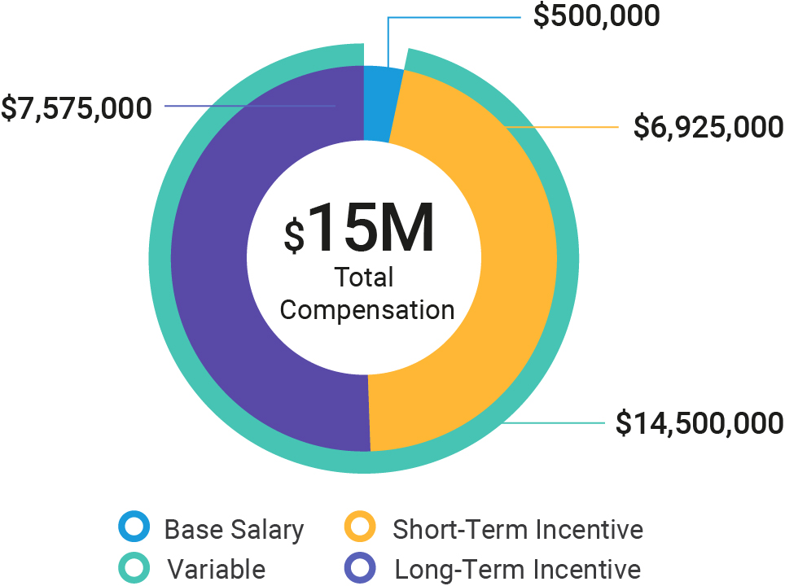
(1)Mr. Bernstein previously held the titles of President and CEO from 2017 through January 5, 2026. Mr. Erzan was appointed President on January 5, 2026; Mr. Bernstein continues to retain the title of Chief Executive Officer.
22 |  |  | AllianceBernstein

Table of Contents
Executive Compensation
 |  |  | Thomas Simeone  Chief Financial Officer effective March 12, 20251  Summary of Achievements: Mr. Simeone was named Chief Financial Officer (CFO) in March 2025 upon his predecessor Jackie Marks’ departure. Mr. Simeone oversaw the delivery of complete, accurate, and timely financial results, both internally and externally (in Forms 10-K and 10-Q and Earnings Releases). As CFO, Mr. Simeone ensured rigor around the tracking of business performance, oversaw strategic initiative spending, drove the implementation of a best-in-class Enterprise Resource Planning (ERP) system, and bolstered the strength of the Finance function. Mr. Simeone previously held the role of Controller and Chief Accounting Officer before his appointment to CFO. |  |  | Individual Achievements  Financial  •Delivered margin expansion from 32.3% to 33.7%, reinforcing disciplined financial management.  •Implemented targeted compensation savings program to maintain operating margin amid increased market volatility.  •Enhanced controls and review processes for non-compensation controllable expenses, driving cost efficiency.  Strategic  •Provided support and financial advisory for several opportunities and corporate development activities.  •Monitored strategic initiatives and performance against planned objectives.  •Furthered strengthened partnership with Equitable across initiatives and with Finance counterparts.  Organizational  •Successfully implemented a new ERP system, positioning the firm for improved scalability and operational efficiency.  •Enhanced financial reporting and strengthened partnership with business units; developed new business-unit level P&L reporting.  •Invested in high performing talent and developed plan for long-term needs within the Finance function.  Culture  •Bolstered engagement across teams through CFO transition.  •Encouraged automation and AI-driven process improvements, accelerating efficiency.  •Fostered development of Finance professionals at all levels via Town Halls and team building events.
 |  |  | 2025 Compensation
 |  |  | 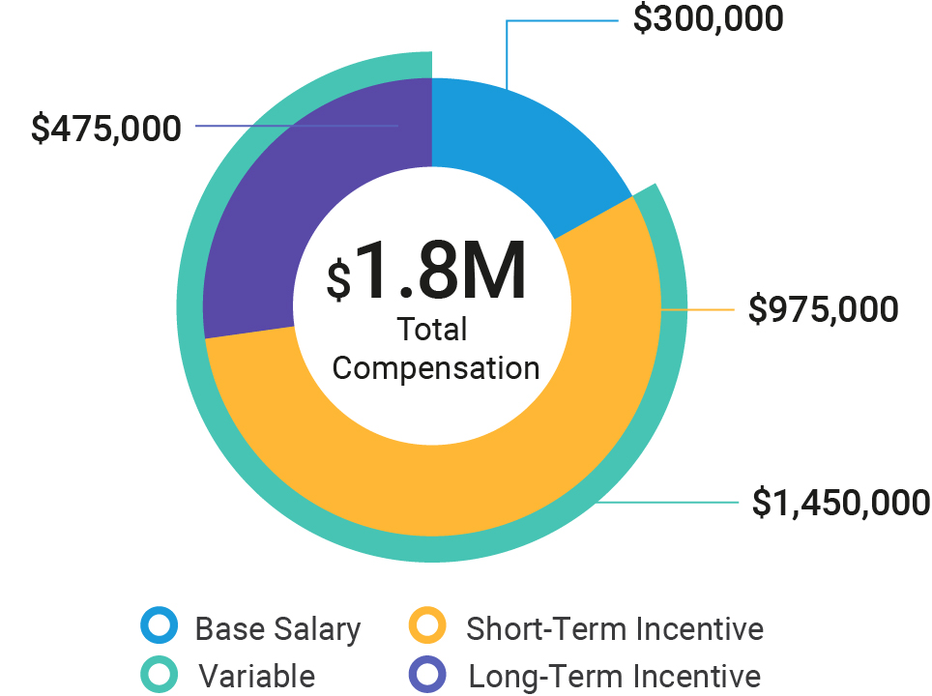
(1)Mr. Simeone was named Chief Financial Officer upon Ms. Mark’s departure on March 12, 2025.
2026 Proxy Statement and LTIP |  |  | 23

Table of Contents
Executive Compensation
 |  |  | Onur Erzan  President effective January 5th, 20261  Summary of Achievements: Mr. Erzan was named President of AllianceBernstein in January 2026. During 2025, Mr. Erzan served as the firm’s Global Head of Private Wealth, Alternatives & Distribution. In this role, Mr. Erzan led global distribution efforts across regions amidst a challenging fundraising environment. Mr. Erzan advanced several strategic initiatives, including the growth of our ETF platform to $14B in assets and launch of Taiwan’s first active Fixed Income ETF, the expansion of our Insurance business to include two new sidecar investments, and the streamlining of capital formation efforts in private alternatives. Mr. Erzan shepherded the Private Wealth business to a fifth year of consecutive organic growth and maintained client retention above 95%. During 2025, Mr. Erzan advanced key strategic priorities across Private Wealth, driving meaningful progress in client experience, advisor excellence, scalable service, and differentiated investment and planning capabilities. Mr. Erzan dedicated resources to employee learning and development and continues to drive a positive, results-oriented culture across his remit. |  |  | Individual Achievements  Financial and Investment Performance  •Drove 3% sales growth year over year; 2025 gross sales were $140B, including $90B retail and $27B institutional, surpassing targets. Sales for the institutional channel more than doubled year-over-year.  •Achieved positive net flows of $2B in Private Wealth channel and a fifth consecutive year of organic growth. Maintained strong client retention, with 3-year average above 95% and retention for relationships over $5M at 96%.  Strategic  •Advanced Insurance business, raising over $15B in assets, including $13.5B general account assets and $2B separate account assets. Added seven new general account relationships across eight investment strategies. Made developments in the insurance sidecar market with investments in Ruby Re (+$1B in AUM) and FCA Re (+$1.5B in AUM).  •Fostered the continued growth of ETF platform to include 24 funds and over $14B in AUM; achieved particular success across International Equities, Municipal Bonds, and Buffered ETFs, raising $2.3B in 2025. Launched Taiwan’s first ever active Fixed Income ETF and bolstered team capabilities via new hires.  •Oversaw generation of over $10B in gross alternatives sales across distribution channels, including nearly $2B for private wealth clients. As of 12/31/2025, private alternatives AUM was $82B, progressing steadily towards AB’s target range of $90-100B by 2027.  •Prioritized advisor excellence for Private Wealth. Sales headcount increased 4%, while advisor teams grew 14%, enabling improved leverage and broader market coverage. Advisor productivity reached record levels, and Private Wealth achieved its strongest net flows since 2021.  •Deepened Bernstein’s value proposition for ultra-high-net-worth clients, leading to significant increases across key segments. UHNW AUM grew 20%, outpacing overall PWM AUM growth. The transition platform expanded with the creation of a dedicated transition team and the successful launch of a 351 ETF conversion. He expanded Bernstein’s engagement with women founders and entrepreneurs by launching the firm’s first women-only forum.  Organizational  •Integrated capital formation team to streamline efforts across Alternatives asset suite.  •Invested in employee talent and development via learning programs. Bolstered the strength of teams and onboarded several senior leaders across global client group.  •Strengthened controls around cyber security; conducted tabletop exercises and loss of technology planning.  •Sought ways to leverage AB India to optimize talent and collaboration across offices.  Culture  •Continued to promote a positive, results-driven culture of continuous learning and development across Client Group, Alternatives, and Private Wealth.  •Conducted quarterly town halls to encourage transparency and cross-department collaboration.  •Launched global exchange program for high potential talent.
 |  |  | 2025 Compensation
 |  |  | 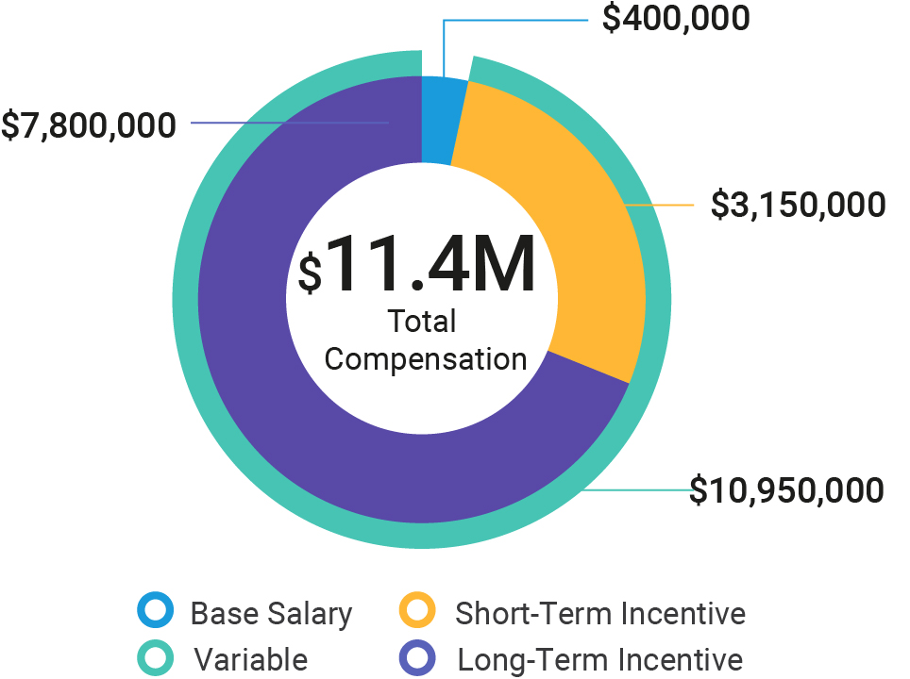
(1)Onur Erzan was named President on January 5, 2026.
24 |  |  | AllianceBernstein

Table of Contents
Executive Compensation
 |  |  | Karl Sprules  Chief Operating Officer  Summary of Achievements: As Chief Operating Officer (COO), Mr. Sprules delivered strong operational leadership by controlling costs, driving strategic technology and AI initiatives, and optimizing global locations. Mr. Sprules advanced organizational effectiveness and culture, including a successful shift to four in-office days and a renewed focus on community and belonging. |  |  | Individual Achievements  Financial  •Maintained stable operating costs across corporate functions while enabling business growth.  •Co-led initiatives for ongoing cost management to enhance economic margin and support investment in the business.  Strategic  •Oversaw a comprehensive evaluation of the technology platform supporting our front, middle, and back-office operations, as well as a review of vendors providing an integrated SaaS solutions. Led the selection of the target platform and managed contract negotiations, ultimately securing the agreement by year-end.  •Realized compensation savings by transferring 256 roles to AB India, which offers comparable capabilities at a lower cost. Led an AB India CEO search and local onboarding. Completed a talent mapping assessment in our Pune office, and secured approval for real estate expansion to support continued growth.  •Sponsored the transition of AI from an experimental phase into a core function of the firm; increased internal usage of generative tools, resulting in productivity boosts across functions.  •Led cross functional effort to prioritize infrastructure resiliency, addressing scenarios like complete technology loss, employee safety, workplace continuity, and office space hardening.  Organizational  •Partnered with the head of investments to separate risk leadership into position focused on investment risk and a broader chief risk officer.  •Directed AB’s global location strategy, completing 55 lease transactions including new agreements, renewals, extensions, and terminations. Optimized space in Nashville and New York through subletting and expansions, consolidated Minneapolis offices into a modern design, and finalized all day two items for the Hudson Yards office.  •Continued to strengthen our presence in Nashville by relocating additional team members from corporate functions and reinforcing existing teams. Encouraged all corporate groups to prioritize the Nashville talent pipeline for key positions and to attract additional top-tier talent to the Nashville office.  •Launched the Strategic Initiatives team, transitioning it from a conventional Project Management Office into a strategic advisory and implementation partner for AB.  Culture  •Championed the transition from three to four in-office days per week and implemented related measurement tools; staff were over 90% compliant with new policy during the second half of the year.  •Advanced our Community and Belonging priorities, relocating leadership to Nashville, adapting to the evolving landscape, and recruiting key talent in London and India to enhance organizational effectiveness.
 |  |  | 2025 Compensation
 |  |  | 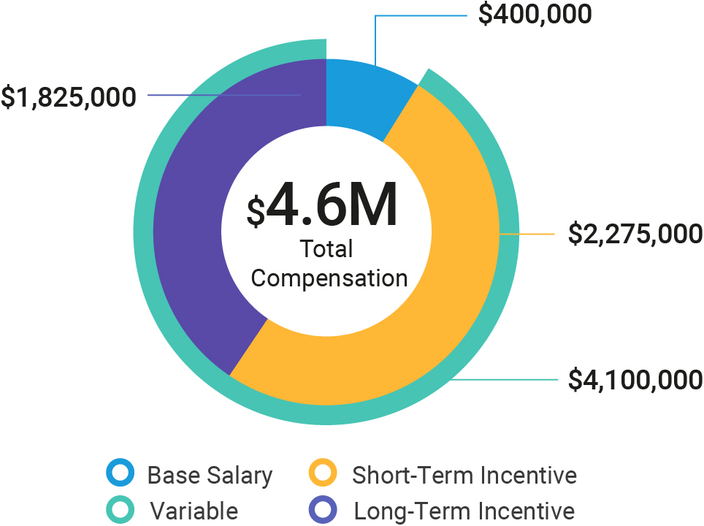
2026 Proxy Statement and LTIP |  |  | 25

Table of Contents
Executive Compensation
 |  |  | Mark Manley  General Counsel & Corporate Secretary  Summary of Achievements: As General Counsel & Corporate Secretary, Mr. Manley oversaw all legal and regulatory affairs for the firm. Mr. Manley played an important role in driving legal initiatives, providing counsel for complex negotiations, supporting strategic initiatives, and serving as a valued advisor to the firm’s leadership. |  |  | Individual Achievements  Financial  •Directed initiatives imposing cost discipline within the legal department, resulting in substantial reductions in external expenditures and driving operational effectiveness across team processes.  •Effectively negotiated and resolved several complex and material contract negotiations, protecting the firm’s interests and financial positions.  •Led important initiatives with Equitable designed to improve governance and investment related collaboration on general account assets.  Strategic  •Demonstrated strong alignment with the firm’s strategic priorities by serving as a key legal advisor on multiple high-impact transactions, including AB’s first investments in insurance sidecars and the launch of new alternative mandates.  •Oversaw implementation of a significant amendment to the SocGen transaction, advancing the company toward its strategic goal of a full exit by 2029.  •Navigated complex regulatory challenges, including off-channel communications, ESG sweep examinations, SEC inquiries and investigations.  Organizational  •Established new roles and recruited senior talent, enhancing succession planning and strengthening the legal department’s leadership pipeline.  •Advanced leadership development by enabling team members to lead high-profile projects, fostering professional growth and independence. Successfully transitioned new Compliance leadership.  Culture  •Served as a valued advisor to company leadership, elevating the profile and impact of the legal and compliance department. Provided strategic focus, deep organizational knowledge, and commercial acumen, contributing to a collaborative and high-performing culture.  •Demonstrated unwavering commitment to fiduciary duties and independent decision-making, reinforcing a culture of integrity and accountability.
 |  |  | 2025 Compensation
 |  |  | 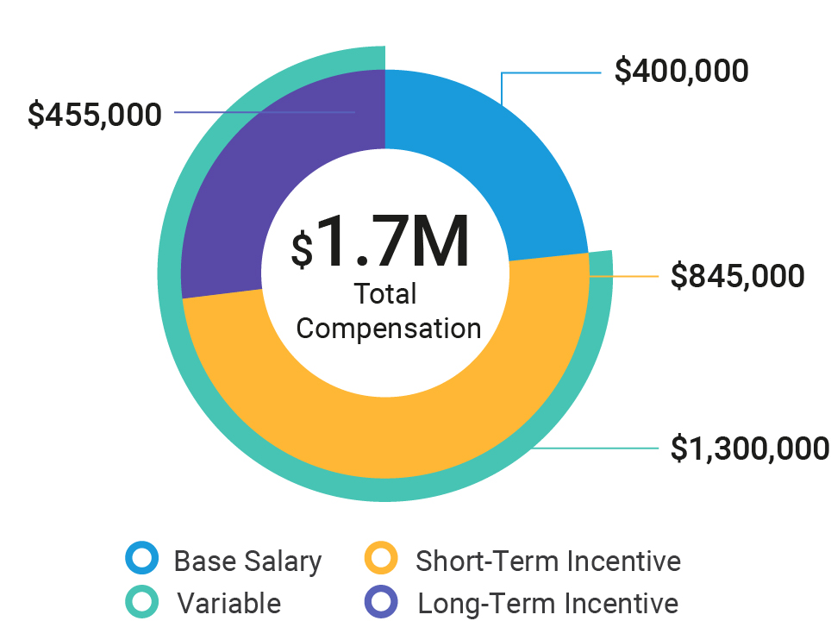
26 |  |  | AllianceBernstein

Table of Contents
Executive Compensation
 |  |  | Jackie Marks  Chief Financial Officer effective March 1, 2024 through March 12, 20251  Summary of Achievements: As Chief Financial Officer (CFO), Ms. Marks oversaw the delivery of complete, accurate and timely financial results both internally and externally (in Forms 10-K and 10-Q and Earnings Releases). Ms. Marks oversaw the enhancement of budget and planning procedures and supported strategic initiatives and corporate development activities. |  |  | Individual Achievements  Financial  •Oversaw maintenance of operating margin and contributed to cost optimization initiatives.  •Drove the improvement of budgeting process and planning and analysis procedures.  Strategic  •Enabled strategic initiatives and corporate development activity.  •Supported diligence process and signing of Investment Management Agreement for AB’s inaugural investment in insurance sidecar space with Reinsurance Group of America’s sidecar Ruby Re.  •Contributed to partnership with Equitable across initiatives and with Finance counterparts.  Organizational  •Led the Finance function and executed all CFO responsibilities for first three months of the year prior to departure.  Culture  •Maintained strong Finance employee engagement, development, and collaboration across workforce.
 |  |  | 2025 Compensation
 |  |  | 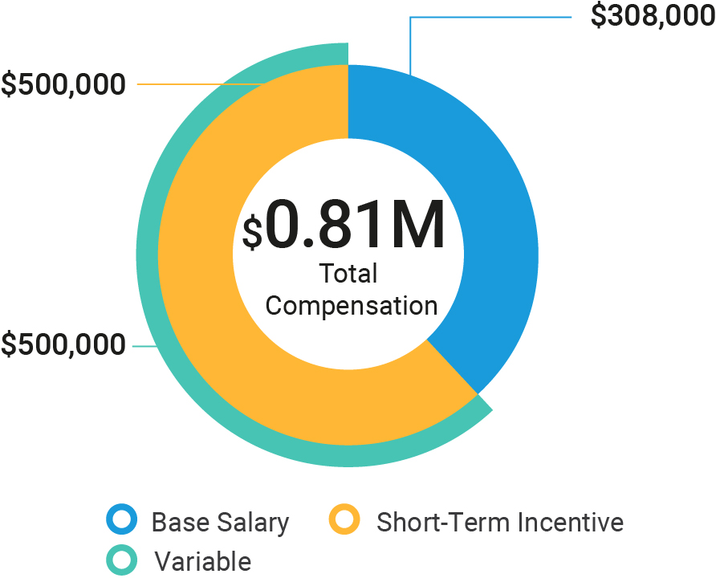
(1)Ms. Marks joined AB on January 8, 2024, as a Senior Advisor and was appointed to the role of Chief Financial Officer as of March 1, 2024. Ms. Marks subsequently departed the firm on March 12, 2025; Mr. Simeone was appointed Chief Financial Officer upon Ms. Mark’s departure.
The compensation of each of these NEOs reflected the Compensation Committee’s judgment (and Mr. Bernstein’s judgment, with respect to each executive other than himself) in assessing the importance of the executive's achievements in the context of our firm’s adjusted financial results and progress in advancing our Growth Strategy.

Compensation Committee; Process for Determining Executive Compensation
The Compensation Committee consists of Mr. Stonehill (Chair), Mr. Kaye and Mr. Pearson. The Compensation Committee held five regular meetings in 2025.
As discussed in “NYSE Governance Matters” in Item 10 of AB's 2025 Form 10-K, AB Holding, as a limited partnership, is exempt from NYSE rules that require public companies to have a compensation committee consisting solely of independent directors. EQH owns, directly and through various subsidiaries, an approximate 68.3% economic interest in AB (as of December 31, 2025), and compensation expense is a significant component of our financial results. For these reasons, Mr. Pearson, director and President and CEO of EQH, is a member of the Compensation Committee, and any action taken by the Compensation Committee requires his affirmative vote or consent. Given this structure, the Compensation Committee has established a sub-committee consisting entirely of non-management directors (i.e., Mr. Stonehill and Mr. Kaye). This “Section 16 Sub-Committee” approves awards of restricted AB Holding Units to NEOs to ensure we can utilize the short-swing trading exemption set forth in
2026 Proxy Statement and LTIP |  |  | 27

Table of Contents
Executive Compensation
Section 16b-3 under the Exchange Act. Under this exemption, equity grants to our firm's executive officers are exempt from short-swing trading rules if each such grant is approved by the full Board or a committee of the Board consisting entirely of “non-employee” directors (generally, directors who are not officers of the company or an affiliate).
The Compensation Committee has general oversight of compensation and compensation-related matters, including:
•determining cash bonuses;
•determining contributions and awards under incentive plans or other compensation arrangements (whether qualified or non-qualified) for employees of AB and its subsidiaries, and amending or terminating such plans or arrangements or any welfare benefit plan or arrangement or making recommendations to the Board with respect to adopting any new incentive compensation plan, including equity-based plans;
•reviewing and approving the compensation of our CEO, evaluating his performance, and determining and approving his compensation level based on this evaluation; and
•reviewing and discussing the CD&A and recommending to the Board its inclusion in each of AB’s and AB Holding’s Form 10-K and, when applicable, proxy statements.
The Compensation Committee has developed a comprehensive process for:
•reviewing our executive compensation program to ensure it is aligned with our firm’s philosophy and strategic objectives;
•evaluating performance by our NEOs against goals and objectives established in each executive's performance scorecard at the beginning of the year; and
•setting compensation for the NEOs and other senior executives.
The Compensation Committee’s year-end process generally focuses on the cash bonuses and long-term incentive compensation awards granted to NEOs and other senior executives. Mr. Bernstein, working with the other senior executives, provides recommendations for individual executive awards to the Compensation Committee for its consideration. As part of this process, and as we discuss more fully below in "Compensation Consultant; Benchmarking Data," the Chief People Officer provides the Compensation Committee with competitive market data from one or more compensation consultants.
Management periodically reviews, with the Compensation Committee, the firm’s expected adjusted financial and operating results, the firm’s actual adjusted financial and operating results and management’s year-end compensation expectations, as they evolve throughout the year. Management accomplished these reviews during regular meetings of the Compensation Committee held in February, May, September, October and November 2025. The Compensation Committee approved the firm's final year-end compensation recommendations during its regular meeting held in November 2025.
Additional information regarding the Compensation Committee’s functions can be found in the Committee's charter, which is available online in the “Corporate Responsibility Overview - Corporate Governance” section of our Internet Site.

Compensation Consultant; Benchmarking Data
In 2025, we contracted with Johnson Associates, Inc. ("Johnson Associates"), an independent compensation consulting firm that specializes in the financial services sector for which we paid approximately $32,000. Johnson Associates consulted on market data and trend forecasting for our NEOs and other senior executives provided by McLagan Partners (“McLagan”) for which we paid McLagan $50,000 (the "2025 Benchmarking Data"). McLagan has an extensive database on compensation for most asset management companies, including private companies for which information is not otherwise available.
The 2025 Benchmarking Data summarized 2024 compensation levels and 2025 salaries, which helps form a reasonable estimation of compensation levels in the industry for executive positions like those held by our NEOs at selected asset management companies comparable to ours in terms of size and business mix (the “Comparable Companies”) and, in so doing, assists in determining the appropriate level of compensation for our NEOs.
28 |  |  | AllianceBernstein

Table of Contents
Executive Compensation
The Comparable Companies, which management selected with input from McLagan, included:
Barings |  |  | Columbia Threadneedle |  |  | Franklin Templeton Investments
Goldman Sachs Asset Management |  |  | Invesco |  |  | Janus Henderson Investors
Loomis, Sayles & Company |  |  | MFS Investment Management |  |  | Pacific Investment Management Company
Neuberger Berman Group |  |  | Nuveen Investments |  |  | T. Rowe Price
Prudential Global Investment Mgmt. |  |  | Schroder Investment Management
The 2025 Benchmarking Data indicated that, as a group, our NEOs fall within market range. Please note that we excluded Ms. Marks and Mr. Hogbin from this analysis as they were no longer with the firm as of December 31, 2025.
The Compensation Committee considered this information in concluding that the compensation levels paid in 2025 to our NEOs were appropriate and reasonable.

Compensation Elements for NEOs
We utilize a variety of compensation elements to achieve the goals described above, consisting of base salary, annual short-term incentive compensation awards (cash bonuses), a long-term incentive compensation award program, a defined contribution plan, and certain other benefits, each of which we discuss below:
Base Salaries
Base salaries comprise a relatively small portion of our NEOs’ total compensation. We consider individual experience, responsibilities and tenure with the firm when determining the narrow range of base salaries paid to our NEOs (refer to “Overview of Mr. Bernstein's Employment Agreement” below for information relating to Mr. Bernstein’s base salary and other compensation elements).
Annual Short-Term Incentive Compensation Awards (Cash Bonuses)
We provide our NEOs with annual short-term incentive compensation awards in the form of cash bonuses.
We believe that annual cash bonuses, which generally reflect individual performance and the firm’s current year adjusted financial performance, provide a short-term retention mechanism for our NEOs because such bonuses typically are paid in December.
Annual cash bonuses for the 2025 performance for each NEO were determined in November 2025 and paid in December 2025. These bonuses, and the 2025 long-term incentive compensation awards described immediately below, were based on management’s evaluation, subject to the Compensation Committee’s review and approval, of each NEO’s performance during the year, the firm's progress in advancing its Growth Strategy during the year, the performance of the NEO’s business Unit or function compared to business and operational goals established in each NEO's performance scorecard at the beginning of the year, and the firm’s current-year adjusted financial performance.
In 2025, Mr. Bernstein received a cash bonus of $6,925,000 in accordance with the terms of the employment agreement into which he entered with the General Partner, AB and AB Holding as of May 1, 2017 (the “CEO Employment Agreement”) and after review of Mr. Bernstein's performance during 2025 by the Compensation Committee. Refer to “Overview of Mr. Bernstein's Employment Agreement” below for additional information relating to Mr. Bernstein’s cash bonus and other compensation elements.
2026 Proxy Statement and LTIP |  |  | 29

Table of Contents
Executive Compensation
Long-Term Incentive Compensation Awards
Long-term incentive compensation awards generally are denominated in restricted AB Holding Units. We utilize this structure to align our NEOs’ long-term interests directly with the interests of our Unitholders and indirectly with the interests of our clients, as strong performance for our clients generally contributes directly to increases in AUM and improved financial performance for the firm.
We believe that annual long-term incentive compensation awards provide a long-term retention mechanism for our NEOs because such awards generally vest ratably over three years. We also believe that certain long term incentive compensation awards can be used for recruitment or retention purposes when it includes a required service period.
For 2025 performance, awards were granted in December 2025 to each of Messrs. Bernstein, Erzan, Manley, Simeone and Sprules pursuant to the AB 2025 Incentive Compensation Award Program (the "ICAP"), an unfunded, non-qualified incentive compensation plan, and the AB 2017 Long Term Incentive Plan, our equity compensation plan (the “2017 Plan”).
Prior to the date on which an award vests, the AB Holding Units underlying an award are restricted and are not permitted to be transferred. Upon vesting, the AB Holding Units underlying an award are generally delivered, unless the award recipient has, in advance, voluntarily elected to defer receipt to future periods or the award is structured with a delayed delivery date. Quarterly cash distributions on vested and unvested restricted AB Holding Units are delivered to award recipients when cash distributions are paid generally to Unitholders.
An award recipient who resigns or is terminated without cause prior to the vesting date is eligible to continue to vest in his or her long-term incentive compensation award subject to compliance with the restrictive covenants set forth in the applicable award agreement, including confidentiality, restrictions on competition, and restrictions on employee and client solicitation. Additionally, the award agreement provides for continued vesting in the event of an award recipient's retirement, subject to applicable restrictive covenants. To be eligible for retirement, an award recipient must provide notice of retirement, enter into a retirement agreement and satisfy a "Rule of 70," whereby the sum of the recipient's age and full years of service must equal at least 70.
Clawbacks
The award agreement contained in the AB Incentive Compensation Award Program ("ICAP") permits AB to claw-back the unvested portion of an award if the recipient fails to adhere to our risk management policies. As such, for accounting purposes, there is no employee service requirement and awards are fully expensed when granted. As used in this Executive Compensation section, “vest” refers to the time at which the awards are no longer subject to forfeiture for breach of these restrictions or risk management policies, which we discuss further below in “Consideration of Risk Matters in Determining Compensation.”
Further, pursuant to Rule 10D-1 of the Exchange Act and Section 303A.14 of the NYSE Listed Company Manual, the Board has adopted a Compensation Recovery Policy (the "Policy") effective November 15, 2023. Pursuant to the Policy, the Company will promptly recover erroneously awarded incentive-based compensation (as defined by section 10D(b)(1) to include any compensation that is granted, earned or vested wholly or in part upon attainment of a financial reporting measure) from any current or former Executive Officer of the Company as defined by Rule 10D-1 of the Exchange Act as required under the Exchange Act and the NYSE Listed Company Manual. The company does not currently award incentive-based compensation as defined by the Act. We have filed the Policy as Exhibit 97.01 to AB's 2025 Form 10-K.
The portion of incentive-based compensation received from EQH specific to Mr. Bernstein and Mr. Erzan is covered under the Compensation Recovery Policy adopted by our parent EQH and will be applicable to any current or previous incentive-based compensation received directly from our parent company by Mr. Bernstein and Mr. Erzan. See "Summary Compensation Table for 2025" for stock awards received by Mr. Bernstein and Mr. Erzan for which the EQH Compensation Recovery Policy is applicable.
30 |  |  | AllianceBernstein

Table of Contents
Executive Compensation
Former CFO Separation
As announced in a Form 8-K filed on March 12, 2025 AB mutually agreed to a separation with Ms. Marks, AB’s Chief Financial Officer since March 1, 2024, effective March 12, 2025.
Defined Contribution Plan
U.S. employees of AB, including each of our NEOs, are eligible to participate in the Profit Sharing Plan for Employees of AB (as amended and restated as of January 1, 2015, and as further amended as of January 1, 2017, as of April 1, 2018, and as of June 28, 2022, the “AB Profit Sharing Plan”), a tax-qualified defined contribution retirement plan. The Compensation Committee determines the amount of company contributions (both the level of annual matching by the firm of an employee’s pre-tax salary deferral contributions and the annual company profit sharing contribution, if any).
With respect to 2025, the Compensation Committee determined in November 2025 that employee deferral contributions would be matched on a dollar-for-dollar basis up to 5% of eligible compensation and that there would be no profit sharing contribution paid by AB.
Defined Benefit Plan
The retirement plan (the "Retirement Plan") was a qualified, noncontributory, defined benefit retirement plan covering current and former employees who were employed in the United States prior to October 2, 2000. Each participant’s benefits were determined under a formula which took into account years of credited service through December 31, 2008, the participant’s average compensation over prescribed periods and Social Security covered compensation. The maximum annual benefit payable under the Retirement Plan was not to exceed the lesser of $100,000 or 100% of a participant’s average aggregate compensation for the three consecutive years in which he or she received the highest aggregate compensation from us or such lower limit as may be imposed by the Internal Revenue Code of 1986, as amended (the "Code") on certain participants by reason of their coverage under another qualified retirement plan we maintain.
During 2024, the Compensation Committee of the AB Board of Directors approved the termination of the Retirement Plan, effective May 22, 2024. We began the process of settling benefits with vested participants and all lump sum disbursements elected by plan participants were distributed in December 2024. The remaining retirement plan participants who did not elect a lump sum disbursement elected to roll over their benefit to a group annuity contract from a qualified insurance company to administer all future payments.
During 2025, we settled all future obligations under the Retirement Plan and transferred the remaining obligations to a qualified insurance provider under a group annuity contract. The plan was formally terminated and the trust was closed effective September 30, 2025. For additional information regarding the termination of the Retirement Plan, see Note 18 to AB's consolidated financial statements in Item 8 of AB's 2025 Form 10-K.
Other Benefits
Change in Control Plan
In December 2020, the Compensation Committee approved the AllianceBernstein Change in Control Plan for Executive Officers (the "CIC Plan"). The purpose of the CIC Plan is to provide certain benefits for each individual designated by our CEO as an executive officer (an "Executive Officer") in the event of a change in control ("CIC") of AB. The CIC Plan contains a change in control provision substantially similar to the change in control provision included in Mr. Bernstein's employment agreement (as described below in "Overview of Mr. Bernstein's Employment Agreement"). The provisions under the CIC Plan also are described in a compensatory table below entitled, “Potential Payments upon Termination or Change in Control.”
The CIC Plan provides that, in the event of a CIC, unless prior to the CIC, any unvested restricted Unit awards (including ICAP awards) then held by an Executive Officer are honored or assumed, or new rights are substituted therefore, so that the Executive Officer's rights and entitlements after the CIC are substantially equivalent to or better than the Executives Officer's rights and entitlements under the award, each award will, prior to the CIC, immediately and fully vest and no longer be subject to forfeiture.
2026 Proxy Statement and LTIP |  |  | 31

Table of Contents
Executive Compensation
In addition, (i) if the Executive Officer's employment is terminated by AB, other than for cause, (ii) the Executive Officer resigns with good reason (as defined in the CIC Plan), or (iii) the Executive Officer dies or becomes disabled, within 12 months following a CIC, the Executive Officer will be entitled to receive the sum of (a) the Executives Officer's annual base salary at the time of his or her termination, and (b) the Executive Officer's most recent annual cash incentive compensation award, multiplied by two.
The CIC Plan defines CIC to include any transaction as a result of which EQH ceases to control AB, or a successor entity that conducts the business of AB. However, there would not be a CIC unless, as a result of the transaction, an entity other than EQH controls AB (or a successor to its business).
Life Insurance
Our firm pays the premiums associated with life insurance policies purchased on behalf of our NEOs.
Consideration of Risk Matters in Determining Compensation
In 2025, we considered whether our compensation practices for employees, including our NEOs, encourage unnecessary or excessive risk-taking and whether any risks arising from our compensation practices are reasonably likely to have a material adverse effect on our firm. For the reasons set forth below, we have determined that our current compensation practices do not create risks that are reasonably likely to have a material adverse effect on our firm.
As described above in “Long-Term Incentive Compensation Awards,” long-term incentive compensation awards generally are denominated in AB Holding Units that are not distributed until subsequent years, so the ultimate value that the employee derives from the award depends on the long-term performance of the firm. Denominating the award in restricted AB Holding Units and deferring their delivery is intended to sensitize employees to risk outcomes and discourage them from taking excessive risks, whether relating to investments, operations, regulatory compliance and/or cyber security, that could lead to a decrease in the value of the AB Holding Units and/or an adverse effect on the firm's long-term prospects. Furthermore, and as noted above in “Long-Term Incentive Compensation Awards,” generally all outstanding long-term incentive compensation awards include a provision permitting us to “claw-back” the unvested portion of an employee’s long-term incentive compensation award if the Compensation Committee determines that (i) the employee failed to adhere to existing risk management policies and (ii) as a result of the employee’s failure, there has been or reasonably could be expected to be a material adverse impact on our firm or the employee’s business unit.
Overview of Mr. Bernstein's Employment Agreement
Employment Agreement Overview
Mr. Bernstein began his role as President and CEO on May 1, 2017, with an initial term ending on May 1, 2020, automatically extending each year thereafter unless the CEO Employment Agreement is terminated in accordance with its terms (the “Employment Term”). The terms were approved by the Board considering various factors including compensation of Mr. Bernstein’s predecessor, the 2016 compensation and 2017 expected compensation of AB’s other executive officers and Mr. Bernstein’s compensation at his former employer. Amendments in December 2018 and 2019 included aligning equity awards with AB's practices, increasing severance payments, redefining change in control, and narrowing the definition of good reason. The terms under the CEO Employment Agreement continue to apply to Mr. Bernstein in his continued role as CEO effective January 5, 2026.
Compensation Elements
Base Salary
Mr. Bernstein’s annual base salary under the CEO Employment Agreement continues to be $500,000 for 2025. This amount is consistent with our firm’s policy to keep base salaries of executives and other highly-compensated employees low in relation to total compensation. Any future increase to Mr. Bernstein's base salary is entirely at the discretion of the Compensation Committee.
32 |  |  | AllianceBernstein

Table of Contents
Executive Compensation
Cash Bonus
Mr. Bernstein is entitled to a target cash bonus of $3,000,000 annually, subject to review. For 2025, he received a $6,925,000 bonus based on performance evaluations. See description of the performance metrics and individual achievement for Mr. Bernstein above.
Restricted AB Holding Units
Starting in 2018, Mr. Bernstein is eligible for annual equity awards with a grant date fair value of $3,500,000, subject to review and increase by the Compensation Committee, in its sole discretion, in accordance with AB’s compensation practices and policies generally applicable to the firm’s executive officers as in effect from time to time. During November 2025, the Compensation Committee approved an equity award to Mr. Bernstein with a grant date fair value equal to $6,575,000, subject to the same terms as other executive officers, which terms and conditions are described above in "Compensation Elements for NEOs - Long-Term Incentive Compensation Awards."
Perquisites and Benefits
Mr. Bernstein is eligible for all executive benefit plans and, for his safety and accessibility, is provided with a company car and driver for business and personal use and cybersecurity protection services contracted through a third party.
Severance and Change in Control Benefits
If Mr. Bernstein is terminated without cause, or because of his death or disability, or resigns for good reason, and he signs and does not revoke a waiver and release of claims, he will receive the following severance benefits:
•A cash payment based on a multiple of his base salary and bonus opportunity (1x for resignation for good reason, 1.5x for termination without cause or because of death or disability).
•A pro rata bonus based on actual performance for the fiscal year in which the termination occurs.
•COBRA coverage costs.
If terminated within 12 months following a change in control (as defined in the amended CEO Employment Agreement), he will receive the same severance benefits as described above, except that his cash payment will be equal to 2x the sum of his base salary and bonus opportunity. In the event any payments made to Mr. Bernstein upon a change in control of AB constitute “golden parachute payments” within the meaning of Section 280G of the Internal Revenue Code and would be subject to an excise tax imposed by Section 4999 of the Internal Revenue Code, such payments will be reduced to the maximum amount that does not result in the imposition of such excise tax, but only if such reduction results in Mr. Bernstein receiving a higher net-after tax amount than he would receive absent such reduction.
For additional information on severance and change in control benefits for Mr. Bernstein as of December 31, 2025, see Potential Payments Upon Termination or Change in Control below.
Mr. Bernstein is subject to confidentiality, non-competition during employment and six months after, and non-solicitation of customers and employees for 12 months post-termination.
Mr. Bernstein negotiated the severance and change-in-control provisions described immediately above to have the security and flexibility to focus on the business and preserve the value of his long-term incentive compensation. The Board and EQH determined that these provisions were reasonable and appropriate because they were necessary to recruit and retain Mr. Bernstein and provided Mr. Bernstein with effective incentives for future performance, aligning his interests with those of AB’s Unitholders and clients, and providing effective incentives for future performance.
Compensation awarded by EQH to Mr. Bernstein and Mr. Erzan
In February 2025, EQH granted to Mr. Bernstein, in connection with his membership on and service to the EQH Management Committee:
•a restricted stock Unit award (for EQH common stock) with a grant date fair value of $400,006; and
2026 Proxy Statement and LTIP |  |  | 33

Table of Contents
Executive Compensation
•a total shareholder return ("TSR") performance share award (for EQH common stock) with a grant date fair value of $300,032, which can be earned subject to EQH’s total shareholder return relative to its peer group.
•an EPS performance share award (for EQH common stock) with a grant date fair value of $300,032, which can be earned subject to EQH's average of annual performance against Non-GAAP Common Operating EPS targets assigned each year.
Additionally, in February 2025, EQH granted to Mr. Erzan, in connection with his membership on and service to the EQH Management Committee:
•a restricted stock Unit award (for EQH common stock) with a grant date fair value of $40,043; and
•a TSR performance share award (for EQH common stock) with a grant date fair value of $30,019, which can be earned subject to EQH’s total shareholder return relative to its peer group.
•an EPS performance share award (for EQH common stock) with a grant date fair value of $30,019, which can be earned subject to EQH's average of annual performance against Non-GAAP Common Operating EPS targets assigned each year.
Assumptions made in determining the EQH restricted stock Unit and performance share figures discussed above are described in footnotes to the compensatory tables below entitled "Summary Compensation Table for 2025" and "Grants of Plan-Based Awards in 2025."
Mr. Bernstein and Mr. Erzan may receive additional equity or cash compensation from EQH in the future related to their continued membership on and service to the EQH Management Committee.
CEO Pay Ratio
In 2025, the compensation of Mr. Bernstein, our CEO, was approximately 98 times the median pay of our employees, resulting in a 98:1 CEO Pay Ratio.
We identified our median employee by examining 2025 total compensation for all individuals, excluding Mr. Bernstein, who were employed by our firm as of December 31, 2025, the last day of our payroll year. We included all of our employees in this process, whether employed on a full-time or part-time basis. We did not make any assumptions or estimates with respect to total compensation, but we did adjust compensation paid to our non-U.S. employees during our 2025 fiscal year based on the average daily exchange rates for the three-month period ending September 30, 2025 (data compiled in fourth quarter) between the local currencies in which such employees are paid and U.S. dollars. We define “total compensation” as the aggregate of base salary (plus overtime, as applicable), commissions (as applicable), cash bonus and the grant date fair value of long-term incentive compensation awards.
After identifying the median employee based on total compensation, we calculated total compensation in 2025 for such employee using the same methodology we use for our NEOs as set forth below in the "Summary Compensation Table for 2025."
As illustrated in the table below, our 2025 CEO Pay Ratio is 98:1:
 |  |  | Seth Bernstein |  |  | Median Employee
Base salary ($) |  |  | 500,000 |  |  | 132,179
Cash bonus ($) |  |  | 6,925,000 |  |  | 15,000
Stock awards ($)(1) |  |  | 7,575,070 |  |  | —
All other compensation ($)(2) |  |  | 133,130 |  |  | 6,878
Total ($) |  |  | 15,133,200 |  |  | 154,057
2025 CEO Pay Ratio |  |  | 98:1
(1)Includes (i) an award granted by AB of restricted AB Holding Units with a grant date fair value of $6,575,000, and (ii) awards granted by EQH with an aggregate grant date fair value of $1,000,070, as more fully described above in “Compensation awarded by EQH to Mr. Bernstein and Mr. Erzan.” For additional information, refer to the compensatory tables below in this Executive Compensation section.
(2)For a description of Mr. Bernstein’s other compensation, refer to the "Summary Compensation Table for 2025" below. The median employee's other compensation consists of a $5,970 contribution match under the AB Profit Sharing Plan, a $360 mobile phone stipend, which is paid to employees generally as well, and an employer-paid group term life insurance premium of $548.
34 |  |  | AllianceBernstein

Table of Contents
Executive Compensation
Other Compensation-Related Matters
AB and AB Holding are, respectively, private and public limited partnerships. They are subject to taxes other than federal and state corporate income tax (see “Structure-related Risks” in Item 1A and Note 21 to AB’s consolidated financial statements in Item 8 of AB's 2025 Form 10-K). Accordingly, Section 162(m) of the Code, which limits tax deductions relating to executive compensation otherwise available to an entity taxed as a corporation, is not applicable to either AB or AB Holding for 2025.
Compensation Committee Interlocks and Insider Participation
Mr. Pearson is a director and the President and CEO of EQH, the parent company of the General Partner.
No executive officer of AB serves as (i) a member of a compensation committee or (ii) a director of another entity, an executive officer of which serves as a member of AB’s Compensation Committee.
Compensation Committee Report
The members of the Compensation Committee reviewed and discussed with management the Compensation Discussion and Analysis set forth above and, based on such review and discussion, recommended to the Board its inclusion in AB's 2025 Form 10-K.
Charles Stonehill (Chair) |  |  | Daniel Kaye
Mark Pearson

2026 Proxy Statement and LTIP |  |  | 35

Table of Contents
Executive Compensation
Summary Compensation Table for 2025
Total compensation of our NEOs for 2025, 2024 and 2023, as applicable, is as follows:
Name and Principal Position |  |  | Year |  |  | Salary  ($) |  |  | Bonus  ($) |  |  | Stock  Awards(1)(2)  ($) |  |  | Option  Awards  ($) |  |  | Pension  ($) |  |  | All Other  Compensation  ($) |  |  | Total  ($)
Seth Bernstein(3)(4)  CEO |  |  | 2025 |  |  | 500,000 |  |  | 6,925,000 |  |  | 7,575,070 |  |  | — |  |  | — |  |  | 133,130 |  |  | 15,133,200
 |  |  | 2024 |  |  | 500,000 |  |  | 5,425,000 |  |  | 6,075,046 |  |  | — |  |  | — |  |  | 127,148 |  |  | 12,127,194
 |  |  | 2023 |  |  | 500,000 |  |  | 4,515,000 |  |  | 4,995,054 |  |  | — |  |  | — |  |  | 114,201 |  |  | 10,124,255
Thomas Simeone(5)  CFO |  |  | 2025 |  |  | 300,000 |  |  | 975,000 |  |  | 475,000 |  |  | — |  |  | — |  |  | 19,904 |  |  | 1,769,904
Onur Erzan(6)  President |  |  | 2025 |  |  | 400,000 |  |  | 3,150,000 |  |  | 7,800,097 |  |  | — |  |  | — |  |  | 22,638 |  |  | 11,372,735
 |  |  | 2024 |  |  | 400,000 |  |  | 3,080,851 |  |  | 2,730,877 |  |  | — |  |  | — |  |  | 19,302 |  |  | 6,231,030
 |  |  | 2023 |  |  | 400,000 |  |  | 2,905,851 |  |  | 2,555,887 |  |  | — |  |  | — |  |  | 17,544 |  |  | 5,879,282
Karl Sprules  COO |  |  | 2025 |  |  | 400,000 |  |  | 2,275,000 |  |  | 1,825,000 |  |  | — |  |  | — |  |  | 60,971 |  |  | 4,560,971
 |  |  | 2024 |  |  | 400,000 |  |  | 2,225,000 |  |  | 1,775,000 |  |  | — |  |  | 123,932 |  |  | 59,109 |  |  | 4,583,041
 |  |  | 2023 |  |  | 400,000 |  |  | 2,025,000 |  |  | 1,575,000 |  |  | — |  |  | 3,018 |  |  | 32,294 |  |  | 4,035,312
Mark Manley(7)  General Counsel and Corporate Secretary |  |  | 2025 |  |  | 400,000 |  |  | 845,000 |  |  | 455,000 |  |  | — |  |  | — |  |  | 33,492 |  |  | 1,733,492
 |  |  | 2024 |  |  | — |  |  | — |  |  | — |  |  | — |  |  | — |  |  | — |  |  | —
 |  |  | 2023 |  |  | 300,000 |  |  | 780,000 |  |  | 345,000 |  |  | — |  |  | 22,934 |  |  | 26,898 |  |  | 1,474,832
Jackie Marks(8)  Former CFO |  |  | 2025 |  |  | 307,692 |  |  | 500,000 |  |  | — |  |  | — |  |  | — |  |  | 1,145 |  |  | 808,837
 |  |  | 2024 |  |  | 383,077 |  |  | 1,428,825 |  |  | 971,175 |  |  | — |  |  | — |  |  | 582 |  |  | 2,783,659
(1)The figures in the “Stock Awards” column provide the aggregate grant date fair value of the awards calculated in accordance with FASB ASC Topic 718. For the assumptions made in determining the AB Holding Unit award values, see Note 19 to AB’s consolidated financial statements in Item 8 of AB's 2025 Form 10-K. Assumptions made in determining the EQH restricted stock unit, TSR performance share, and EPS performance share figures in the "Stock Awards" column are set forth in the EQH 2025 Long-Term Incentive Compensation Program and described in a footnote to the "Grants of Plan-Based Awards in 2025" table below.
(2)See “Grants of Plan-Based Awards in 2025” below.
(3)See "Overview of Mr. Bernstein's Employment Agreement" and "Compensation Awarded by EQH to Mr. Bernstein and Mr. Erzan" above in CD&A for a description of Mr. Bernstein's compensatory elements. Please be advised that Mr. Bernstein's compensation is also disclosed by EQH.
(4)The "Stock Awards" column for 2025 includes the grant date fair value of the restricted stock award (grant date fair value of $400,006), the TSR performance share award (grant date fair value of $300,032), and the EPS performance share award (grant date fair value of $300,032) Mr. Bernstein received from EQH in February 2025. For 2024, this column includes the grant date fair value of the restricted stock Unit award (grant date fair value of $400,006), the TSR performance share award (grant date fair value of $300,019), and the EPS performance share award (grant date fair value of $300,021) Mr. Bernstein received from EQH in February 2024. For 2023, this column includes the grant date fair value of the restricted stock Unit award (grant date fair value of $332,029) and the TSR performance share award (grant date fair value of $498,025) Mr. Bernstein received from EQH in February 2023.
(5)We have not provided 2024 and 2023 compensation for Mr. Simeone as he was not deemed to be a NEO in those years.
(6)The "Stock Awards" column for 2025 includes the grant date fair value of the restricted stock Unit award (grant date fair value of $40,043), the TSR performance share award (grant date fair value of $30,019), and EPS performance share award (grant date fair value of $30,019) Mr. Erzan received from EQH in February 2025. For 2024, this column includes the grant date fair value of the restricted stock Unit award (grant date fair value of $40,007), the TSR performance share award (grant date fair value of $30,013), and EPS performance share award (grant date fair value of $30,006) Mr. Erzan received from EQH in February 2024. For 2023, this column includes the grant date fair value of the restricted stock Unit award (grant date fair value of $40,024) and the TSR performance share award (grant date fair value of $60,012) received from EQH in February 2023.
36 |  |  | AllianceBernstein

Table of Contents
Executive Compensation
(7)We have not provided 2024 compensation for Mr. Manley as he was not disclosed in accordance with applicable SEC rules and regulations in that year.
(8)AB mutually agreed to a separation with Ms. Marks effective March 12, 2025. Ms. Marks received a standard severance package, which included salary continuation for 6 months and a portion of her 2025 incentive compensation.
The “All Other Compensation” column includes the aggregate incremental cost to our company of certain other expenses and perquisites. For 2025, this column includes the following:
Name |  |  | Personal  Use of Car  and Driver  ($) |  |  |  |  |  | Contributions  to Profit  Sharing Plan  ($) |  |  | Life  Insurance  Premiums  ($) |  |  | Other(2)  ($)
Seth Bernstein |  |  | 107,948 |  |  | (1) |  |  | 17,500 |  |  | 3,564 |  |  | 4,118
Thomas Simeone |  |  | — |  |  |  |  |  | 15,000 |  |  | 450 |  |  | 4,454
Onur Erzan |  |  | — |  |  |  |  |  | 17,500 |  |  | 630 |  |  | 4,508
Karl Sprules |  |  | — |  |  |  |  |  | 17,500 |  |  | 4,002 |  |  | 39,469
Mark Manley |  |  | — |  |  |  |  |  | 17,500 |  |  | 11,484 |  |  | 4,508
Jackie Marks |  |  | — |  |  |  |  |  | — |  |  | 121 |  |  | 1,024
(1)Mr. Bernstein is entitled to the use of a dedicated car and driver pursuant to his employment agreement for security and business purposes. The amount reflects Mr. Bernstein's personal use for commuting and other non-business use. Car and driver services were contracted through a third party. The cost of providing a car is determined annually and includes, as applicable, the cost of the driver, annual car lease, insurance cost and various miscellaneous expenses such as fuel and car maintenance.
(2)These amounts represent (i) mobile phone stipends paid to Messrs. Bernstein, Simeone, Erzan, and Manley, which are paid to employees generally as well; (ii) a stipend paid to Mr. Sprules to help cover a portion of the housing cost in New York while traveling for business; and (iii) full-year cybersecurity protection services contracted through a third party for Messrs. Bernstein, Simeone, Erzan, Sprules, and Manley and partial-year services for Ms. Marks to help mitigate cyber, privacy, identity theft, and reputational threats, which are available to executive officers, directors, and employees whose role includes representing AB publicly or handling significant financial transactions.

2026 Proxy Statement and LTIP |  |  | 37

Table of Contents
Executive Compensation
Grants of Plan-Based Awards in 2025
Grants of awards under the 2017 Plan, our equity compensation plan, during 2025 made to our NEOs are as follows (we also discuss awards issued by EQH to Mr. Bernstein and Mr. Erzan below):
 |  |  | Grant Date |  |  | Estimated Future Payouts Under Equity  Incentive Plan Awards(3) |  |  |  |  |  |  |  |  | All Other  Stock Awards:  Number of Shares  of Stock  or Units  (#) |  |  | Grant Date  Fair Value  of Stock  Awards(1)  ($)
Name |  |  |  |  |  | Threshold  (#) |  |  | Target  (#) |  |  | Maximum  (#)
Seth Bernstein(2)(3) |  |  | 12/10/2025 |  |  |  |  |  |  |  |  |  |  |  | 159,937 |  |  | 6,575,000
 |  |  | 2/13/2025 |  |  |  |  |  |  |  |  |  |  |  | 7,502 |  |  | 400,006
 |  |  | 2/13/2025 |  |  | 1,407 |  |  | 5,627 |  |  | 11,254 |  |  | 5,627 |  |  | 300,032
 |  |  | 2/13/2025 |  |  | 1,407 |  |  | 5,627 |  |  | 11,254 |  |  | 5,627 |  |  | 300,032
Thomas Simeone(2) |  |  | 12/10/2025 |  |  |  |  |  |  |  |  |  |  |  | 11,554 |  |  | 475,000
Onur Erzan(2)(3)(4) |  |  | 12/10/2025 |  |  |  |  |  |  |  |  |  |  |  | 65,678 |  |  | 2,700,000
 |  |  | 1/6/2025 |  |  |  |  |  |  |  |  |  |  |  | 134,735 |  |  | 5,000,016
 |  |  | 2/13/2025 |  |  |  |  |  |  |  |  |  |  |  | 751 |  |  | 40,043
 |  |  | 2/13/2025 |  |  | 141 |  |  | 563 |  |  | 1,126 |  |  | 563 |  |  | 30,019
 |  |  | 2/13/2025 |  |  | 141 |  |  | 563 |  |  | 1,126 |  |  | 563 |  |  | 30,019
Karl Sprules(2) |  |  | 12/10/2025 |  |  |  |  |  |  |  |  |  |  |  | 44,393 |  |  | 1,825,000
Mark Manley(2) |  |  | 12/10/2025 |  |  |  |  |  |  |  |  |  |  |  | 11,068 |  |  | 455,000
(1)This column provides the aggregate grant date fair value of the awards calculated in accordance with FASB ASC Topic 718. For the assumptions made in determining the AB Holding Unit values, see Note 19 to AB's consolidated financial statements in Item 8 of AB's 2025 Form 10-K.
(2)As discussed above in “Overview of 2025 Incentive Compensation Program” and “Compensation Elements for NEOs—Long-Term Incentive Compensation Awards,” long-term incentive compensation awards granted in December 2025 to our NEOs were denominated in restricted AB Holding Units. These awards vest in equal annual increments on each of December 1, 2026, 2027 and 2028. These awards are shown in the “All Other Stock Awards” column of this table, the “Stock Awards” column of the Summary Compensation Table for 2025 and the “AB Holding Unit and/or EQH Awards” columns of the Outstanding Equity Awards at 2025 Fiscal Year-End table.
(3)In February 2025, EQH granted to each of Mr. Bernstein and Mr. Erzan (i) a restricted stock Unit award with a grant date fair value of $400,006 and $40,043, respectively, (ii) a TSR performance share award with a grant date fair value of $300,032 and $30,019, respectively, which can be earned subject to EQH's TSR relative to its peer group, and (iii) a EPS performance share award with a grant date fair value of $300,032 and $30,019, respectively, which can be earned subject to EQH's average of annual performance against Non-GAAP Common Operating EPS targets assigned each year. TSR is the total amount a company returns to investors during a designated period, including share price appreciation and dividends. The number of TSR performance shares that are earned, which cliff vest on February 28, 2028, subject to continued service, will be determined at the end of the performance period (December 2027) by multiplying the number of unearned TSR performance shares by one of the following performance factors: 200% if EQH's TSR relative to its peers is in the 87.5th percentile or greater; 100% if in the 50th percentile; 25% if in the 30th percentile; and nothing if falls below the 30th percentile. Non-GAAP Common Operating EPS is the Non-GAAP Operating Earnings (subject to certain adjustments) divided by Diluted Common Shares Outstanding. The number of EPS performance shares that are earned, which cliff vest on February 28, 2028, subject to continued service, will be determined at the end of the performance period (December 2027) by multiplying the number of unearned EPS performance shares by the three-year average of the following initial EPS performance factors: 200% if Non-GAAP Common Operating EPS increase is 18% or greater over the Starting EPS Amount; 100% if increase is 12% over the Starting EPS Amount; 25% if increase is 3% over Starting EPS Amount; and nothing if increase is less than 3%. The Starting EPS Amount is assigned each year based on the comparative increase in Non-GAAP Common Operating EPS for each calendar year, over the Non-GAAP Operating EPS for the calendar year immediately preceding each calendar year. EQH performance shares receive dividend equivalents subject to the same vesting schedule and performance conditions as the performance shares themselves. The restricted stock Unit awards, which vest in equal annual increments on each of February 28, 2026, 2027 and 2028, subject to continued service, increase or decrease in value depending on the price of an EQH common share. EQH restricted stock units receive dividend equivalents subject to the same vesting schedule as the restricted stock units themselves.
(4)In January 2025, Mr. Erzan received a long-term incentive award, denominated in restricted AB Holding Units, which cliff vests on December 1, 2028 subject to Mr. Erzan's continued service.
38 |  |  | AllianceBernstein

Table of Contents
Executive Compensation
In 2025, the number of restricted AB Holding Units comprising year-end long-term incentive compensation awards granted to each NEO was determined based on the closing price of an AB Holding Unit as reported for NYSE composite transactions on December 10, 2025, the eighth business day of December as determined by the Compensation Committee. At the time of these awards, the Compensation Committee consisted of Mr. Stonehill (Chair) and Messrs. Kaye and Pearson; the Section 16 Subcommittee, which approved awards to our NEOs, consisted of Mr. Stonehill (Chair) and Mr. Kaye. For further information regarding the material terms of such awards, including the vesting terms and the formulas or criteria to be applied in determining the amounts payable, refer to "Overview of 2025 Incentive Compensation Program" and "Compensation Elements for NEOs" above.

Outstanding Equity Awards at 2025 Fiscal Year-End
Outstanding equity awards held by our NEOs as of December 31, 2025 are as follows:
 |  |  | Option Awards |  |  |  |  |  |  |  |  |  |  |  |  |  |  | AB Holding Unit and/or EQH Awards
Name |  |  | Number of  Securities  Underlying  Unexercised  Options  Exercisable  (#) |  |  | Number of  Securities  Underlying  Unexercised  Options  Unexercisable  (#) |  |  | Option  Exercise  Price  ($) |  |  | Option  Expiration  Date |  |  |  |  |  | Number of  Shares  or Units of  Stock That  Have Not  Vested  (#) |  |  | Market  Value of  Shares or  Units of  Stock That  Have Not  Vested(10)  ($)
Seth Bernstein(1)(2)(4) |  |  | — |  |  | — |  |  | — |  |  | — |  |  |  |  |  | 298,855 |  |  | 11,499,924
 |  |  | — |  |  | — |  |  | — |  |  | — |  |  |  |  |  | 19,537 |  |  | 930,941
 |  |  | — |  |  | — |  |  | — |  |  | — |  |  |  |  |  | 48,529 |  |  | 2,312,407
 |  |  | — |  |  | — |  |  | — |  |  | — |  |  |  |  |  | 30,046 |  |  | 1,431,692
Thomas Simeone(5) |  |  | — |  |  | — |  |  | — |  |  | — |  |  |  |  |  | 28,069 |  |  | 1,080,108
Onur Erzan(3)(4)(6) |  |  | — |  |  | — |  |  | — |  |  | — |  |  |  |  |  | 275,663 |  |  | 10,607,525
 |  |  | — |  |  | — |  |  | — |  |  | — |  |  |  |  |  | 2,029 |  |  | 96,681
 |  |  | — |  |  | — |  |  | — |  |  | — |  |  |  |  |  | 5,275 |  |  | 251,354
 |  |  | — |  |  | — |  |  | — |  |  | — |  |  |  |  |  | 3,007 |  |  | 143,284
Karl Sprules(7) |  |  | — |  |  | — |  |  | — |  |  | — |  |  |  |  |  | 94,270 |  |  | 3,627,518
Mark Manley(8) |  |  | — |  |  | — |  |  | — |  |  | — |  |  |  |  |  | 22,476 |  |  | 864,869
Jackie Marks(9) |  |  | — |  |  | — |  |  | — |  |  | — |  |  |  |  |  | 17,890 |  |  | 688,419
(1)Mr. Bernstein was awarded: (i) 159,937 restricted AB Holding Units in December 2025 that are scheduled to vest in equal increments on each December 1, 2026, 2027 and 2028; (ii) 140,232 restricted AB Holding Units in December 2024, one-third of which vested on December 1, 2025, and the remainder of which is scheduled to vest in equal increments on each of December 1, 2026 and 2027; (iii) 136,289 restricted AB Holding Units in December 2023, one-third of which vested on each of December 1, 2024 and 2025, and the remainder of which is scheduled to vest on December 1, 2026. For further information, see “Overview of Mr. Bernstein's Employment Agreement” above.
(2)EQH restricted stock Unit awards, which are described for Mr. Bernstein in the second line of data in the above table, will vest ratably over a three-year vesting period subject to continued employment during the vesting period. EQH TSR performance share awards, which are described in the third line of data in the above table, and EQH EPS performance share awards, which are described in the fourth line of data in the above table, cliff vest on the third anniversary of the grant date subject to continued employment during the vesting period and meeting the applicable performance criteria. In February 2025, 2024 and 2023, EQH granted to Mr. Bernstein (i) a restricted stock Unit award with a grant date fair value of $400,006, $400,006 and $332,029, respectively; (ii) a TSR performance share award with a grant date fair value of $300,032, $300,019 and $498,025, respectively; and (iii) an EPS performance share award with a grant date fair value of $300,032 and $300,021 respectively. The TSR performance share awards granted in 2025, 2024 and 2023 can be earned subject to EQH's TSR relative to its peer group. The EPS performance share awards granted in 2025 and 2024 can be earned subject to EQH's average of annual performance against Non-GAAP Common Operating EPS targets assigned each year. Actual and projected performance factors have been applied to the TSR performance share and EPS performance share awards reflected in the "Outstanding Equity Awards at 2025 Fiscal Year-End" table above. See the table above entitled "Grants of Plan-Based Awards in 2025" for additional information regarding the EQH awards.
2026 Proxy Statement and LTIP |  |  | 39

Table of Contents
Executive Compensation
(3)EQH restricted stock Unit awards, which are described for Mr. Erzan in the second line of data in the above table, will vest ratably over a three-year vesting period subject to continued employment during the vesting period. EQH TSR performance share awards, which are described in the third line of data in the above table, and EQH EPS performance share awards, which are described in the fourth line of data in the above table, cliff vest on the third anniversary of grant date subject to continued employment during the vesting period and meeting the applicable performance criteria. In February 2025, 2024 and 2023, respectively, EQH granted to Mr. Erzan (i) a restricted stock Unit award with a grant date fair value of $40,043, $40,007 and $40,024, respectively; (ii) a TSR performance share award with a grant date fair value of $30,019, $30,013 and $60,012, respectively; and (iii) an EPS performance share award with a grant date fair value of $30,019 and $30,006 respectively. The TSR performance share awards granted in 2025, 2024 and 2023 can be earned subject to EQH's TSR relative to its peer group. The EPS performance share awards granted in 2025 and 2024 can be earned subject to EQH's average of annual performance against Non-GAAP Common Operating EPS targets assigned each year. Actual and projected performance factors have been applied to the TSR performance share and EPS performance share awards reflected in the "Outstanding Equity Awards at 2025 Fiscal Year-End" table above. See the table above entitled "Grants of Plan-Based Awards in 2025" for additional information regarding the EQH awards.
(4)For further information regarding the equity awards granted to Mr. Bernstein and Mr. Erzan by EQH, see "Compensation awarded by EQH to Mr. Bernstein and Mr. Erzan" above in CD&A.
(5)Mr. Simeone was awarded 11,554 restricted AB Holding Units in December 2025 that are scheduled to vest in equal increments on each of December 1, 2026, 2027 and 2028. The total AB Holding Unit figure set forth in the table includes AB Holding Units granted in years prior to when Mr. Simeone was deemed to be a NEO.
(6)Mr. Erzan was awarded: (i) 65,678 restricted AB Holding Units in December 2025 that are scheduled to vest in equal increments on each of December 1, 2026, 2027 and 2028; (ii) 134,735 restricted AB Holding Units in January 2025, of which are scheduled to cliff vest on December 1, 2028; (iii) 72,695 restricted AB Holding Units in December 2024, of which one-third vested on December 1, 2025, and the remainder of which is scheduled to vest in equal increments on each of December 1, 2026 and 2027; and (iv) 80,362 restricted AB Holding Units in December 2023, one-third of which vested on December 1, 2024 and December 1, 2025, and the remainder of which is scheduled to vest on December 1, 2026.
(7)Mr. Sprules was awarded: (i) 44,393 restricted AB Holding Units in December 2025 that are scheduled to vest in equal increments on each of December 1, 2026, 2027 and 2028; (ii) 49,047 restricted AB Holding Units in December 2024, of which one-third vested on December 1, 2025, and the remainder of which is scheduled to vest in equal increments on each of December 1, 2026 and 2027; and (iii) 51,538 restricted AB Holding Units in December 2023, one-third of which vested on December 1, 2024 and December 1, 2025, and the remainder of which is scheduled to vest on December 1, 2026.
(8)Mr. Manley was awarded: (i) 11,068 restricted AB Holding Units in December 2025 that are scheduled to vest in equal increments on each of December 1, 2026 2027 and 2028; and (ii) 11,289 restricted AB Holding Units in December 2023, one-third of which vested on December 1, 2024 and December 1, 2025, and the remainder of which is scheduled to vest on December 1, 2026. The total AB Holding Unit figure set forth in the table includes AB Holding Units granted in years when Mr. Manley was not disclosed in accordance with applicable SEC rules and regulations.
(9)Ms. Marks was awarded 26,835 restricted AB Holding Units in December 2024, of which one-third vested on December 1, 2025, and the remainder of which is scheduled to vest in equal increments on each of December 1, 2026 and 2027 provided Ms. Marks complies with the applicable agreements and restrictive covenants in the ICAP award agreement.
(10)The market values of restricted AB Holding Units (rounded to the nearest whole unit) set forth in this column were calculated assuming a price per AB Holding Unit of $38.48, which was the closing price on the NYSE of an AB Holding Unit on December 31, 2025, the last trading day of AB's last completed fiscal year. The market values of EQH shares set forth in this column were calculated assuming a price per share of $47.65, which was the closing price on the NYSE of an EQH share on December 31, 2025.

40 |  |  | AllianceBernstein

Table of Contents
Executive Compensation
Option Exercises and AB Holding Units and EQH Shares Vested in 2025
AB Holding Units and EQH shares held by our NEOs that vested during 2025 are as follows:
 |  |  | AB Holding Unit and EQH  Option Awards |  |  |  |  |  |  |  |  | AB Holding Unit and EQH  Share Awards
Name |  |  | Number of AB  Holding Units  or EQH  Options  Acquired on  Exercise  (#) |  |  | Value Realized  on Exercise  ($) |  |  |  |  |  | Number of AB  Holding Units  or EQH Shares  Acquired on  Vesting  (#) |  |  | Value Realized  on Vesting  ($)
Seth Bernstein(1) |  |  | — |  |  | — |  |  |  |  |  | 168,758 |  |  | 7,498,822
Thomas Simeone |  |  | — |  |  | — |  |  |  |  |  | 2,660 |  |  | 110,184
Onur Erzan(2) |  |  | — |  |  | — |  |  |  |  |  | 67,749 |  |  | 2,858,559
Karl Sprules |  |  | — |  |  | — |  |  |  |  |  | 43,012 |  |  | 1,781,969
Mark Manley |  |  | — |  |  | — |  |  |  |  |  | 10,546 |  |  | 436,936
Jackie Marks |  |  | — |  |  | — |  |  |  |  |  | 8,945 |  |  | 370,598
(1)Includes 37,320 EQH shares acquired with a value of $2,053,369 that vested during 2025.
(2)Includes 3,806 EQH shares acquired with a value of $209,417 that vested during 2025.

Potential Payments upon Termination or Change in Control
Estimated payments and benefits to which our NEOs would have been entitled upon a change in control of AB or the specified qualifying events of termination of employment as of December 31, 2025 are as follows:
Name and Trigger Event |  |  | Cash  Payments(1)  ($) |  |  | Acceleration of  Restricted  AB Holding Unit  Awards(2)  ($) |  |  | Other  Benefits(3)  ($)
Seth Bernstein
Change in control |  |  | — |  |  | 11,499,924 |  |  | —
Termination by Mr. Bernstein for good reason(4) |  |  | 3,500,000 |  |  | 11,499,924 |  |  | 22,359
Termination of Mr. Bernstein's employment by AB other than for cause or due to Death or Disability(5)(6)(7) |  |  | 5,250,000 |  |  | 11,499,924 |  |  | 22,359
Change in control + termination by Mr. Bernstein for good reason or termination of Mr. Bernstein's employment without cause(4) |  |  | 7,000,000 |  |  | 11,499,924 |  |  | 22,359
Resignation (complies with applicable agreements and restrictive covenants) under ICAP(8) |  |  | — |  |  | 11,499,924 |  |  | —
Death or disability(7) |  |  | — |  |  | 11,499,924 |  |  | 22,359
Thomas Simeone
Change in control |  |  | — |  |  | 1,080,108 |  |  | —
Change in control + employment terminated by AB other than for cause, termination by Mr. Simeone for good reason, or termination due to death or disability |  |  | 2,550,000 |  |  | 1,080,108 |  |  | —
Resignation, retirement or termination by AB without cause (complies with applicable agreements and restrictive covenants) under ICAP; death or disability under ICAP; excludes 2024 RSU award(7)(8) |  |  | — |  |  | 563,707 |  |  | —
Termination by AB without cause; death or disability (2024 RSU award) |  |  | — |  |  | 180,779 |  |  | —
2026 Proxy Statement and LTIP |  |  | 41

Table of Contents
Executive Compensation
Name and Trigger Event |  |  | Cash  Payments(1)  ($) |  |  | Acceleration of  Restricted  AB Holding Unit  Awards(2)  ($) |  |  | Other  Benefits(3)  ($)
Onur Erzan
Change in control |  |  | — |  |  | 10,607,525 |  |  | —
Change in control + employment terminated by AB other than for cause, termination by Mr. Erzan for good reason, or termination due to death or disability |  |  | 7,100,000 |  |  | 10,607,525 |  |  | —
Resignation, retirement or termination by AB without cause (complies with applicable agreements and restrictive covenants) under ICAP; death or disability under ICAP; excludes 2025 RSU award(7)(8) |  |  | — |  |  | 5,422,922 |  |  | —
Termination by AB without cause; termination by Mr. Erzan for good reason; death or disability (2025 RSU award) |  |  | — |  |  | 1,308,897 |  |  | —
Karl Sprules
Change in control |  |  | — |  |  | 3,627,518 |  |  | —
Change in control + employment terminated by AB other than for cause, termination by Mr. Sprules for good reason, or termination due to death or disability |  |  | 5,350,000 |  |  | 3,627,518 |  |  | —
Resignation, retirement or termination by AB without cause (complies with applicable agreements and restrictive covenants) under ICAP; death or disability under ICAP(7)(8) |  |  | — |  |  | 3,627,518 |  |  | —
Mark Manley
Change in control |  |  | — |  |  | 864,869 |  |  | —
Change in control + employment terminated by AB other than for cause, termination by Mr. Manley for good reason, or termination due to death or disability |  |  | 2,490,000 |  |  | 864,869 |  |  | —
Resignation, retirement or termination by AB without cause (complies with applicable agreements and restrictive covenants) under ICAP; death or disability under ICAP(7)(8) |  |  | — |  |  | 864,869 |  |  | —
Jackie Marks(9) |  |  | — |  |  | — |  |  | —
(1)It is possible that each NEO could receive a cash severance payment on the termination of his or her employment that is not contemplated in the CIC Plan. The amounts of any such cash severance payments would be determined at the time of such termination (other than for Mr. Bernstein); therefore, we are unable to estimate such amounts. The amounts shown for Mr. Bernstein are described in the CEO Employment Agreement. The amounts shown for Messrs. Simeone, Erzan, Sprules, and Manley in the event of a change in control coupled with termination of employment are described in the CIC Plan.
(2)See Notes 2 and 19 in AB’s consolidated financial statements in Item 8 of AB's 2025 Form 10-K and “Long-Term Incentive Compensation Awards” above in CD&A for a discussion of the terms set forth in long-term incentive compensation award agreements relating to termination of employment.
(3)Reflects the value of group medical coverage to which Mr. Bernstein would be entitled.
(4)See "Overview of Mr. Bernstein's Employment Agreement" above for a discussion of the terms set forth in the CEO Employment Agreement relating to termination of employment.
(5)The CEO Employment Agreement defines “Disability” as a good faith determination by AB that Mr. Bernstein is physically or mentally incapacitated and has been unable for a period of 180 days in the aggregate during any 12-month period to perform substantially all of the duties for which he is responsible immediately before the commencement of the incapacity.
(6)Under the CEO Employment Agreement, upon termination of Mr. Bernstein’s employment due to death or disability, and after the COBRA period, AB will provide Mr. Bernstein and his spouse with access to participation in AB’s medical plans at Mr. Bernstein’s (or his spouse’s) sole expense based on a reasonably determined fair market value premium rate.
42 |  |  | AllianceBernstein

Table of Contents
Executive Compensation
(7)“Disability” is defined in the ICAP award agreements of each NEO as the inability to engage in any substantial gainful activity by reason of any medically determinable physical or mental impairment that can be expected to last for a continuous period of not less than 12 months, as determined by the carrier of the long-term disability insurance program maintained by AB or its affiliate that covers the NEO.
(8)Applicable agreements and restrictive covenants in the ICAP award agreement include confidentiality, restrictions on competition, and restrictions on employee and client solicitation.
(9)AB mutually agreed to a separation with Ms. Marks effective March 12, 2025. As a result, she was ineligible for any potential payment or benefit upon a change in control of AB as of December 31, 2025. For further information, see "Outstanding Equity Awards at 2025 Fiscal Year-End" above.
Additionally, estimated payments and benefits to which Mr. Bernstein or Mr. Erzan would have been entitled upon a change in control of EQH or the specified qualifying events of termination of employment as of December 31, 2025 are as follows (these amounts would be payable by EQH):
Reason for Employment Termination |  |  | Acceleration of EQH Option  and Share Awards(5)  ($)
Seth Bernstein
Retirement(1) |  |  | 2,057,083
Death or Disability(2) |  |  | 2,969,234
Involuntary termination (no change in control)(3) |  |  | 2,057,083
Change in control (without termination of employment)(4) |  |  | 2,580,782
Onur Erzan
Death or Disability(2) |  |  | 313,958
Involuntary termination (no change in control)(3) |  |  | 175,298
Change in control (without termination of employment)(4) |  |  | 280,555
(1)Reflects, as of December 31, 2025: (i) the full value of the restricted stock Unit and TSR performance share awards granted by EQH to Mr. Bernstein in 2023; and (ii) the full value of the restricted stock unit, TSR performance share, and EPS performance share awards granted by EQH to Mr. Bernstein in 2024. Excludes restricted stock unit, TSR performance share, and EPS performance share awards granted by EQH to Mr. Bernstein in 2025 due to minimum vesting requirements.
(2)Reflects, as of December 31, 2025: (i) the full value of the restricted stock Unit and TSR performance share awards granted by EQH to Mr. Bernstein and Mr. Erzan in 2023; and (ii) the full value of the restricted stock unit, TSR performance share, and EPS performance share awards granted by EQH to Mr. Bernstein and Mr. Erzan in 2024 and 2025. For additional information regarding these awards, see the "Summary Compensation Table for 2025", "Grants of Plan-Based Awards in 2025" and "Outstanding Equity at 2025 Fiscal Year-End" above in this Item 11.
(3)Reflects, as of December 31, 2025: (i) the full value of the restricted stock Unit and TSR performance share awards granted by EQH to Mr. Bernstein in 2023; (ii) the full value of the restricted stock unit, TSR performance share, and EPS performance share awards granted by EQH to Mr. Bernstein in 2024; (iii) the prorated value of the restricted stock Unit and TSR performance share awards granted by EQH to Mr. Erzan in 2023; and (iv) the prorated value of the restricted stock unit, TSR performance share, and EPS performance share awards granted by EQH to Mr. Erzan in 2024. Restricted stock unit, TSR performance share, and EPS performance share awards granted to Mr. Bernstein and Mr. Erzan in 2025 are excluded until a minimum of one year of vesting is reached.
(4)Reflects, as of December 31, 2025: (i) the full value of the restricted stock Unit awards granted by EQH to Mr. Bernstein and Mr. Erzan in 2023, 2024 and 2025; (ii) the target prorated value of 2025 TSR performance share and EPS performance share awards granted by EQH to Mr. Bernstein and Mr. Erzan in 2025; (iii) the prorated value of the TSR performance share and EPS performance share awards granted by EQH to Mr. Bernstein and Mr. Erzan in 2024, with projected performance factor applied; and (iv) the prorated value of the TSR performance share award granted by EQH to Mr. Bernstein and Mr. Erzan in 2023, with actual performance factor applied.
(5)Acceleration of EQH awards is contingent on the award recipient's compliance with various agreements and restrictive covenants set forth in the applicable award agreement under the EQH 2025 Long-Term Incentive Compensation Program, including protection of confidential information, non-competition, non-solicitation of employees and non-solicitation of customers.

2026 Proxy Statement and LTIP |  |  | 43

Table of Contents
Executive Compensation
Director Compensation in 2025
During 2025, we compensated our directors, who satisfied applicable NYSE and SEC standards relating to independence (“Independent Directors”), as follows:
Name |  |  | Fees Earned or  Paid in Cash  ($) |  |  | Stock  Awards(1)(2)  ($) |  |  | Total  ($)
Bruce Holley |  |  | 110,250 |  |  | 170,000 |  |  | 280,250
Daniel Kaye |  |  | 106,750 |  |  | 170,000 |  |  | 276,750
Joan Lamm-Tennant |  |  | 147,750 |  |  | 170,000 |  |  | 317,750
Das Narayandas |  |  | 111,250 |  |  | 170,000 |  |  | 281,250
Charles Stonehill |  |  | 155,250 |  |  | 170,000 |  |  | 325,250
Todd Walthall |  |  | 113,250 |  |  | 170,000 |  |  | 283,250
(1)The aggregate number of restricted AB Holding Units underlying awards outstanding but not yet distributed at December 31, 2025, was: Mr. Holley, 7,581 AB Holding Units; for Mr. Kaye, 9,254 AB Holding Units; for Ms. Lamm-Tennant, 9,254 AB Holding Units; for Mr. Narayandas, 9,254 AB Holding Units; for Mr. Stonehill, 9,254 AB Holding Units; and for Mr. Walthall, 9,254 AB Holding Units.
(2)Reflects the aggregate grant date fair value of the awards calculated in accordance with FASB ASC Topic 718. For the assumptions made in determining these values, see Note 19 to AB’s consolidated financial statements in Item 8 of AB's 2025 Form 10-K.
Independent Director Compensation Elements
The Board approved the compensation elements described immediately below for Independent Directors during its regular meeting held in May 2025 and has agreed to re-consider such compensation elements bi-annually:
•an annual retainer of $97,750 (paid quarterly after any quarter during which an Independent Director serves on the Board; annual retainers relating to Committee service, as described below, are paid quarterly in arrears as well);
•an annual retainer of $50,000 for acting as Independent Chair of the Board;
•an annual retainer of $37,500 for acting as Chair of the Audit Committee;
•an annual retainer of $20,000 for acting as Chair of the Compensation Committee;
•an annual retainer of $13,500 for acting as Chair of the Governance Committee;
•an annual retainer of $12,500 for serving as a member of the Audit Committee;
•an annual retainer of $9,000 for serving as a member of the Compensation Committee;
•an annual retainer of $3,000 for serving as a member of the Governance Committee; and
•an annual equity-based grant under an equity compensation plan consisting of restricted AB Holding Units with a grant date fair value of $170,000.
In 2025, the Board granted to each Independent Director then serving (which included Ms. Lamm-Tennant and Messrs. Holley, Kaye, Narayandas, Stonehill and Walthall) 4,253 restricted AB Holding Units. The number of AB Holding Units granted was determined by dividing the $170,000 grant date fair value noted above by the closing price of an AB Holding Unit on the date of the May 2025 Board Meeting, or $39.98 per unit, rounded up to the nearest whole unit. These awards are scheduled to vest in equal increments on each May 1, 2026, 2027 and 2028.
Further, in order to avoid any perception that our directors’ exercise of their fiduciary duties might be impaired, restricted AB Holding Unit grants to Independent Directors are not forfeitable, except if the director is terminated for “Cause,” as that term is defined in the 2017 Plan or the applicable award agreement. Accordingly, restricted AB Holding Units generally are delivered as soon as administratively feasible following an Independent Director’s resignation from the Board.
Equity grants to Independent Directors generally are made at the May meeting of the Board. The date of the May meeting is set by the Board at least a year in advance.
44 |  |  | AllianceBernstein

Table of Contents
Executive Compensation
The General Partner may reimburse any director for reasonable expenses incurred in connection with attendance at Board meetings as well as additional Board responsibilities. AB Holding and AB, in turn, reimburse the General Partner for expenses incurred by the General Partner on their behalf, including amounts in respect of directors’ fees and expenses. These reimbursements are subject to any relevant provisions of the AB Holding Partnership Agreement and the AB Partnership Agreement.
Independent Director AB Holding Unit Ownership Guidelines
Each Independent Director, by the later of five years from the initial implementation date of these guidelines (February 2018) and the date as of which the director's tenure on the Board begins, shall accumulate, either through accumulating AB Holding Units awarded by the Board or purchasing Units on the open market, AB Holding Units with a market value equal to five (5) times the director's annual retainer. Each Independent Director must maintain this ownership level for the duration of the director's tenure on the Board.
As of December 31, 2025, each Independent Director then serving either complied with this policy or was on track to do so within the allotted time.

Pay Versus Performance
As required by Item 402(v) of Regulation S-K, we are providing the following information regarding the relationship between compensation actually paid ("CAP") to our NEOs (as determined under SEC rules) and certain aspects of our financial performance for each of the last three completed fiscal years. In determining CAP to our NEOs, we are required to make various adjustments to amounts reported in our Summary Compensation Table ("SCT"), as the SEC’s valuation methods for this section differ from those required in the SCT. The table below summarizes compensation values both reported in our SCT and as adjusted under the SEC’s methodology for the 2023 through 2025 fiscal years.
Value of Initial Fixed
$100
Investment Based on:
Year  (a) |  |  | Summary  Compensation  Table Total  for CEO(1)  (b) |  |  | Compensation  Actually Paid  to CEO(2)  (c) |  |  | Average  Summary  Compensation  Table Total  for Non-CEO  NEOs(1)  (d) |  |  | Average  Compensation  Actually Paid  to Non-CEO  NEOs(2)  (e) |  |  | Total  Shareholder  Return(3)  (f) |  |  | Peer Group  Total  Shareholder  Return(4)  (g) |  |  | GAAP  Net Income(5)  (in thousands)  (h) |  |  | Company  Selected  Measure:  Adjusted Net  Revenue(6)  (in thousands)  (i) |  |  | Supplemental  Measure:  Adjusted  Compensation  Ratio(7)  (i)
2025 |  |  | $ | 15,133,200 |  | $ | 16,582,198 |  | $ | 4,049,188 |  | $ | 4,481,221 |  | $ | 144.73 |  | $ | 160.38 |  | $ | 982,489 |  | $ | 3,524,626 |  | 48.30 |  | %
2024 |  |  | 12,127,194 |  |  | 16,614,540 |  |  | 4,016,953 |  |  | 4,797,138 |  |  | 127.62 |  |  | 151.73 |  |  | 1,173,247 |  |  | 3,528,398 |  |  | 47.90
2023 |  |  | 10,124,255 |  |  | 10,074,194 |  |  | 2,596,256 |  |  | 1,893,475 |  |  | 98.02 |  |  | 114.60 |  |  | 764,610 |  |  | 3,371,949 |  |  | 49.00
(1)Reflects compensation amounts reported in the SCT for Mr. Bernstein, who served as our CEO for the respective years shown. Reflects average compensation amounts reported in the SCT for the following non-CEO NEOs for the fiscal years noted below:
•2025: Messrs. Simeone, Erzan, Sprules, Manley and Ms. Marks
•2024: Ms. Marks and Messrs. Erzan, Hogbin, Sprules and Siemers
•2023: Messrs. Siemers, Sprules, Erzan, Manley and Ms. Burke
2026 Proxy Statement and LTIP |  |  | 45

Table of Contents
Executive Compensation
(2)Dollar amounts reflect CAP for our CEO and average CAP for our non-CEO NEOs for each of the 2023 through 2025 fiscal years. In determining the CAP to our NEOs, we are required by SEC rules to include various adjustments to amounts that have been reported in the SCT for 2025 and in previous years, as the SEC’s valuation methods for this section differ from those required in the SCT. In particular, these adjustments include the deduction of grant date fair values of equity awards as reported in the SCT and the addition of equity award fair values measured at each fiscal year-end and upon vesting, as well as changes in fair value of outstanding unvested and vested awards from prior years, and the deduction of changes in actuarial present value of accumulated pension benefits. Deductions from the SCT are shown in Tables A and B below. Adjustments made to arrive at the CAP are shown in tables C and D below. The pension service cost and prior service cost were zero for each fiscal year. These amounts do not reflect the year-end executive pay decisions made by the Compensation Committee as detailed in the SCT. For information regarding the decisions made by the Compensation Committee in regard to our NEOs’ compensation for each fiscal year, see the "Compensation Committee; Process for Determining Executive Compensation" section of AB's Form 10-K filings for the fiscal years covered in the table above, including the section in this Proxy Statement.
With respect to the equity award fair value adjustments reflected in tables C and D below, the valuation assumptions used are consistent with those used in AllianceBernstein's and Equitable's audited financial statements in accordance with FASB ASC Topic 718, updated as of each applicable measurement date. The following summarizes the valuation methodology by award type:
•Restricted stock ("RSUs") values represent fair values for restricted AB Holding Units and restricted EQH shares, calculated using the price per AB Holding Unit and EQH share as of each measurement date.
•Performance share ("PS") values represent estimate values for EQH TSR and EQH EPS performance share awards during the performance period, calculated using Monte Carlo valuations, and actual values for EQH TSR and EQH EPS performance share awards at the end of the performance period using final performance factors, as of each measurement date. For further information, see "Grants of Plan-Based Awards" of Item 11 on AB's Form 10-K for year ended December 31, 2022, 2023, 2024, and 2025.
•Option values ("Options") represent the fair values of EQH stock options, calculated using the Black-Scholes option pricing model as of each measurement date. No additional EQH option awards have been granted to Mr. Bernstein since 2020. For further information, see "Summary Compensation Table" of Item 11 on AB's Form 10-K for year ended December 31, 2020.
CEO SCT Total to CAP Reconciliation - Deductions - Table A
 |  |  |  |  |  |  |  |  |  |  |  |  |  |  | Deductions from SCT Total
Year |  |  | Salary  (included in SCT Total  and CAP) |  |  | Bonus  (included in SCT  Total and CAP) |  |  | All Other  Compensation  (included in SCT  Total and CAP) |  |  | SCT Total  (as shown in column  (b) above) |  |  | Pension  (deduct change in  pension values  reported in the  "Pension" column of the  SCT from SCT Total) |  |  | Equity  (deduct stock and  option award values  reported in the "Stock  Awards" column of the  SCT from SCT Total)
2025 |  |  | $ | 500,000 |  | $ | 6,925,000 |  | $ | 133,130 |  | $ | 15,133,200 |  | $ | — |  | $ | 7,575,070
2024 |  |  | 500,000 |  |  | 5,425,000 |  |  | 127,148 |  |  | 12,127,194 |  |  | — |  |  | 6,075,046
2023 |  |  | 500,000 |  |  | 4,515,000 |  |  | 114,201 |  |  | 10,124,255 |  |  | — |  |  | 4,995,054
Average Non-CEO NEOs SCT Total to CAP Reconciliation – Deductions – Table B
 |  |  |  |  |  |  |  |  |  |  |  |  |  |  | Deductions from SCT Total
Year |  |  | Salary  (included in SCT Total  and CAP) |  |  | Bonus and Non-  Bonus Equity  Incentive  Compensation  (included in SCT  Total and CAP) |  |  | All Other  Compensation  (included in SCT  Total and CAP) |  |  | SCT Total  (as shown in column  (b) above) |  |  | Pension  (deduct change in  pension values  reported in the  "Pension" column of the  SCT from SCT Total) |  |  | Equity  (deduct stock and  option award values  reported in the "Stock  Awards" column of the  SCT from SCT Total)
2025 |  |  | $ | 361,539 |  | $ | 1,549,000 |  | $ | 27,630 |  | $ | 4,049,188 |  | $ | — |  | $ | 2,111,019
2024 |  |  | 376,616 |  |  | 1,981,935 |  |  | 23,205 |  |  | 4,016,953 |  |  | 24,786 |  |  | 1,610,410
2023 |  |  | 334,769 |  |  | 1,271,170 |  |  | 18,941 |  |  | 2,596,256 |  |  | 5,190 |  |  | 966,185
46 |  |  | AllianceBernstein

Table of Contents
Executive Compensation
CEO Equity Component of CAP - Table C
Year |  |  | Equity Type |  |  | Fair Value of  Current Year Equity  Awards at 12/31  (a) |  |  | Change in Value  of Prior Years’  Awards Unvested  at 12/31  (b) |  |  | Change in Value  of Prior Years’  Awards That Vested  in FY  (c) |  |  | Cash  Dividends  (d) |  |  | Equity Value  Included in CAP  (e) = (a)+(b)+(c)+(d)
2025 |  |  | PS |  |  | 545,989 |  |  | (52,795) |  |  | 200,583 |  |  | — |  |  | 693,777
2025 |  |  | RSUs |  |  | 6,519,207 |  |  | 210,109 |  |  | 662,842 |  |  | 938,133 |  |  | 8,330,291
 |  |  | Total |  |  | $ | 7,065,196 |  | $ | 157,314 |  | $ | 863,424 |  | $ | 938,133 |  | $ | 9,024,068
2024 |  |  | PS |  |  | 985,629 |  |  | 1,218,110 |  |  | 8,364 |  |  | — |  |  | 2,212,103
2024 |  |  | RSUs |  |  | 5,772,975 |  |  | 953,530 |  |  | 792,738 |  |  | 831,047 |  |  | 8,350,289
 |  |  | Total |  |  | $ | 6,758,604 |  | $ | 2,171,639 |  | $ | 801,102 |  | $ | 831,047 |  | $ | 10,562,392
2023 |  |  | PS |  |  | 531,448 |  |  | 90,921 |  |  | 71,496 |  |  | — |  |  | 693,865
2023 |  |  | RSUs |  |  | 4,576,365 |  |  | (406,309) |  |  | (696,478) |  |  | 735,407 |  |  | 4,208,985
2023 |  |  | Options |  |  | — |  |  | — |  |  | 42,142 |  |  | — |  |  | 42,142
 |  |  | Total |  |  | $ | 5,107,813 |  | $ | (315,388) |  | $ | (582,840) |  | $ | 735,407 |  | $ | 4,944,993
Average Non-CEO NEOs Equity Component of CAP - Table D
Year |  |  | Equity Type |  |  | Fair Value of  Current Year Equity  Awards at 12/31  (a) |  |  | Change in Value  of Prior Years’  Awards Unvested  at 12/31  (b) |  |  | Change in Value  of Prior Years’  Awards That Vested  in FY  (c) |  |  | Cash  Dividends  (d) |  |  | Equity Value  Included in CAP  (e) = (a)+(b)+(c)+(d)
2025 |  |  | PS |  |  | 10,926 |  |  | (969) |  |  | 4,020 |  |  | — |  |  | 13,976
2025 |  |  | RSUs |  |  | 2,065,429 |  |  | 47,883 |  |  | 114,026 |  |  | 301,738 |  |  | 2,529,077
 |  |  | Total |  |  | $ | 2,076,354 |  | $ | 46,915 |  | $ | 118,046 |  | $ | 301,738 |  | $ | 2,543,053
2024 |  |  | PS |  |  | 19,718 |  |  | 26,094 |  |  | 197 |  |  | — |  |  | 46,009
2024 |  |  | RSUs |  |  | 1,641,394 |  |  | 218,877 |  |  | 258,480 |  |  | 250,624 |  |  | 2,369,374
 |  |  | Total |  |  | $ | 1,661,112 |  | $ | 244,971 |  | $ | 258,677 |  | $ | 250,624 |  | $ | 2,415,382
2023 |  |  | PS |  |  | 12,808 |  |  | (10,905) |  |  | — |  |  | — |  |  | 1,903
2023 |  |  | RSUs |  |  | 948,788 |  |  | (777,606) |  |  | (79,391) |  |  | 174,901 |  |  | 266,691
 |  |  | Total |  |  | $ | 961,595 |  | $ | (788,511) |  | $ | (79,391) |  | $ | 174,901 |  | $ | 268,594
(3)Represents the cumulative Total Shareholder Return (“TSR”) of AllianceBernstein for the periods ending on December 31, 2025, 2024, and 2023, respectively, based on an initial fixed investment of $100 in AB Holding Units on December 31, 2022. For 2025, represents the 3-year TSR (2023-2025); for 2024, represents the two-year TSR (2023-2024); and for 2023, represents the one-year TSR (2023).
(4)Represents the cumulative TSR of the S&P U.S. BMI Asset Management & Custody Banks Index, for the periods ending on December 31, 2025, 2024, and 2023, respectively, based on an initial fixed investment of $100 in such Index on December 31, 2022. For 2025, represents the 3-year TSR (2023-2025); for 2024, represents the two-year TSR (2023-2024); for 2023, represents the one-year TSR (2023).
(5)Reflects Net Income Attributable to AB Unitholders in the Company’s Consolidated Statements of Income. For 2023-2025, see page 76 of AB's Form 10-K for year ended December 31, 2025.
(6)AllianceBernstein's Company-Selected Measure is Adjusted Net Revenue. For a reconciliation with GAAP for 2023-2025, see page 41 of AB's Form 10-K for the year ended December 31, 2025.
(7)AllianceBernstein's Supplemental Measure is the Adjusted Compensation Ratio. For an explanation of Adjusted Compensation Ratio, see "Employee Compensation and Benefits" and "Overview of 2025 Incentive Compensation Program" on pages 49 and 142 of AB's Form 10-K for the year ended December 31, 2025.
2026 Proxy Statement and LTIP |  |  | 47

Table of Contents
Executive Compensation
List of Most Important Measures
The following table presents the most important financial performance measures that we use to link CAP (as defined by SEC rules) to our NEOs to our performance. Performance outcomes for each measure are generally assessed in the context of external market conditions, and may be considered relative to industry performance or over variable time horizons. These measures are not ranked.
Measure
Adjusted Net Revenue
Adjusted Employee Compensation & Benefits Expense
Adjusted Operating Margin
Adjusted EPU
Total Shareholder Return
Relationship Between CAP and Performance Measures Disclosed in the Pay Versus Performance Table
The following chart shows that the CAP to our CEO and average CAP to our non-CEO NEOs for each of the 2023 through 2025 fiscal years align to trends with our peer group’s (S&P U.S. BMI Asset Management & Custody Banks Index) cumulative TSR over the same period.
CAP Vs. TSR
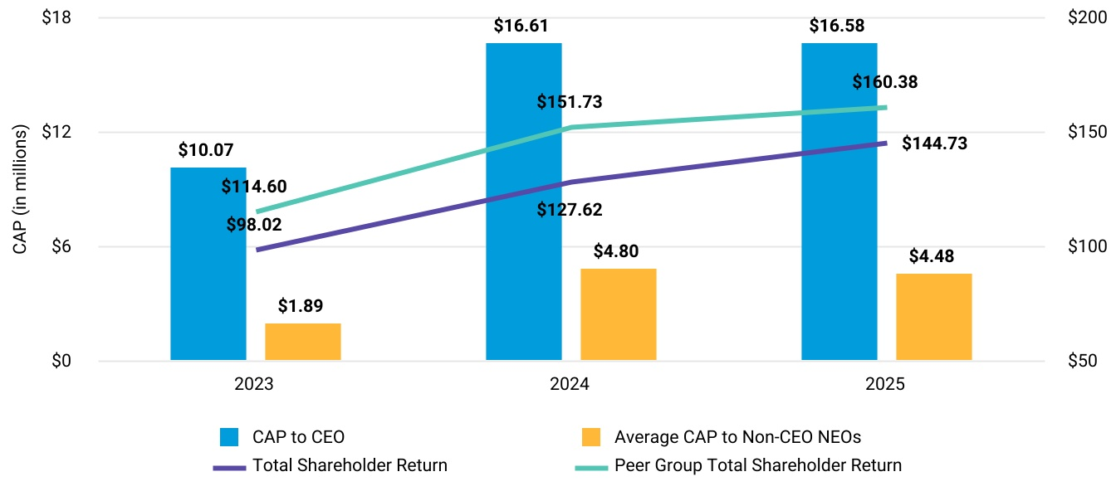
48 |  |  | AllianceBernstein

Table of Contents
Executive Compensation
The following chart shows that the CAP to our CEO and average CAP to our non-CEO NEOs for each of the 2023 through 2025 fiscal years align to trends with AB's GAAP Net Income, over the same period.
CAP Vs. GAAP Net Income1
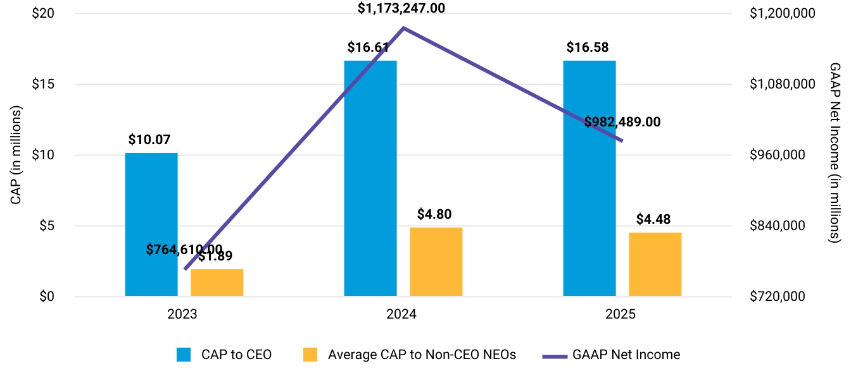
1Reflects Net Income Attributable to AB Unitholders in the Company's Consolidated Statements of Income included in AB's Form 10-K for each of the fiscal years ended December 31, 2023, 2024 and 2025.
2026 Proxy Statement and LTIP |  |  | 49

Table of Contents
Executive Compensation
The following chart shows that the CAP to our CEO and average CAP to our non-CEO NEOs for each of the 2023 through 2025 fiscal years align to trends with AB's Adjusted Net Revenues over the same period.
CAP Vs. Company Selected Measure: Adjusted Net Revenue2
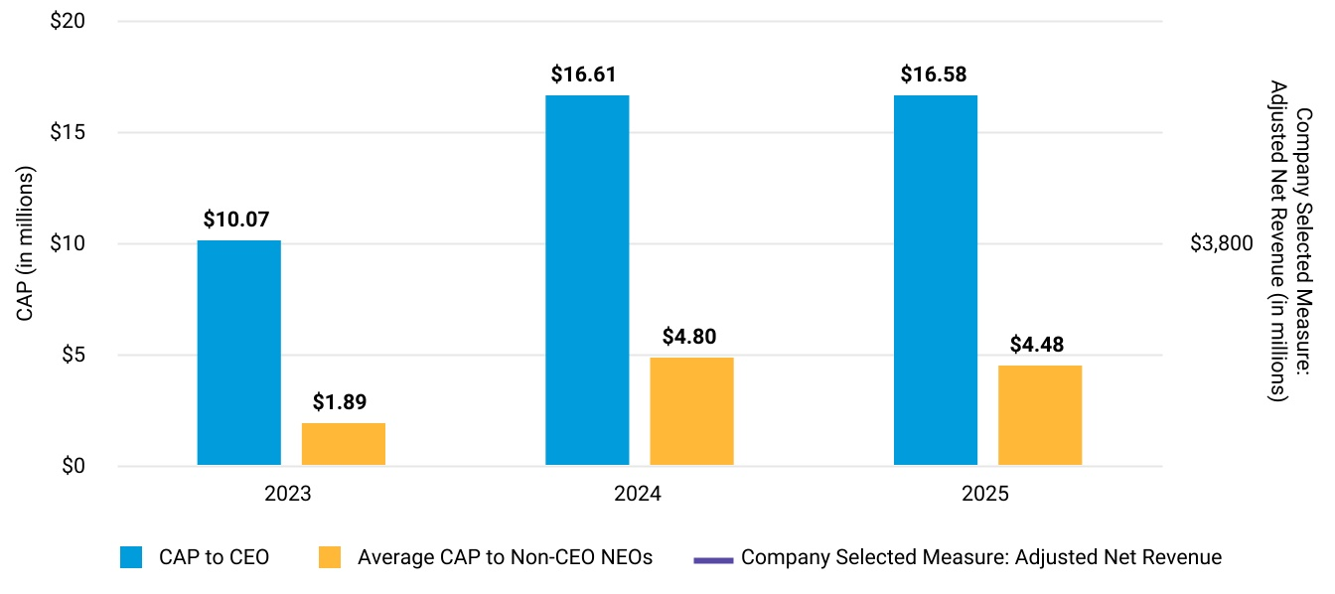
2AB's Company-Selected Measure is Adjusted Net Revenue. For a reconciliation with GAAP for 2023-2025, see AB's Form 10-K for the year ended December 31, 2023, 2024 and 2025.
50 |  |  | AllianceBernstein

Table of Contents
Executive Compensation
The following chart shows that the CAP to our CEO and average CAP to our non-CEO NEOs for each of the 2023 through 2025 fiscal years align to trends with AB's Adjusted Compensation Ratio over the same period.
CAP Vs. Supplemental Measure: Adjusted Compensation Ratio3
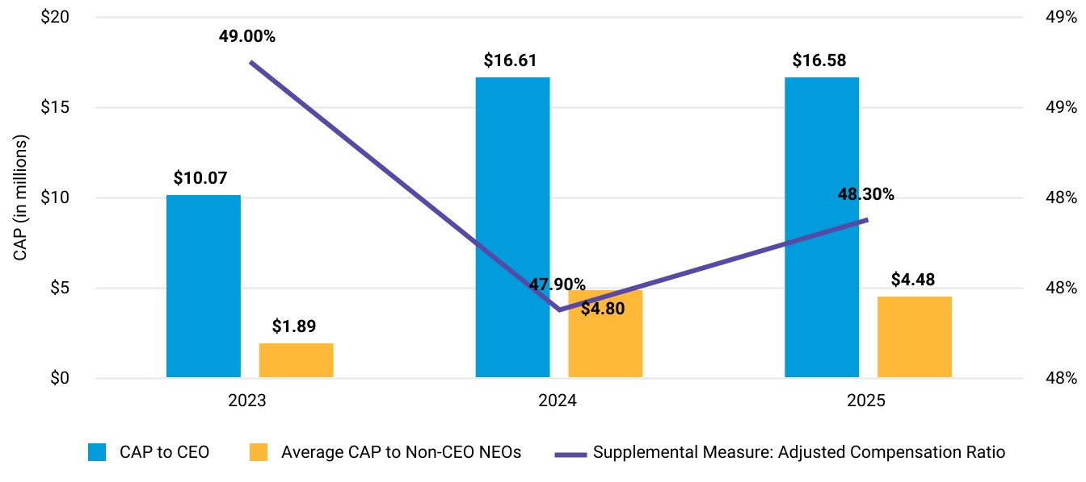
3AB's Supplemental Measure is Adjusted Compensation Ratio. For a reconciliation with GAAP for 2023-2025, see AB's Form 10-K for the years ended December 31, 2023, 2024 and 2025.

2026 Proxy Statement and LTIP |  |  | 51

Table of Contents

Security Ownership of Certain Beneficial Owners and Management and Related Stockholder Matters

The information provided in “Security Ownership of Certain Beneficial Owners and Management and Related Stockholder Matters” is an excerpt from AB’s 2025 Form 10-K, as filed with the Commission on February 12, 2026. See above in this proxy statement for relevant changes relating to our CEO.
Securities Authorized for Issuance under Equity Compensation Plans
AB Holding Units to be issued pursuant to our equity compensation plans as of December 31, 2025 are as follows:
Equity Compensation Plan Information
Plan Category |  |  | Number of  securities to  be issued upon  exercise of  outstanding  options, warrants  and rights |  |  | Weighted average  exercise price  of outstanding  options, warrants  and rights |  |  | Number of  securities  remaining  available  for future  issuance(1)
Equity compensation plans approved by security holders |  |  | — |  |  | — |  |  | 20,797,691
Equity compensation plans not approved by security holders |  |  | — |  |  | — |  |  | —
Total |  |  | — |  |  | — |  |  | 20,797,691
(1)All AB Holding Units remaining available for future issuance will be issued pursuant to the 2017 Plan, which was approved during a Special Meeting of AB Holding Unitholders held on September 29, 2017.
There are no AB Units to be issued pursuant to an equity compensation plan.
For information about our equity compensation plans, see Note 19 to AB’s consolidated financial statements in Item 8 of AB's 2025 Form 10-K.

Principal Security Holders
As of December 31, 2025, we had no information that any person beneficially owned more than 5% of the outstanding AB Units, except as reported by EQH and certain of its subsidiaries. We have prepared the following table, and the note that follows, in reliance on information supplied by EQH:
Name and Address of Beneficial Owner |  |  | Amount and Nature of  Beneficial Ownership  Reported on Schedule |  |  |  |  |  | Percent of  Class
Equitable Holdings(1)  1345 Avenue of the Americas  New York, NY 10105 |  |  | 202,370,757 |  |  | (1) |  |  | 68.3 |  | % | (1)
52 |  |  | AllianceBernstein

Table of Contents
Security Ownership of Certain Beneficial Owners and Management and Related Stockholder Matters
(1)By reason of their relationships, EQH and its subsidiaries that hold AB Units may be deemed to share the power to vote or to direct the vote and to dispose or direct the disposition of all or a portion of these AB Units. The 68.3% includes the 1.0% general partnership interest held by EQH.
As of December 31, 2025, AB Holding was the record owner of 92,284,367, or 31.4%, of the issued and outstanding AB Units (or 31.1% including the 1.0% general partnership interest held by EQH).

Management
As of December 31, 2025, the beneficial ownership of AB Holding Units by each director and NEO of the General Partner and by all directors and executive officers as a group is as follows:
Name of Beneficial Owner |  |  | Number of AB  Holding Units and  Nature of Beneficial  Ownership |  |  | Percent of Class
Seth Bernstein(1)(2) |  |  | 865,194 |  |  | *
Onur Erzan(1)(3) |  |  | 304,245 |  |  | *
Bruce Holley |  |  | 9,245 |  |  | *
Daniel Kaye(1) |  |  | 44,130 |  |  | *
Joan Lamm-Tennant(1) |  |  | 20,478 |  |  | *
Nick Lane(1) |  |  | — |  |  | *
Alexis Luckey(1)(4) |  |  | 7,903 |  |  | *
Mark Manley(1)(5) |  |  | 97,913 |  |  | *
Das Narayandas |  |  | 44,921 |  |  | *
Mark Pearson(1) |  |  | — |  |  | *
Robin Raju(1) |  |  | — |  |  | *
Thomas Simeone(1)(6) |  |  | 54,635 |  |  | *
Karl Sprules(1)(7) |  |  | 223,910 |  |  | *
Charles Stonehill(1) |  |  | 25,176 |  |  | *
Todd Walthall |  |  | 20,880 |  |  | *
All directors and executive officers as a group (15 persons)(8) |  |  | 1,718,630 |  |  | 1.8%
* Number of AB Holding Units listed represents less than 1% of the Units outstanding.
(1)Excludes AB Holding Units beneficially owned by EQH and its subsidiaries. Ms. Lamm-Tennant and Messrs. Bernstein, Kaye, Lane, Pearson, Raju, and Stonehill, each is a director and/or officer of EQH, Equitable Financial and/or Equitable America. Ms. Luckey and Messrs. Bernstein, Erzan, Sprules, Simeone and Manley each is a director and/or officer of the General Partner.
(2)Includes 597,308 restricted AB Holding Units granted to Mr. Bernstein that have not yet vested or with respect to which Mr. Bernstein has deferred delivery. See “Overview of Mr. Bernstein's Employment Agreement – Compensation Elements – Restricted AB Holding Units,” “Grants of Plan-Based Awards in 2025” and “Outstanding Equity Awards at 2025 Fiscal Year-End” in the Executive Compensation section for additional information.
(3)Includes 275,663 restricted AB Holding Units granted to Mr. Erzan that have not yet vested. For information regarding Mr. Erzan's long-term incentive compensation awards, see "Grants of Plan-Based Awards in 2025” and “Outstanding Equity Awards at 2025 Fiscal Year-End” in the Executive Compensation section.
(4)Includes 7,903 restricted AB Holding Units granted to Ms. Luckey that have not yet vested.
(5)Includes 26,298 restricted AB Holding Units granted to Mr. Manley that have not yet vested or with respect to which Mr. Manley has deferred delivery. For information regarding Mr. Manley's long-term incentive compensation awards, see “Grants of Plan-Based Awards in 2025” and “Outstanding Equity Awards at 2025 Fiscal Year-End” in the Executive Compensation section.
(6)Includes 28,069 restricted AB Holding Units granted to Mr. Simeone that have not yet vested. For information regarding Mr. Simeone's long-term incentive compensation awards, see "Grants of Plan-Based Awards in 2025” and “Outstanding Equity Awards at 2025 Fiscal Year-End” in the Executive Compensation section.
2026 Proxy Statement and LTIP |  |  | 53

Table of Contents
Security Ownership of Certain Beneficial Owners and Management and Related Stockholder Matters
(7)Includes 94,270 restricted AB Holding Units granted to Mr. Sprules that have not yet vested. For information regarding Mr. Sprules's long-term incentive compensation awards, see “Grants of Plan-Based Awards in 2025" and “Outstanding Equity Awards at 2025 Fiscal Year-End” in the Executive Compensation section.
(8)Includes 1,029,511 restricted AB Holding Units awarded to the executive officers as a group as long-term incentive compensation that have not yet vested and/or with respect to which the executive officer has deferred delivery.
As of December 31, 2025, our directors and executive officers did not beneficially own any AB Units.
As of December 31, 2025, the beneficial ownership of the common stock of EQH by each director and named executive officer of the General Partner and by all directors and executive officers as a group is as follows:
EQH Common Stock
Name of Beneficial Owner |  |  | Number of Shares and  Nature of Beneficial  Ownership |  |  | Percent of Class
Seth Bernstein(1) |  |  | 43,022 |  |  | *
Onur Erzan(2) |  |  | 6,166 |  |  | *
Bruce Holley |  |  | — |  |  | *
Daniel Kaye |  |  | 55,686 |  |  | *
Joan Lamm-Tennant |  |  | 47,891 |  |  | *
Nick Lane(3) |  |  | 172,299 |  |  | *
Alexis Luckey |  |  | — |  |  | *
Mark Manley |  |  | — |  |  | *
Das Narayandas |  |  | — |  |  | *
Mark Pearson(4) |  |  | 856,020 |  |  | *
Robin Raju(5) |  |  | 138,523 |  |  | *
Thomas Simeone |  |  | — |  |  | *
Karl Sprules |  |  | — |  |  | *
Charles Stonehill |  |  | 37,457 |  |  | *
Todd Walthall |  |  | — |  |  | *
All directors and executive officers as a group (15 persons)(6) |  |  | 1,357,064 |  |  | *
*Number of shares listed represents less than 1% of the outstanding EQH common stock.
(1)Includes (i) zero options Mr. Bernstein has the right to exercise within 60 days and (ii) 10,309 restricted stock units that will vest within 60 days and settle in EQH shares.
(2)Includes (i) zero options Mr. Erzan has the right to exercise within 60 days and (ii) 1,107 restricted stock units that will vest within 60 days and settle in EQH shares.
(3)Includes (i) 44,417 options Mr. Lane has the right to exercise within 60 days and (ii) 30,170 restricted stock units that will vest within 60 days and settle in EQH shares.
(4)Includes (i) 190,400 options Mr. Pearson has the right to exercise within 60 days and (ii) 126,389 restricted stock units that will vest within 60 days and settle in EQH shares.
(5)Includes (i) zero options Mr. Raju has the right to exercise within 60 days and (ii) 29,746 restricted stock units that will vest within 60 days and settle in EQH shares.
(6)Includes 234,817 options that may be exercised and 197,721 restricted stock units that will vest within 60 days and settle in EQH shares for the directors and executive officers as a group.

54 |  |  | AllianceBernstein

Table of Contents
Information Incorporated by Reference
We are incorporating by reference into this Proxy Statement the information found in Item 7 (“Management’s Discussion and Analysis of Financial Condition and Results of Operations”) and Item 8 (“Financial Statements and Supplementary Data”) in AB's 2025 Form 10-K and Item 1 (“Financial Statements”) and Item 2 (“Management’s Discussion and Analysis of Financial Condition and Results of Operations”) in AB's Form 10-Q for the quarter ended June 30th, 2026. We encourage you to review the information in these reports to help ensure you have a complete understanding of our business and our need for your support of our proposal.

2026 Proxy Statement and LTIP |  |  | 55

Table of Contents
Appendix A

AB
2026 Long Term Incentive Plan

Effective as of November 30, 2026

Section 1. Purpose.
The purpose of the AB 2026 Long Term Incentive Plan (the “Plan”) is to promote the interest of AllianceBernstein L.P. (together with any successor thereto, the “Partnership”) by (i) attracting and retaining talented officers, employees and directors of the Partnership and its Affiliates, (ii) motivating such officers, employees and directors by means of performance-related incentives to achieve longer-range business and operational goals, (iii) enabling such officers, employees and directors to participate in the long-term growth and financial success of the Partnership, and (iv) aligning the interests of such officers, employees and directors with those of AllianceBernstein Holding L.P (“AB Holding”) Unitholders.

Section 2. Definitions.
As used in the Plan, the following terms shall have the meanings set forth below:

“Affiliate” shall mean (i) any entity that, directly or indirectly, is controlled by the Partnership and (ii) any entity in which the Partnership has a significant equity interest, in either case as determined by the Committee.

“Acquisition Event” shall have the meaning set forth in Section 4(c)(ii).

“Award” shall mean any Option, Restricted Unit, Phantom Restricted Unit or Other Unit-Based Award.

“Award Agreement” shall mean any written agreement, contract, offer letter or other instrument or document evidencing any Award.

“Board” shall mean the Board of Directors of the general partner of the Partnership.

“Cause” shall mean with respect to a Participant’s Termination of Employment, unless otherwise specified in the applicable Award Agreement, any of the following: (a) conviction, whether following trial or by plea of guilty or nolo contendere (or similar plea), in a criminal proceeding (i) on a misdemeanor charge involving fraud, false statements or misleading omissions, wrongful taking, embezzlement, bribery, forgery, counterfeiting or extortion; (ii) on a felony charge; or (iii) on a charge equivalent to any of the charges set forth in clauses (i) and (ii) in any jurisdiction that does not use such designations; (b) engaging in any conduct that constitutes an employment disqualification under applicable law (including any “statutory disqualification”, as defined under the Exchange Act); (c) failure to perform satisfactorily the duties associated with the Participant’s job function or to follow reasonable requests of his or her manager; (d) violation of any securities or commodities laws, any rules or regulations issued pursuant to such laws, or the rules and regulations of any securities or commodities exchange or association to which the Partnership or any Affiliate is subject; (e) violation of any Partnership policy concerning confidential or proprietary information, or material violation of any other Partnership policy in effect from time to time; (f) engaging in any act or making any statement which impairs, impugns, denigrates, disparages or negatively reflects upon the name, reputation or business interests of the Partnership or any Affiliate; or (g) engaging in any conduct detrimental to the Partnership or any Affiliate, including any activity deemed by management, the Committee or the Board to be competitive with the Partnership or any Affiliate. With respect to a Participant’s Termination of Directorship, unless otherwise specified in the applicable Award Agreement, “cause” shall mean an act or failure to act that constitutes cause for removal of a director under applicable Delaware law.

“Closing Price” on any date shall mean the closing price for a Unit or, if no sale of a Unit occurred on such date, the closing price for a Unit on the most recent preceding date on which the sale of a Unit occurred, in either case as reported on the principal stock market or exchange on which the Units are quoted or traded on such date or, if the Units are not so quoted or traded on such date, in such manner as determined by the Committee in its sole discretion.
56 |  |  | AllianceBernstein

“Code” shall mean the U.S. Internal Revenue Code of 1986, as amended.

“Committee” shall mean the Compensation Committee of the Board as appointed from time to time by the Board, or another committee of the Board designated by the Board to administer the Plan.

“Eligible Employee” shall mean any employee of the Partnership or any Affiliate.

“Exchange Act” shall mean the U.S. Securities Exchange Act of 1934, as amended.

“Fair Market Value” shall mean, unless otherwise required by any applicable provision of the Code, as of any date and except as provided below, (i) with respect to a Unit, the Closing Price for such Unit on such date, and (ii) with respect to any other property, the fair market value of such property as determined by the Board or the Committee in its sole discretion and in accordance with Section 409A, if applicable.

“Non-Management Director” shall mean a member of the Board who is (i) “independent” within the meaning of Section 303A.02 of the New York Stock Exchange Listed Company Manual or other applicable law or applicable stock exchange rules, as determined by the Board in its business judgment, or (ii) a former executive, a former employee or a former consultant of an affiliate of AB Holding (for this purpose only, “affiliate” includes any company or other entity that directly, or indirectly through one or more intermediaries, controls, is controlled by or is under common control with, the Partnership).
“Option” shall mean an option granted under Section 6(a).

“Organizational Documents” shall have the meaning set forth in Section 3(e)(iii).

“Other Unit-Based Award” shall mean any right granted under Section 6(c).

“Participant” shall mean any Eligible Employee or Non-Management Director granted an Award under the Plan.

“Payment Date” shall have the meaning set forth in Section 11(b).

“Person” shall mean any individual, corporation, partnership, limited liability company, association, joint-stock company, trust, unincorporated organization, government or political subdivision thereof or other entity.

“Phantom Restricted Unit” shall mean any Award granted under Section 6(b) as a Phantom Restricted Unit.

“Prior Plan” shall mean the Partnership’s 2017 Long Term Incentive Plan, as amended.

“Restricted Unit” shall mean any Unit granted under Section 6(b) as a Restricted Unit.

“Section 409A CIC” shall have the meaning set forth in Section 11(c).

“Substitute Awards” shall mean Awards granted in assumption of, or in substitution for, outstanding awards previously granted by an entity or business acquired by the Partnership or any Affiliate, or with which the Partnership or any Affiliate combines or otherwise granted pursuant to Section 4(c) of the Plan.

“Termination” shall mean a Termination of Directorship or Termination of Employment, as applicable.

“Termination of Directorship” shall mean that a Participant has ceased to be a director of the Partnership; except that if the Participant becomes an Eligible Employee upon the termination of his or her directorship, unless otherwise determined by the Board or the Committee in its sole discretion, the Participant shall not experience a Termination until the Participant has a Termination of Employment.
“Termination of Employment” shall mean: (a) a termination of employment of a Participant from the Partnership and its Affiliates; or (b) an entity employing a Participant ceasing to be an Affiliate, unless the Participant otherwise is, or thereupon
2026 Proxy Statement and LTIP |  |  | 57

Table of Contents
becomes, employed by the Partnership or another Affiliate at the time the entity ceases to be an Affiliate. Notwithstanding the foregoing, the Committee may otherwise define Termination of Employment in the Award Agreement or, if no rights of a Participant are adversely affected, may otherwise define Termination of Employment thereafter.

“Unitholder” shall mean a holder of record or beneficial owner of Units.

“Units” shall mean units representing assignments of beneficial ownership of limited partnership interests in AB Holding.

Section 3. Administration.
(a) Authority of Committee. The Plan shall be administered by the Committee. Subject to the terms of the Plan and applicable law, in addition to other express powers and authorizations conferred on the Committee by the Plan, and except as otherwise limited by the Board, the Committee shall have full power and authority to (i) designate Participants; (ii) determine the type or types of Awards to be granted to an Eligible Employee or, subject to Section 3(b), a Non-Management Director; (iii) determine the number of Units to be covered by, or with respect to which payments, rights or other matters are to be calculated in connection with, Awards; (iv) determine the terms and conditions of Awards, not inconsistent with the terms of the Plan; (v) determine whether, to what extent and under what circumstances Awards may be exercised, settled, canceled, forfeited or suspended and the method or methods by which Awards may be exercised, settled, canceled, forfeited or suspended, and whether to accelerate the vesting of an Award in connection with an Acquisition Event, a qualifying termination of employment or any other event or circumstance that the Committee determines to be appropriate; (vi) determine whether and under what circumstances Awards may be exercised for or settled in cash, Units and/or Restricted Units, (vii) determine whether, to what extent and under what circumstances cash, Units and/or Restricted Units payable with respect to an Award shall be deferred either automatically or at the election of the holder thereof or of the Committee, and in any event, in accordance with Section 409A of the Code; (viii) determine whether to require a Participant, as a condition of the granting of an Award, to not sell or otherwise dispose of Units acquired pursuant to the exercise or settlement of the Award for a period of time as determined by the Committee, in its sole discretion; (ix) determine the terms of any Award Agreement, including terms relating to retirement, forfeiture, termination, garden leave and restrictive covenants (such as non-competition, non-solicitation and non-disparagement); (x) determine whether an Option shall cease to be exercisable or an Award shall be forfeited, or that proceeds or profits applicable to an Award shall be returned to the Partnership, in each case, in the event that the applicable Participant fails to adhere to the terms and conditions specified in the applicable Award Agreement; (xi) interpret and administer the Plan and any instrument or agreement relating to, or Award made under, the Plan; (xii) establish, amend, suspend or waive such rules and regulations and appoint such agents as it shall deem appropriate for the proper administration of the Plan; (xiii) subject to the terms of the Plan and applicable law, delegate to one or more officers or managers of the Partnership or its general partner or any Affiliate, or to a committee of such officers or managers, the authority, subject to such terms and limitations as the Committee shall determine, to grant Awards to, or to cancel, modify or waive rights with respect to, or to alter, discontinue, suspend or terminate Awards held by, individuals who receive Awards as part of recruitment, severance or retirement arrangements and/or Eligible Employees who are not executive officers or directors of the Partnership for purposes of Section 16 of the Exchange Act, or any successor section thereto, or who are otherwise not subject to such Section; and (xiv) make any other determination and take any other action that the Committee deems necessary or desirable for the administration of the Plan.

(b) Grants of Awards to Non-Management Directors. Notwithstanding the provisions of Section 3(a), grants of Awards to Non-Management Directors must be approved by the Board.

(c) Committee Discretion Binding. Unless otherwise expressly provided in the Plan, and subject to Section 3(b), all designations, determinations, interpretations and other decisions under or with respect to the Plan or any Award shall be within the sole discretion of the Committee, may be made at any time and shall be final, conclusive and binding upon all Persons, including the Partnership, any Affiliate, any Participant, any holder or beneficiary of any Award, any Unitholder and any Eligible Employee or any Non-Management Director.

(d) Guidelines. Subject to Section 8, the Committee shall have the authority to: (i) adopt, alter and repeal such administrative rules, guidelines and practices governing the Plan and perform all acts, including the delegation of its responsibilities (to the extent permitted by applicable law and applicable stock exchange rules), as it shall, from time to time, deem advisable; (ii) construe and interpret the terms and provisions of the Plan and any Award (and any agreements relating to the Plan or such Award); and (iii) otherwise supervise the administration of the Plan. The Committee may correct any defect, supply any omission or reconcile any inconsistency in the Plan or in any agreement relating thereto in the manner and to the extent it shall
58 |  |  | AllianceBernstein

deem necessary to effectuate the purpose and intent of the Plan. Notwithstanding the foregoing, no action of the Committee under this Section 3(d) shall materially reduce the rights of any Participant relating to any existing Award without the Participant’s consent. To the extent applicable, the Plan is intended to comply with the applicable requirements of Rule 16b-3 under the Exchange Act, and the Plan shall be limited, construed and interpreted in a manner so as to comply therewith. Without limiting the generality of the foregoing, the Committee may adopt special guidelines and provisions for persons who are residing in or employed in, or subject to the taxes of, any domestic or foreign jurisdictions, to comply with applicable laws, regulations, or accounting, listing or other rules with respect to such domestic or foreign jurisdictions, including but not limited to otherwise defining Fair Market Value and Closing Price.

(e) Assistance of Employees and Advisors; Liability and Indemnification.
(i) The Committee may designate employees of the Partnership and professional advisors to assist the Committee in the administration of the Plan and (to the extent permitted by applicable law and applicable exchange rules) may grant authority to officers or other employees to execute agreements or other documents on behalf of the Committee.
(ii) The Committee may employ such legal counsel, consultants and agents as it may deem desirable for the administration of the Plan and may rely upon any opinion received from any such counsel or consultant and any computation received from any such consultant or agent. Expenses incurred by the Committee or the Board in the engagement of any such counsel, consultant or agent shall be paid by the Partnership. The Committee, its members and any person designated pursuant to Section 3(e)(i) shall not be liable for any action or determination made in good faith with respect to the Plan. To the maximum extent permitted by applicable law, no officer of the Partnership or member or former member of the Committee or the Board shall be liable for any action or determination made in good faith with respect to the Plan or any Award.

(iii) To the maximum extent permitted by applicable law and the amended and restated agreements of limited partnership of the Partnership and/or AB Holding (“Organizational Documents”), each officer and member or former member of the Committee or the Board shall be indemnified and held harmless by the Partnership and AB Holding against any cost or expense (including reasonable fees of counsel reasonably acceptable to the Committee) or liability (including any sum paid in settlement of a claim with the approval of the Committee), and advanced amounts necessary to pay the foregoing at the earliest time and to the fullest extent permitted, arising out of any act or omission to act in connection with the administration of the Plan, except to the extent arising out of such officer’s, member’s or former member’s own fraud or bad faith. Such indemnification shall be in addition to any rights of indemnification such officer, member or former member may have under applicable law or under the Organizational Documents, the organizational documents of any Affiliate or any agreement of indemnification. Notwithstanding anything else herein, this indemnification will not apply to the actions or determinations made by an individual with regard to Awards granted to him or her under the Plan.

Section 4. Units Available for Awards.
(a) Units Available.

(i) Subject to adjustment as provided in Sections 4(b) and (c), the number of Units with respect to which Awards may be granted under the Plan shall be 60 million, less one Unit for every one Unit that was subject to an award (including options) granted after the effective date of the Plan under the Prior Plan. All 60 million Units that are available for grant under the Plan (including Options) may be Units reacquired by the Partnership on the open market or otherwise, while up to half of these 60 million Units (i.e., 30 million Units) may be newly-issued.

(ii) If any Units covered by an Award granted under the Plan (other than Substitute Awards) or by an award granted after the effective date of the Plan under the Prior Plan, or to which such Award or award related, are forfeited, or if such Award or award terminates or is canceled without the delivery of Units, or is exercised for or settled in cash, then the Units covered by such Award or award, or to which such Award or award relates, or the number of Units otherwise counted against the aggregate number of Units with respect to which Awards may be granted, to the extent of any such forfeiture, termination, cancellation, or cash exercise or settlement, shall again become Units with respect to which Awards may be granted in accordance with this Section 4.

(b) Availability of Certain Units.

(i) In determining the number of Units available for Awards, if Units otherwise deliverable in respect of Awards under the Plan (other than Substitute Awards) or awards granted after the effective date of the Plan under the Prior Plan are withheld for
2026 Proxy Statement and LTIP |  |  | 59

Table of Contents
payment of withholding taxes in respect of such Awards or awards, the number of Units so withheld shall again become Units with respect to which Awards may be granted in accordance with this Section 4.

(ii) The Units available for Awards under the Plan shall also be available to exchange for units of limited partnership interest in the Partnership on a one-for-one basis if, and to the extent to which, the Partnership issues such units to Eligible Employees under the Partnership’s employee incentive compensation programs. Any Units that are so exchanged will be counted against the Unit limit under the Plan.

(iii) To avoid double-counting, any Units underlying Substitute Awards shall not be counted against the Units available for Awards under the Plan. Additionally, in the event that an entity acquired by the Partnership or an Affiliate, or with which the Partnership or an Affiliate combines, has securities available under a pre-existing plan approved by equity holders and not adopted in contemplation of such acquisition or combination, the securities available for grant pursuant to the terms of such pre-existing plan (as adjusted, to the extent appropriate, using the exchange ratio or other adjustment or valuation ratio or formula used in such acquisition or combination to determine the consideration payable to the holders of securities of the entities party to such acquisition or combination) may be used for Awards under the Plan and shall not reduce the number of Units authorized for grant under the Plan; provided that Awards using such available securities shall not be made after the date awards or grants could have been made under the terms of the pre-existing plan, absent such acquisition or combination, and shall not be made to individuals who were employed by the Partnership or its Affiliates immediately before such acquisition or combination.

(c) Adjustments.

(i) In the event that any distribution (whether in the form of cash, limited partnership interests, other securities or other property), recapitalization (including, without limitation, any subdivision or combination of limited partnership interests), reorganization, spinoff, merger, consolidation, combination, repurchase, or exchange of limited partnership interests or other securities of the Partnership or AB Holding, issuance of warrants or other rights to purchase limited partnership interests or other securities of the Partnership or AB Holding, any incorporation (or other change in form) of the Partnership or AB Holding, or other similar transaction or event affects the Units such that an adjustment is appropriate in order to prevent dilution or enlargement of the benefits or potential benefits intended to be made available under the Plan, then the Committee shall, in such manner as it may deem equitable, adjust, as applicable, (A) the number of Units or other securities of the Partnership or AB Holding (or the number and kind of other securities or property) with respect to which Awards may be granted under Sections 4(a) and (b), (B) the number of Units or other securities of the Partnership or AB Holding (or the number and kind of other securities or property) subject to outstanding Awards, and (C) the exercise or purchase price with respect to any Award, or, if deemed appropriate, make provision for a cash payment to the holder of an outstanding Award. In the event of incorporation (or other change in form) of the Partnership or AB Holding, the Committee shall make such adjustments as it deems appropriate and equitable with respect to Options for the optionee to purchase stock in the resulting corporation in place of the Options. Any such adjustment or arrangement may provide for the elimination without compensation of any fractional Unit which might otherwise become subject to an Option, and shall be subject to Section 3(c).

(ii) In the event of (A) the consummation of any merger or consolidation of the Partnership or AB Holding in which the Partnership or AB Holding (as applicable) is not the continuing or surviving entity, (B) any transaction that results in the acquisition of all or substantially all of the outstanding Units by a single person or entity or by a group of persons and/or entities acting in concert, or (C) the sale or transfer of all or substantially all of the Partnership’s or AB Holding’s assets (each of the foregoing being referred to as an “Acquisition Event”), then the outstanding Awards held by each Participant shall be subject to the agreement with respect to such Acquisition Event, which agreement may, subject to the terms of the applicable Award Agreements and in accordance with Section 409A of the Code, provide for (i) the continuation or assumption of such Awards by the Partnership or AB Holding (or the successor or surviving entity); (ii) the substitution for such Awards by such successor or surviving entity with equity-based awards with substantially the same terms and economic value; (iii) the acceleration prior to the closing of such Acquisition Event of the vesting and exercisability of any such Awards that are Options or Other Unit-Based Awards that are scheduled to become exercisable by such Participant, and the expiration of such Awards to the extent not timely exercised by such Participant prior to such closing or such other earlier time determined by the Committee, after reasonable advance written notice thereof to such Participant; provided that any such exercise shall be contingent on the consummation of such Acquisition Event; and/or (iv) the cancellation of all or any portion of such Awards as of immediately prior to such Acquisition Event, in exchange for a cash payment on such terms and conditions as
60 |  |  | AllianceBernstein

determined by the Committee, the amount of which may be zero in the case of any Option with an exercise price that exceeds the Fair Market Value of the Units subject to such Option.

Section 5. Eligibility.
All Eligible Employees and Non-Management Directors shall be eligible to be granted Awards and to be designated as Participants under the Plan. Awards and actual participation in the Plan shall be determined by the Committee (subject to Section 3(b)) or the Board in its sole discretion.

Section 6. Awards.
(a) Options.

(i) Grant. Subject to the terms of the Plan, the Committee shall (subject to Section 3(b)) have sole and complete authority to determine the Eligible Employees and Non-Management Directors to whom Options shall be granted and, with respect to each Option, the number of Units to be covered by such Option, the exercise price of such Option and the conditions and limitations applicable to the exercise of such Option.
(ii) Exercise Price. The exercise price of an Option shall be not less than the Fair Market Value of the Units subject to the Option on the date the Option is granted.

(iii) Exercise. The Committee shall specify in the applicable Award Agreement the rate at which an Option shall become initially exercisable. No Option shall be exercisable after the expiration of ten years from the date of grant. The right to exercise an Option shall be cumulative, so that to the extent that an Option is not exercised when it becomes initially exercisable, it shall be exercisable at any time thereafter until the expiration of the term of the Option. The Committee may impose such conditions with respect to the exercise of Options, including without limitation, any relating to the application of federal or state securities laws, as it may deem necessary or advisable.

(iv) Prohibition on Re-pricing. Other than pursuant to Section 4(c), in the absence of approval by the holders of Units, neither the Board nor the Committee shall be permitted to (A) lower the exercise price per Unit of an Option after it is granted, (B) cancel an Option when the exercise price per Unit exceeds the Fair Market Value of the underlying Units in exchange for cash or another Award (other than in connection with Substitute Awards), or (C) take any other action with respect to an Option that may be treated as a re-pricing under the rules and regulations of the New York Stock Exchange or the applicable stock exchange upon which the Units are then listed.

(v) Termination. Except as otherwise (A) provided in the applicable Award Agreement or (B) determined by the Committee at grant or (if no rights of the Participant are adversely affected) thereafter, subject to the terms of the Plan, upon a Participant’s Termination for any reason prior to having exercised his or her options, all unexercised Options will vest or be forfeited in accordance with the terms and conditions established by the Committee at grant or thereafter (if no rights of the Participant are adversely affected).
(vi) Unvested Options. Except as otherwise (A) provided in the applicable Award Agreement or in Section 6(a)(v) or (B) determined by the Committee at grant or (if no rights of the Participant are adversely affected) thereafter, Options that are not vested as of the date of a Participant’s Termination of Employment shall terminate and expire as of the date of such Termination.

(b) Restricted Units and Phantom Restricted Units.

(i) Grant. Subject to the terms of the Plan, the Committee shall (subject to Section 3(b)) have sole and complete authority to determine the Eligible Employees and Non-Management Directors to whom Restricted Units and Phantom Restricted Units shall be granted, the number of Restricted Units and/or Phantom Restricted Units to be granted to each Participant, the duration of the period during which, and the conditions under which, the Restricted Units and/or Phantom Restricted Units vest, are distributed and may be forfeited to the Partnership, and the other terms and conditions of such Awards. Except for restrictions applicable to non-routine Awards (e.g., Awards for recruitment, severance or retirement) and Substitute Awards, restrictions applicable to Awards of Restricted Units and/or Phantom Restricted Units that lapse purely based on service shall lapse over a period of not less than three years (whether such lapse occurs ratably or otherwise, so long as such restrictions lapse not more than 50% in the first year), except upon a Termination due to death, “disability” or “retirement” (as such terms
2026 Proxy Statement and LTIP |  |  | 61

Table of Contents
are defined in the applicable Award Agreement), or to the extent provided in connection with an Acquisition Event, unless (A) the grant of an Award (or acceleration of the lapse of restrictions applicable to an outstanding Award) is authorized by the Committee or the Board and (B) the cumulative number of Units subject to such Awards does not exceed 5% of the number of Units available for grant pursuant to Section 4(a) (as may be adjusted pursuant to Sections 4(b) and (c)); and provided that, where duly authorized by the Committee or the Board, continued vesting of Awards after a Termination in circumstances where such continued vesting is conditioned on compliance with (A) one or more restrictive covenants, and/or (B) a standard of conduct regarding appropriate consideration of risk set forth in the applicable Award Agreement, shall count towards satisfying the minimum vesting requirement of this Section 6(b)(i).

(ii) Transfer Restrictions. Subject to Section 7(c), Restricted Units and Phantom Restricted Units may not be sold, assigned, transferred, pledged or otherwise encumbered, except as provided in the Plan or the applicable Award Agreement. Any certificate issued in respect of Restricted Units with respect to which transfer restrictions remain in effect shall bear a legend describing the restrictions to which the Restricted Units are subject. Upon the lapse of the restrictions applicable to such Restricted Units, the holder thereof may surrender to the Partnership the certificate or certificates representing such Units and receive in exchange therefor a new certificate or certificates representing such Units free of the legend (or an electronic transfer of such Units to a designated brokerage account of such holder’s choosing) and a certificate or certificates representing the remainder of the Units, if any, with the legend.

(iii) Payment. Any Phantom Restricted Unit shall have a value equal to the Fair Market Value of a Unit. Phantom Restricted Units shall be paid in Units, other securities, cash or other property, as determined in the sole discretion of the Committee, upon the lapse of the restrictions applicable thereto, or otherwise in accordance with the applicable Award Agreement.

(iv) Termination. Except as otherwise (A) provided in the applicable Award Agreement or (B) determined by the Committee at grant or (if no rights of the Participant are adversely affected) thereafter, subject to the terms of the Plan, upon a Participant’s Termination for any reason during the relevant restriction period, all Restricted Units and Phantom Restricted Units still subject to restriction will vest, continue to vest, be settled or be forfeited in accordance with the terms and conditions established by the Committee at grant or thereafter (if no rights of the Participant are adversely affected).
(c) Other Unit-Based Awards. The Committee shall (subject to Section 3(b)) have authority to grant to Eligible Employees and/or Non-Management Directors an Other Unit-Based Award, which shall consist of any right (including, without limitation, Unit appreciation rights and performance Awards) which is (i) not an Award described in Section 6(a) or 6(b), and (ii) an Award of Units or an Award denominated or payable in, valued in whole or in part by reference to, or otherwise based on or related to, Units (including, without limitation, securities convertible into Units), as deemed by the Committee to be consistent with the purposes of the Plan. Subject to the terms of the Plan and the applicable Award Agreement, the Committee shall determine the terms and conditions of any such Other Unit-Based Award.

Section 7. General Provisions Applicable to Awards.
(a) Awards May be Granted Separately or Together. Awards may, in the discretion of the Committee, be granted either alone or in addition to, in tandem with, or in substitution for any other Award granted under the Plan or any award granted under any other plan of the Partnership or any Affiliate. Awards granted in addition to or in tandem with such other Award or award may be granted either at the same time as or at a different time from the grant of such other Award or award.

(b) Forms of Payment by the Partnership Under Awards. Subject to the terms of the Plan and of any applicable Award Agreement and the requirements of applicable law, payments or transfers to be made by the Partnership or an Affiliate upon the grant, exercise or payment of an Award may be made in such form or forms as the Committee shall determine, including cash, Units, other securities, other Awards or other property, or any combination thereof, and may be made in a single payment or transfer, in installments, or on a deferred basis, in each case in accordance with rules and procedures established by the Committee in accordance with Section 409A of the Code. Such rules and procedures may include, without limitation, provisions for the payment or crediting of reasonable interest on installment or deferred payments.

(c) Limits on Transfers of Awards. Except as otherwise provided by the Committee, no Award shall be transferable by a holder other than by will or the laws of descent and distribution.

(d) Terms of Awards. The term of each Award shall be for such period as may be determined by the Committee, to the extent not inconsistent with the terms of the Plan.
62 |  |  | AllianceBernstein

(e) Consideration for Grants. Awards may be granted for no cash consideration, for such nominal cash consideration as may be required by applicable law or for such greater amount as may be established by the Committee.

(f) Distributions and Distribution Equivalents. Subject to the terms of the Plan and compliance with Section 409A of the Code, the terms of any Award other than an Option (including a deferred Award) may provide, if so determined by the Committee in its sole discretion, for the payment of cash, Units or other property in respect of Unitholder distributions relating to the number of Units subject to such Award.

Section 8. Amendment and Termination.
(a) Amendments to the Plan. The Board or the Committee may amend, alter, suspend, discontinue or terminate the Plan or any portion thereof at any time; provided, however, that no such amendment, alteration, suspension, discontinuation or termination shall be made without the approval of the limited partners of AB Holding (i) to increase the aggregate number of Units that may be issued under the Plan (except by operation of Section 4(c) or solely to reflect a reorganization, Unit split, merger, spinoff or similar transaction); (ii) change the maximum term of any Option; (iii) extend the period during which new Awards may be granted under the Plan; (iv) expand the types of Awards available under the Plan; (v) materially expand the class of officers, employees or directors eligible to participate in the Plan; (vi) alter Section 6(a)(iv) or any other language regarding re-pricing; or (vii) if such approval is necessary to comply with any tax or regulatory requirement for which or with which the Committee deems it necessary or desirable to qualify or comply. Notwithstanding anything to the contrary herein, the Committee may amend the Plan in such manner as may be necessary or advisable so as to have the Plan conform with local rules and regulations in any jurisdiction outside the United States.

(b) Amendments to Awards. The Committee may waive any conditions or rights under, amend any terms of, or alter, suspend, discontinue, cancel or terminate, any Award theretofore granted, prospectively or retroactively; provided, however, that any such waiver, amendment, alteration, suspension, discontinuance, cancellation or termination that would adversely affect the rights of any Participant or any holder or beneficiary of any Award theretofore granted shall not to that extent be effective without the consent of such Participant, holder or beneficiary. Notwithstanding the foregoing or anything herein to the contrary, all Awards, proceeds, amounts and benefits delivered or realized in connection therewith shall be subject to the terms and conditions of any clawback, recoupment, or forfeiture policy maintained by the Partnership or any of its Affiliates, as may be amended from time to time, and no consent of any Participant, holder or beneficiary shall be required for any amendment, alteration, cancellation or other action taken to comply with applicable law, including Sections 409A and 457A of the Code, Section 10D of the Exchange Act and Rule 10D-1 thereunder, and applicable stock exchange listing standards.

Section 9. Miscellaneous.

(a) No Rights to Awards. No Eligible Employee, Non-Management Director, Participant or other Person shall have any claim to be granted any Award, and there is no obligation for uniformity of treatment of Eligible Employees, Non-Management Directors, Participants, or holders or beneficiaries of Awards. The terms and conditions of Awards need not be the same with respect to each recipient.

(b) Unit Certificates. All certificates for Units or other securities of the Partnership or any Affiliate delivered under the Plan pursuant to any Award or the exercise or settlement thereof shall be subject to such stop transfer orders and other restrictions as the Committee may deem advisable under the Plan or the rules, regulations, and other requirements of the U.S. Securities and Exchange Commission, any stock exchange upon which such Units or other securities are then listed, and any applicable federal, state or foreign laws or regulations, and the Committee may cause a legend or legends to be put on any such certificates to make appropriate reference to such restrictions.

(c) Withholding. A Participant may be required to pay to the Partnership or any Affiliate, and the Partnership or any Affiliate shall have the right and is hereby authorized to withhold from any Award, from any payment due or transfer made under any Award or the Plan or from any compensation or other amount owing to a Participant, the amount (in cash, Units, other securities, other Awards or other property) of any applicable withholding taxes in respect of any Award, its exercise, or any payment or transfer under such Award or the Plan and to take such other actions as may be necessary in the opinion of the Partnership to satisfy all obligations for the payment of such taxes.

2026 Proxy Statement and LTIP |  |  | 63

Table of Contents
(d) Award Agreements. Each Award hereunder shall be evidenced by an Award Agreement which shall be made available to the Participant (whether electronically or otherwise) and shall specify the terms and conditions of such Award and any rules applicable thereto, including but not limited to the effect on such Award of the death, disability, retirement or other termination of service of a Participant.

(e) No Limit on Other Compensation Arrangements. Nothing contained in the Plan shall prevent the Partnership or any Affiliate from adopting or continuing in effect other compensation arrangements, including without limitation any such arrangements that provide for the grant of options, restricted Units, phantom restricted Units and other types of awards provided for hereunder (subject to approval of the limited partners of the Partnership if such approval is required), and such arrangements may be either generally applicable or applicable only in specific cases.

(f) No Right to Employment or Retention as Director. The grant of an Award shall not be construed as giving a Participant the right to be retained in the employ of the Partnership or any Affiliate, or to be retained as a Non-Management Director. Further, the Partnership or an Affiliate may at any time dismiss a Participant from service, free from any liability or any claim under the Plan, unless otherwise expressly provided in the Plan, any Award Agreement or any other agreement between the Partnership or any Affiliate and the Participant.

(g) No Rights as Unitholder. Subject to the provisions of the applicable Award Agreement, no Participant or holder or beneficiary of any Award shall have any rights as a Unitholder with respect to any Units to be distributed under the Plan until he or she has become the holder of such Units.

(h) Governing Law. The validity, construction and effect of the Plan and any rules and regulations relating to the Plan shall be determined in accordance with the internal laws of the State of New York.

(i) Severability. If any provision of the Plan or any Award Agreement is or becomes or is deemed to be invalid, illegal or unenforceable in any jurisdiction or as to any Person or Award, or would disqualify the Plan or any Award under any law deemed applicable by the Committee, such provision shall be construed or deemed amended to conform to applicable laws, or if it cannot be construed or deemed amended without, in the determination of the Committee, materially altering the intent of the Plan or such Award Agreement, such provision shall be stricken as to such jurisdiction, Person or Award and the remainder of the Plan and such Award Agreement shall remain in full force and effect.

(j) Additional Powers. The Committee may refuse to issue or transfer any Units or other consideration under an Award if, acting in its sole discretion, it determines that the issuance or transfer of such Units or such other consideration might violate any applicable law or regulation or entitle the Partnership to recover the same under Section 16(b) of the Exchange Act, and any payment tendered to the Partnership by a Participant, other holder or beneficiary in connection with the exercise of such Award shall be promptly refunded to such Participant, holder or beneficiary. Without limiting the generality of the foregoing, no Award granted hereunder shall be construed as an offer to sell securities of the Partnership, and no such offer shall be outstanding, unless and until the Committee in its sole discretion has determined that any such offer, if made, would be in compliance with all applicable requirements of the U.S. federal securities laws and any other laws to which such offer, if made, would be subject.

(k) No Trust or Fund Created. Neither the Plan nor any Award shall create or be construed to create a trust or separate fund of any kind or fiduciary relationship between the Partnership or any Affiliate and a Participant or any other Person. To the extent that any Person acquires a right to receive payments from the Partnership or any Affiliate pursuant to an Award, such right shall be no greater than the right of any unsecured general creditor of the Partnership or such Affiliate.

(l) No Fractional Units. No fractional Units shall be delivered pursuant to the Plan or any Award, and the Committee shall determine whether cash, other securities or other property shall be paid or transferred in lieu of any fractional Units or whether such fractional Units or any rights thereto shall be canceled, terminated or otherwise eliminated.

(m) Headings. Headings are given to the Sections and subsections of the Plan solely as a convenience to facilitate reference. Such headings shall not be deemed in any way material or relevant to the construction or interpretation of the Plan or any provision thereof.

64 |  |  | AllianceBernstein

(o) Successors and Assigns. The Plan shall be binding on all successors and assigns of the Partnership and AB Holding and on each Participant and each Participant’s heirs, legatees, distributees, executors, administrators and legal representatives.

(p) Electronic Delivery and Participation. The Partnership may, in its sole discretion, deliver any documents related to the Plan or any Award, and any other documents that the Partnership is required to deliver to Participants, by electronic means, and may request a Participant’s consent to participate in the Plan or accept an Award by electronic means, including through an electronic signature or online acceptance procedure.

(q) Data Privacy. By accepting an Award, each Participant consents to the collection, use, processing and transfer of the Participant’s personal data by the Partnership, AB Holding, their Affiliates and their third-party administrators, in each case for the exclusive purpose of implementing, administering and managing the Plan and Awards, including the transfer of such data to jurisdictions that may not provide the same level of data protection as the Participant’s home jurisdiction, in each case subject to applicable law.

Section 10. Term of the Plan.
(a) Effective Date. The Plan shall be effective as of November 30, 2026 subject to approval by the limited partners of AB Holding and shall have a term of 10 years.

(b) Expiration Date. No Award shall be granted under the Plan after November 30, 2036. However, unless otherwise expressly provided in the Plan or in an applicable Award Agreement, any Award theretofore granted may, and the authority of the Board or the Committee to amend, alter, adjust, suspend, discontinue, or terminate such Award or to waive any conditions or rights under any such Award shall, extend beyond such date.

Section 11. Sections 409A and 457A of the Code.
(a) Although none of the Committee, the Partnership, AB Holding, any of their affiliates or any of their agents make any guarantee with respect to the Plan or Awards granted hereunder and shall not be responsible in any event with regard to compliance with Sections 409A or 457A of the Code (as applicable), the Plan and the Awards granted hereunder are intended to be exempt from Sections 409A and 457A of the Code, as applicable, or otherwise comply with the requirements of Sections 409A or 457A of the Code, as applicable, and the Plan and the applicable Award Agreements shall be limited, construed and interpreted in accordance with the foregoing. None of the Committee, the Partnership, AB Holding, any of their affiliates or any of their agents shall have any liability to any Participant or beneficiary as a result of any tax, interest, penalty or other payment required to be paid or due pursuant to, or because of a violation of, Sections 409A or 457A of the Code.

(b) With regard to any distribution or payment with respect to an Award that is considered “nonqualified deferred compensation” under Sections 409A or 457A of the Code, as applicable, a Termination shall not be deemed to have occurred unless such Termination is also a “separation from service” within the meaning of Section 409A of the Code and, for purposes of such distribution or payment, references to a “Termination,” “Termination of Employment,” “Termination of Directorship” or like terms in the applicable Award Agreement or the Plan shall mean “separation from service.” If the Participant is deemed on the date of Termination to be a “specified employee” within the meaning of that term under Section 409A(a)(2)(B) of the Code, then with regard to any distribution or payment that is considered “nonqualified deferred compensation” under Section 409A of the Code payable on account of a “separation from service,” such distribution or payment shall be paid or provided on the date (the “Payment Date”) which is the earlier of (i) the expiration of the six-month period measured from the date of such “separation from service,” and (ii) the date of the Participant’s death. On the Payment Date, all distributions and payments delayed pursuant to this Section 11(b) (whether they would have otherwise been payable in a single sum or in installments in the absence of such delay) shall be paid or provided to the Participant in a lump sum, and any remaining distributions and payments due under the Plan shall be paid or provided in accordance with the normal payment dates specified in the applicable Award Agreement or the Plan. Each amount or benefit payable pursuant to this Plan and any Award Agreement shall be deemed a separate payment for purposes of Sections 409A and 457A of the Code, to the extent applicable.

(c) Notwithstanding any other provision of this Plan, an Award Agreement or any other agreement for any Award that constitutes “nonqualified deferred compensation” within the meaning of Section 409A of the Code, an Acquisition Event shall not constitute a settlement or distribution event with respect to such Award or an event that otherwise changes the timing of settlement or distribution of such Award, unless the Acquisition Event also constitutes a “change in ownership” of the Partnership or AB Holding , a “change in effective control” of the Partnership or AB Holding or a “change in the ownership of a substantial portion of the assets” of the Partnership or AB Holding, in each case as defined under Section 409A of the Code
2026 Proxy Statement and LTIP |  |  | 65

Table of Contents
(a “Section 409A CIC”); provided, however, that whether or not an Acquisition Event is a Section 409A CIC, such Acquisition Event may result in the accelerated vesting of such Award as provided by the Award Agreement, this Plan, any agreement for any Award or otherwise by the Committee.

66 |  |  | AllianceBernstein

