UNITED STATES

SECURITIES AND EXCHANGE COMMISSION

Washington, D.C. 20549

FORM 8-K

 | CURRENT REPORT
Pursuant to Section 13 or 15(d) of the Securities Exchange Act of 1934
Date of Report (Date of earliest event reported): |  |  | November 17, 2010
ALLIANCEBERNSTEIN L.P.
(Exact name of registrant as specified in its charter)
Delaware | 000-29961 | 13-4064930
(State or other jurisdiction of incorporation or organization) | (Commission File Number) |  | (I.R.S. Employer Identification Number)
1345 Avenue of the Americas, New York, New York |  | 10105
(Address of principal executive offices) |  |  | (Zip Code)
Registrant’s telephone number, including area code: |  | 212-969-1000

Check the appropriate box below if the Form 8-K filing is intended to simultaneously satisfy the filing obligations of the registrant under any of the following provisions:

- Written communications pursuant to Rule 425 under the Securities Act (17 CFR 230.425)

- Soliciting material pursuant to Rule 14a-12 under the Exchange Act (17 CFR 240.14a-12)

- Pre-commencement communications pursuant to Rule 14d-2(b) under the Exchange Act (17 CFR 240.14d-2(b))

- Pre-commencement communications pursuant to Rule 13e-4(c) under the Exchange Act (17 CFR 240.13e-4(c))

Section 7. Regulation FD

Item 7.01. Regulation FD Disclosure.

AllianceBernstein L.P. (“AllianceBernstein”) is furnishing a presentation made by Peter S. Kraus, Chairman and Chief Executive Officer, at the 2010 Bank of America Merrill Lynch Banking and Financial Services Conference (“Conference”) on November 17, 2010 (“Presentation”). The Presentation is attached hereto as Exhibit 99.01.

AllianceBernstein is furnishing a transcript of the portion of the Conference relating to the Presentation (“Transcript”). The Transcript is attached hereto as Exhibit 99.02.

Section 9. Financial Statements and Exhibits

Item 9.01. Financial Statements and Exhibits.

- Exhibits.

99.01 News Release.

99.02 Presentation.

SIGNATURES

Pursuant to the requirements of the Securities Exchange Act of 1934, the registrant has duly caused this report to be signed on its behalf by the undersigned thereunto duly authorized.

ALLIANCEBERNSTEIN L.P.

Dated: November 18, 2010 By: /s/ John B. Howard

John B. Howard

Chief Financial Officer

Exhibit 99.01


November 17, 2010

AllianceBernstein: Breadth and Balance

Bank of America Merrill Lynch Banking and Financial Services Conference

Peter S. Kraus

Chairman and Chief Executive Officer


Cautions Regarding Forward-Looking Statements

Certain statements provided by management in this presentation are “forward-looking statements” within the meaning of the Private Securities Litigation Reform Act of 1995. Such forward-looking statements are subject to risks, uncertainties, and other factors that could cause actual results to differ materially from future results expressed or implied by such forward-looking statements. The most significant of these factors include, but are not limited to, the following: the performance of financial markets, the investment performance of sponsored investment products and separately-managed accounts, general economic conditions, industry trends, future acquisitions, competitive conditions, and current and proposed government regulations, including changes in tax regulations and rates and the manner in which the earnings of publicly-traded partnerships are taxed. AllianceBernstein cautions readers to carefully consider such factors. Further, such forward-looking statements speak only as of the date on which such statements are made; AllianceBernstein undertakes no obligation to update any forward-looking statements to reflect events or circumstances after the date of such statements. For further information regarding these forward-looking statements and the factors that could cause actual results to differ, see “Risk Factors” and “Cautions Regarding Forward-Looking Statements” in AllianceBernstein’s Form 10-K for the year ended December 31, 2009 and subsequent Forms 10-Q. Any or all of the forward-looking statements made in this presentation, Form 10-K, Form 10-Q, other documents AllianceBernstein files with or furnishes to the SEC, and any other public statements issued by AllianceBernstein, may turn out to be wrong. It is important to remember that other factors besides those listed in “Risk Factors” and “Cautions Regarding Forward-Looking Statements”, and those listed above, could also adversely affect AllianceBernstein’s financial condition, results of operations and business prospects.

AllianceBernstein.com | 2010 BofA Merrill Lynch Banking and Financial Services | 1
 | Conference

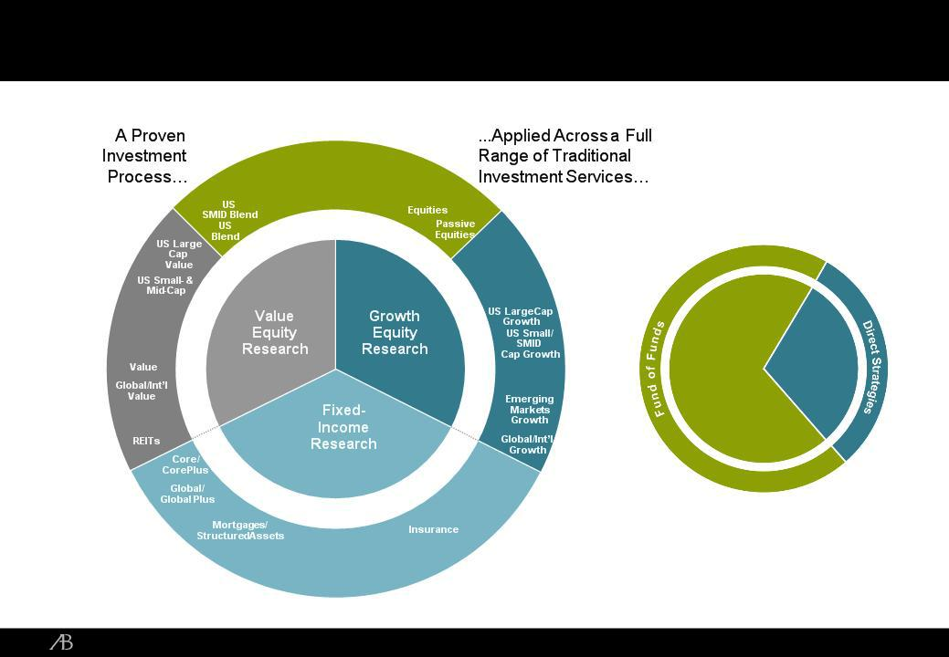
A Broad Array of Investment Services

Global/Int’l |  | US
Blend |  | US
 |  | Structured
Regional Emerging | Target | Equities
Blend Markets | Date | Global/Int’l
Blend | Funds | Structured

…Including

Alternative

Strategies

Value

Regional
Value

Emerging

Markets

Extension
Strategies

Diversified Yield

TIPS

Emerging
Market Debt

US
Thematic
Research

Global
Thematic
Research

Regional

Growth

Currency

LDI

Bank Loans/
Private
Placements

Asset
Management
Credit/
Global Credit

L/S
Equity
Emerging ^{L/S}
Markets ^{Multi-}
Asset

Event | Event Driven
Driven | Real Estate
Credit/ | Venture
Distressed | Capital

Private Capital

High Yield US
Municipals

AllianceBernstein.com

2010 BofA Merrill Lynch Banking and Financial Services | 2
Conference

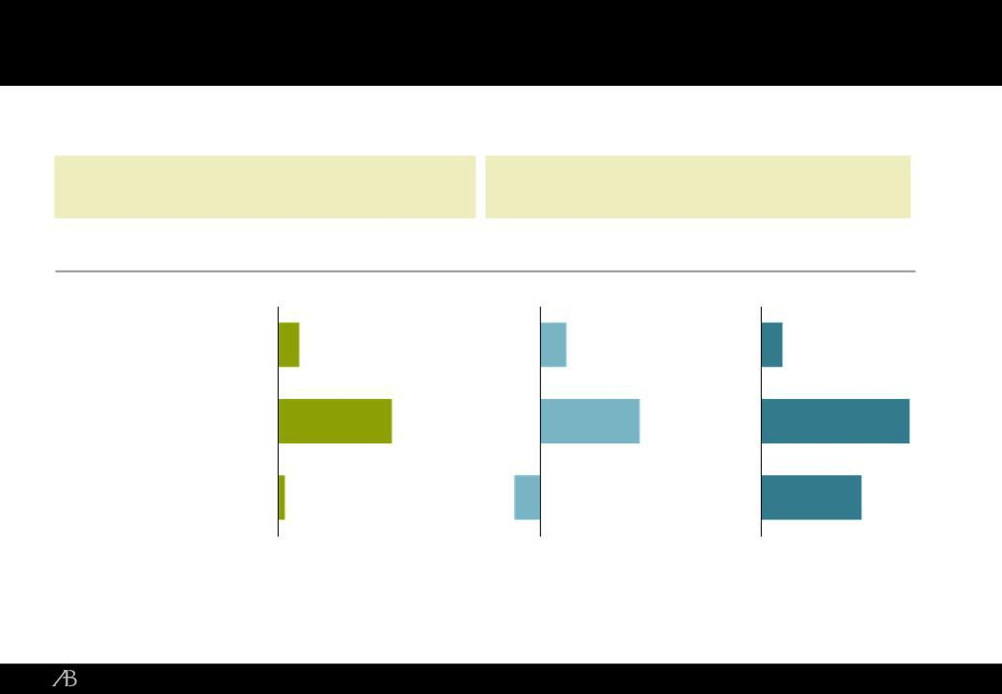
A World-Class Fixed Income Franchise

Assets Under Management

$209 Billion in Fixed Income

US Fixed Income: $122 Bil. |  | Non-US Fixed Income: $87 Bil.
II Rank* | 15th | 7th
 | Relative Performance
Strategic Core |  | Global | Emerging Market
 | Plus | Plus | Debt
YTD (9/30/10) | 2.4% | 2.9% | 2.3%
Full Year 2009 | 12.4% | 10.9% | 16.2%
Five Year | 0.8% | (2.8)% | 11.0%
(through 12/31/09) | 0.8% | (2.8)% | 11.0%
Benchmark | Custom Index | Barclays Global Aggregate | JPM EMBI Global
Benchmark | Custom Index | Bond Index (Unhedged) | JPM EMBI Global

Performance is preliminary as of September 30, 2010.
The information in this table is provided solely for use in connection with this presentation, and is not directed toward existing or potential investment advisory clients of AllianceBernstein.

Investment performance of composites is presented after investment management fees.

*2010 Institutional Investor Magazine Survey of America’s Biggest Money Managers; Rankings as of December 31, 2009 Source: Institutional Investor and AllianceBernstein

AllianceBernstein.com | 2010 BofA Merrill Lynch Banking and Financial Services | 3
 | Conference

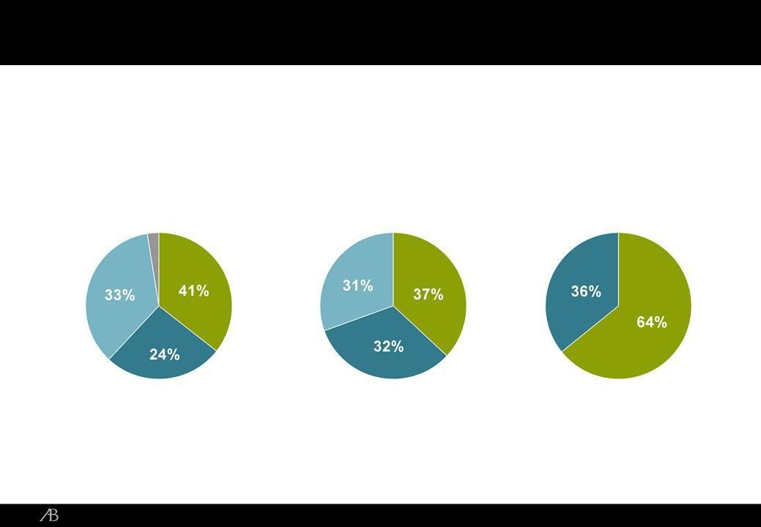
Balanced Across Channels, Services and Geographies

Assets Under Management: $484 Billion

Firm-Wide Diversification

(On Annualized Fee Base of $2.1 Billion)

 | By | By | By Client
 | Strategy | Channel | Domicile
 | 2% Other | Institutions | Non-US
 | Private | Institutions | Non-US
 | Client |  | US
Fixed | Value |  | US

Growth Retail

As of September 30, 2010

AllianceBernstein.com | 2010 BofA Merrill Lynch Banking and Financial Services | 4
 | Conference

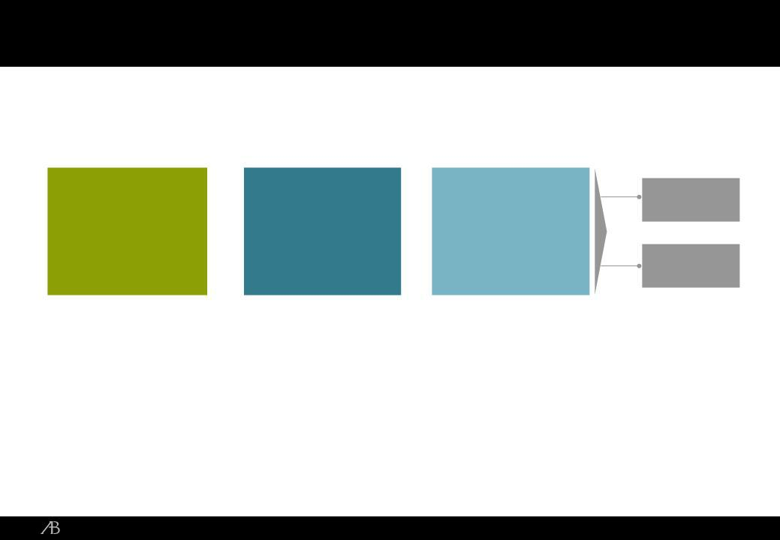
AllianceBernstein: How We Grow Our Business

Global |  | Innovative |  | Global | Sell
Global | + | Innovative | + | Global | Side
Research | + | Innovative | + | Client | Side
Research | + | Solutions | + | Client
Platform |  | Solutions |  | Base | Buy
 |  |  |  |  | Side

AllianceBernstein.com | 2010 BofA Merrill Lynch Banking and Financial Services | 5
 | Conference

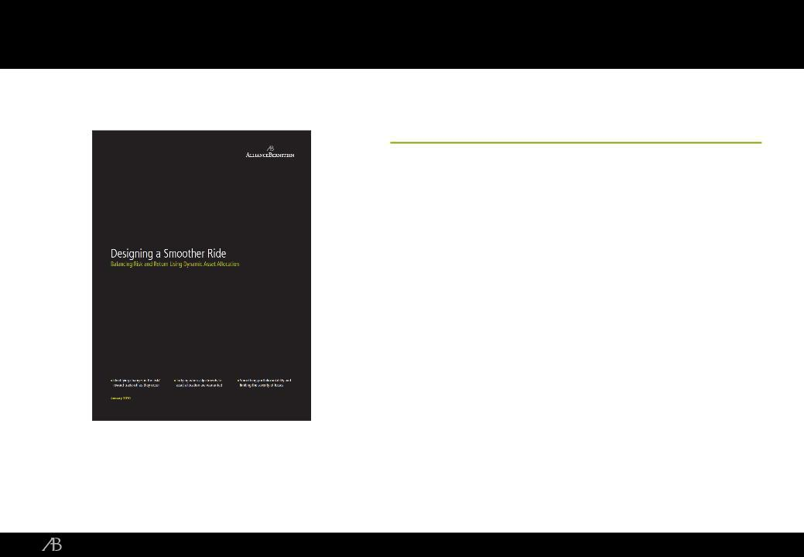
Addressing Client Concerns About High Market Volatility and Tail Risk

Dynamic Asset Allocation (DAA)

<Private Client: February 2010 Launch; about

50% of eligible private clients now in service

<Institutional: Subadvisory and Defined Contribution momentum

<Retail: DAA embedded in Target Date; Applications to other services in US and abroad

AllianceBernstein.com | 2010 BofA Merrill Lynch Banking and Financial Services | 6
 | Conference

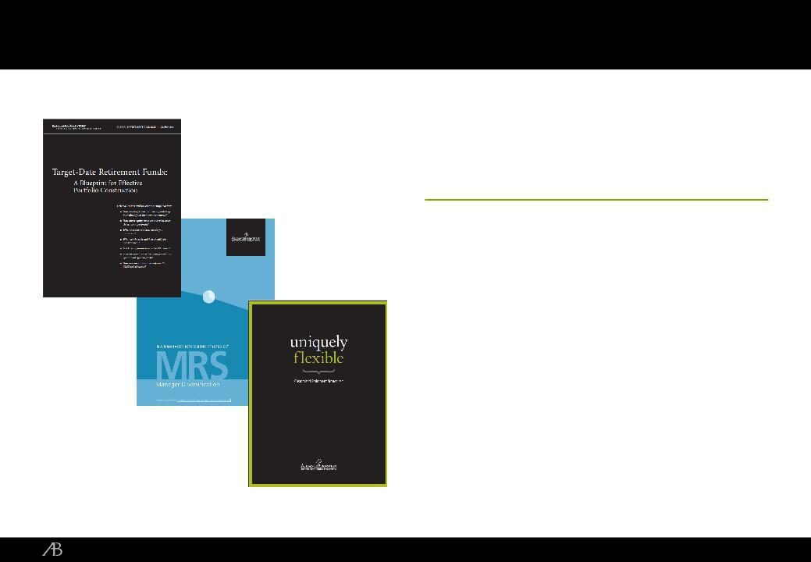
Addressing the Defined Contribution Need

DC Strategies: Focused on Target-Date

<A Secular Shift

<Groundbreaking research; Innovative

Implementations

<Scalable, Long-Term Opportunity

AllianceBernstein.com | 2010 BofA Merrill Lynch Banking and Financial Services | 7
 | Conference

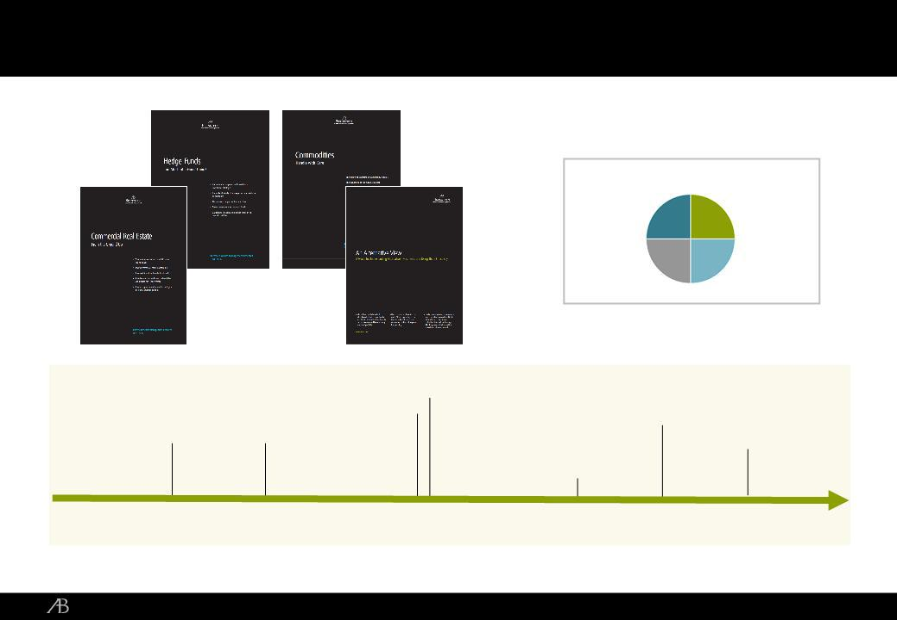
Uncorrelated Alpha: A History of Innovation in Alternative Investments

 |  |  | Venture Capital
 |  | Commodities Long/Short
 | Fixed Income Global Equity and
US Equity | Long/Short | Currency
Long/Short |  | Long/Short
1997 | 2001 | 2002 | 2006

*For illustrative purposes only

Source: AllianceBernstein

AllianceBernstein.com

Alternative Investments*

Private Capital | Hedge Fund
Fund of Funds | Hedge Fund
Fund of Funds | Fund of Funds
Direct Private | Direct Hedge
Capital | Fund Strategies

Government
Assets (TALF and PPIP) |  | Diversified
Distressed | Real | Alternative
Investing | Estate | Fund of
 |  | Funds
2008 | 2009 | 2010

2010 BofA Merrill Lynch Banking and Financial Services | 8
Conference

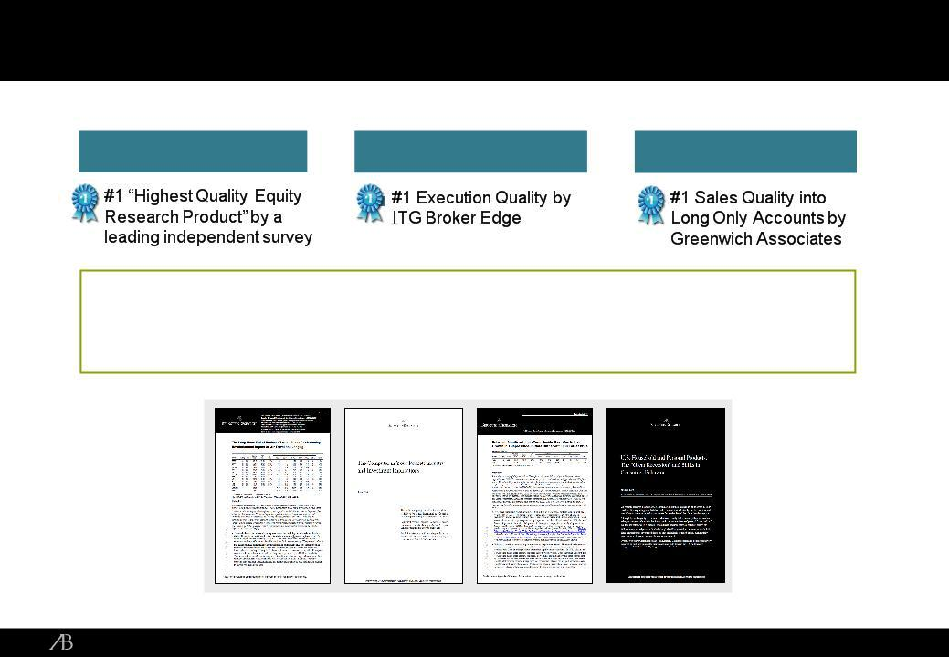
Sanford C. Bernstein: Industry Leading Research and Trading Platform

Research Trading Sales

- A leader in research for nearly 40 years; known for insight, independence and integrity

- Today, 375 employees with seven offices in the US, Europe and Asia

- Growth driven by expansion of geographic footprint, trading capabilities and research product suite

Source: AllianceBernstein

AllianceBernstein.com | 2010 BofA Merrill Lynch Banking and Financial Services | 9
 | Conference


Keys to AllianceBernstein’s Success (From Last Year’s Conference)

<Focused execution in 2010

<Providing Dynamic Asset Allocation to our Private and Institutional clients

<Deepening our sell-side electronic and derivative trading capabilities

<Expanding our sell-side research franchise

<Building non-traditional investment services

AllianceBernstein.com | 2010 BofA Merrill Lynch Banking and Financial Services | 10
 | Conference

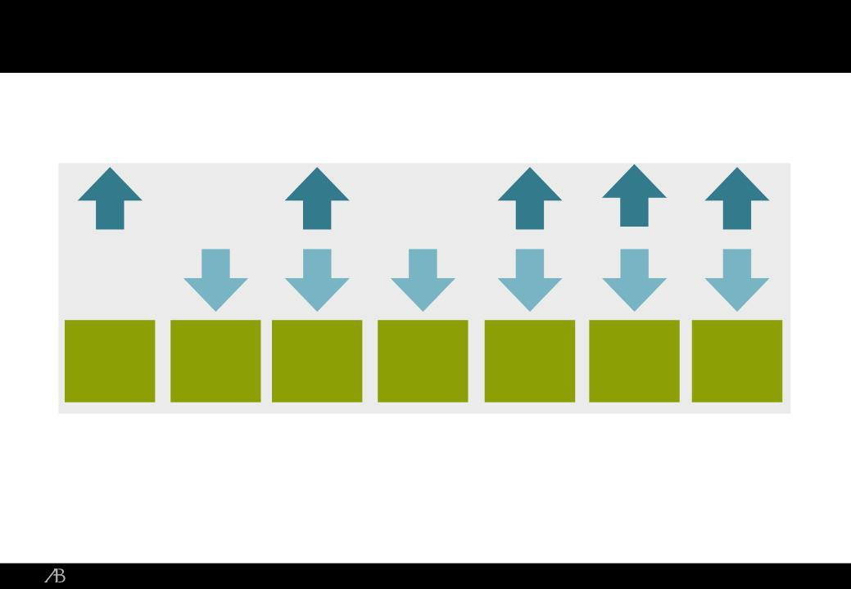
Working to Build an All Weather Firm

Market

Direction

Long | Fixed |  |  | Target |  | Trading
Long | Fixed | Alternatives | DAA | Target | Passive | and
Equities | Income | Alternatives | DAA | Date/DC | Passive | and
Equities | Income |  |  | Date/DC |  | Research

AllianceBernstein.com | 2010 BofA Merrill Lynch Banking and Financial Services | 11
 | Conference

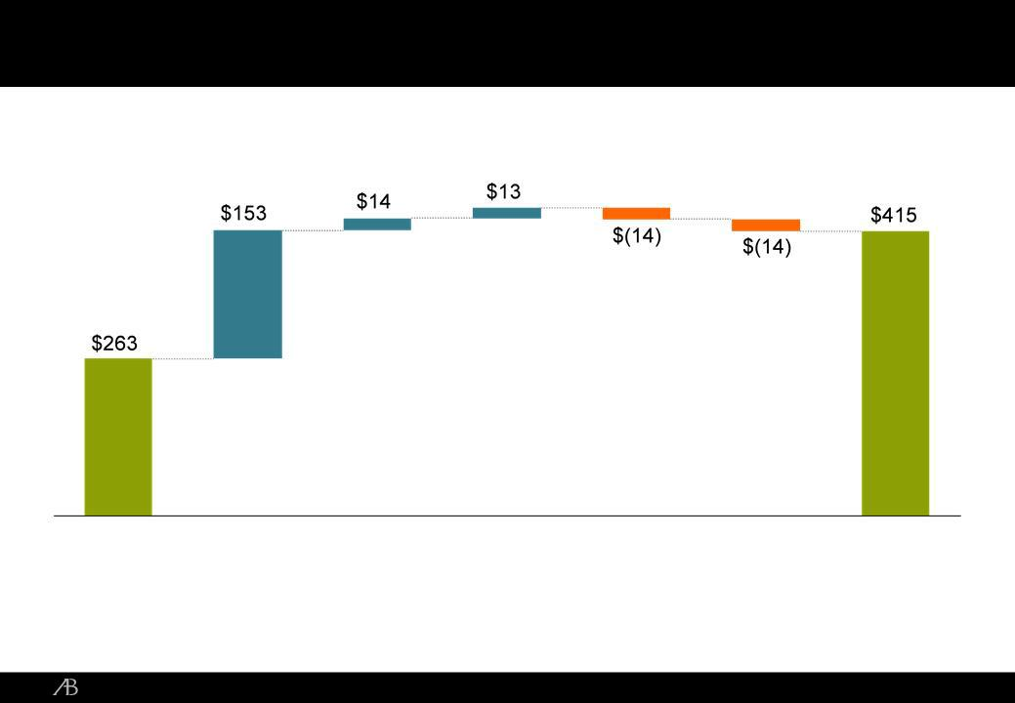
Adjusted Operating Income*: YTD2010 vs. YTD2009

In USD millions

YTD | Base | Severance | Net | Incentive | T&E | YTD
2009 | Advisory | Expense | Distribution | Compensation | Expense | 2010
Adjusted | Fees |  | Revenues | (ex. MTM) | and Other | Adjusted
Operating |  |  |  |  |  | Operating
Income |  |  |  |  |  | Income
*As of September 30, 2010
AllianceBernstein.com |  |  |  |  | 2010 BofA Merrill Lynch Banking and Financial Services |  | 12
 |  |  |  |  |  | Conference

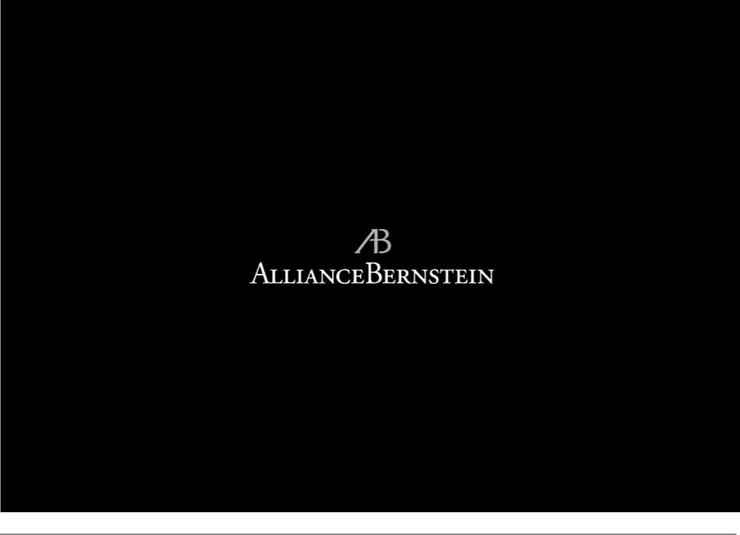

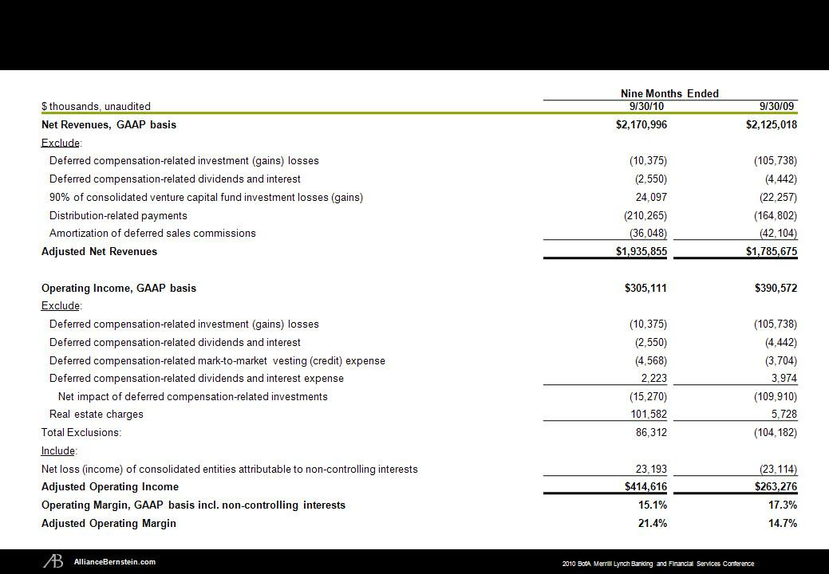
AllianceBernstein Adjusted Earnings Reconciliation

14

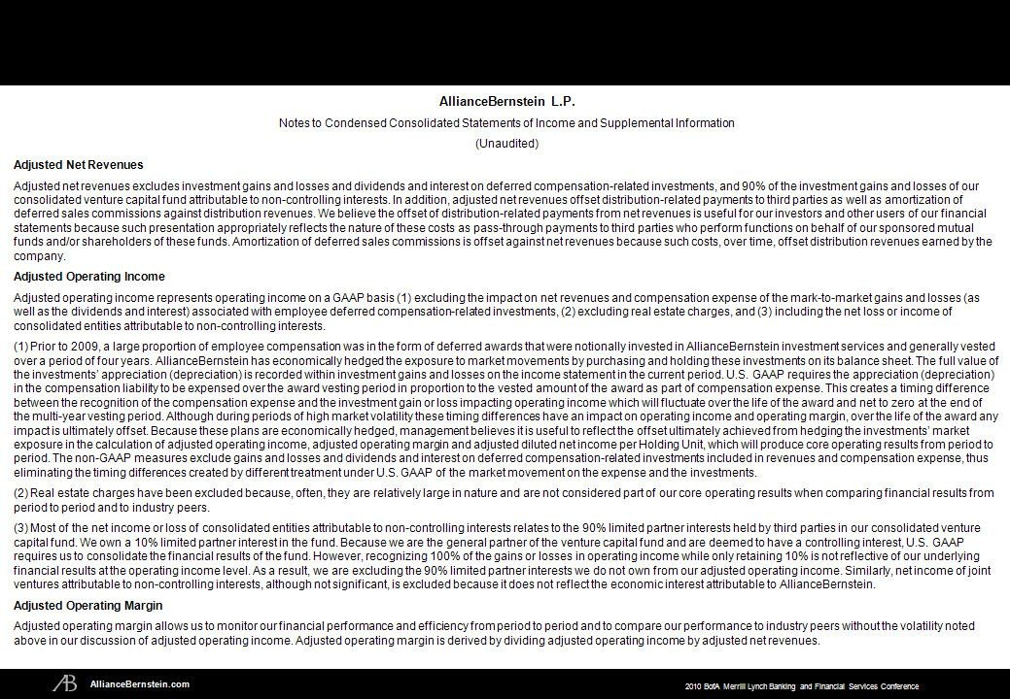
AllianceBernstein Adjusted Financial Results Reconciliation

15

Exhibit 99.02

Peter Kraus at BofA ML Conference

11/17/2010

Cynthia Mayer, Analyst at Bank of America Securities

Welcome to the AllianceBernstein Presentation. Among the public asset managers, Alliance is distinguished in a bunch of ways but I would say especially by having an unusually broad business with retail, institutional and high net worth channels as well as the sell side business and a global footprint with some 35% and more of its assets under management held by overseas investors. I also believe it is the only financial master limited partnership, giving it a low tax rate and a high distribution yield.

That said, recent years have also seen challenges in performance and outflows which continued through the third quarter. Each month Alliance reports its assets under management monthly so that continues to be watched very closely by investors. With us here today to talk about the firm is CEO, Peter Kraus. Peter has been CEO now almost two years and has made a number of changes in introducing new products, new hires, increased emphasis on the sell side which I’m sure he will tell you about and I’m really pleased that he could come over today to update us on Alliance.

Peter S. Kraus, Chairman and Chief Executive Officer, AllianceBernstein

Thank you so much, Cynthia. So I’m going to break the presentation into two parts today and then hopefully leave time for questions. One is an overview of the firm, some of the things we’re working on. And then two, try to get to the questions I know are on your mind and to deal with those head on.

So just to talk about an overview for a second, as observers have seen us in the past, we are viewed primarily as an equity shop and then within that, primarily as a value shop. But as you will see, we built a widely diversified business and it’s across a number of different investment services and a number of different clients and a number of different geographies. So we’re actually proud of that and think that that will lend itself towards balanced growth and balanced opportunities for investors going forward.

Our challenges to date are obvious. Many, although not all, of our equity portfolios or equity services have had choppy performance in 2010. Flows, primarily institutional, have also been discouraging for us. Having said that, fixed income performance is uniformly excellent across the board and it’s setting up very strong three-year numbers, which we will benefit from in the future.

We’ve also made significant strategic progress towards our goals with regard to other things in the firm that we were focused on. We are a firm today of sufficient global scale, almost $500 billion of assets, product diversity, client breadth and capable of taking advantage of any market that we are likely to see in the foreseeable future.

So talking about the broad array of services to be more specific, you can see on the wheel on the left that it’s not just equities and fixed income, it’s large to small, large cap to small cap, value, blend, growth, U.S., international, global. Fixed income includes traditional fixed income, emerging markets, high yield, real estate, mortgages, munis, high yield munis, inflation protected securities and bank loans, a pretty diversified business on a long side of the fence.

If you look at the right side, the smaller wheel, that’s our alternative strategies. We have proprietary liquid strategies and long/short hedge funds, multi-strategy hedge funds, venture hedge funds and relative value activities. We have illiquid strategies in real estate, commercial real estate, venture capital and distressed lending. We have a fund of fund business and we’ve had what has been publicly discussed with the government, both TALF and PPIP programs.

We are also a solutions provider where we have embedded advice in target date funds, dynamic asset allocation and thematic portfolios. So, I would challenge all organizations to have this much diversification in their product line up, in their globality and in their client mix. And we think that’s part of the reason why we feel strongly that we can serve almost any market that we are likely to see.

Let’s now take a look at our fixed income franchise, with $209 billion in fixed income assets as of date. We ranked 15th in U.S. and 7th in non-U.S. fixed income and that includes passive entities, which if we removed obviously we would rank higher amongst the active portfolio managers.

Our performance for 2010 year-to-date as you can see is outstanding. Our five year performance is also strong and if you look at the performance ‘08 and ‘09, you would see in these three products almost all of the loss of ‘08 was recovered in ‘09 and then some. We have seen a very strong positive market reaction to these services all over the world. In the last nine months, we’ve raised assets of $30 billion, net $10 billion. What’s interesting about that is 75% of those flows have gone into global and that is change the mix, as you recognized the percentage of global to total is around 40%, but yet 75% of the flows are going into global. And 40% of that 75% or 30% of the total went into our global retail products, which have very attractive fees relative to equities.

Continuing with the diversification just to give us a sense of strategy, channel and client domicile, you can see fees are split by a third for both strategy and channel, and by client domicile 36% outside the United State and growing. Obviously emerging market growth outside the U.S. is fast and we’re benefiting from that. We also continue to believe that that percentage in client domicile will improve, meaning non-U.S. will grow relative to U.S.

So how do we grow the business, what’s really going on inside of AllianceBernstein? First of all, as you’ve heard us say many times, it all starts with research. Our unique franchise is our global research platform and that platform, on which we base all of our investment decisions, is focused on identifying insight and thoughtful opportunities to approach the market on the buy side and the sell side. We create innovative solutions. We drive that to the client base, and as I said that is in both the sell side and buy side.

One thing that I think people miss in understating us is why we are in both businesses, buy side and sell side. We know how to manage research talent, managing research talent is not a commodity skill. That is core skill. And having a brand and an environment, in which researchers feel comfortable and attracted to us is also the unique franchise. We leverage that in both businesses; buy side and sell side.

Research leads to innovation and product development. Some of the things that we focused on in the last little bit is market volatility, how to mitigate it, prospect of inflation, how to manage it and the retirement dilemma, all of which have been significant questions for our client base.

So let’s get into a little bit of that. So here is a specific example, dynamic assets allocation, which we’ve talked about before, with the intensive two-year effort culminating in a portfolio that tactically adjusts a client’s strategic allocation based on changes in the current expectations of different asset classes and based upon the changes in risk in those different asset classes. It is a dynamic process not just model driven but also part of an investment process. We’ve applied that to 50% of our private clients at the present time, significant take-up. We provide that capability in the institutional marketplace to sub-advisory and defined contribution systems. And we also provide that on the retail side through a target date fund that has DAA embedded in it.

Our actual performance this year has also been excellent. In the sovereign debt crisis, we had -- during that time and proceeding that time actually moved the equity exposure down by 10 points from 60% to 50% in a 60-40 referential portfolio. As better economic data began to come out into the market, we were able to take back that equity balance up to 50% and then exceed 60% all the way to 67%. So if you look at the amplitude of movement 67 to 50 or 17 points, almost 30% from 50 to 67, there is a very large move and you’ll find that very few other products that are making those kinds of changes.

Let’s look at what we did on the defined contribution stage, another place in which we have spent a fair bit of time. We all have talked about the secular shift from DB to DC; $1 trillion moving in the next five years. Since 2005, we’ve been on the target date bandwagon I would say, one of the first people to write about it in depth.

We’ve continued to innovate in that marketplace making it easier for larger plans to embed target date strategies in their defined contribution offerings. We’ve also created our own unique customized retirement solutions, which provide open architecture and the possibility of synthetically managed DB plans going forward.

Currently, the size of our business is $25 billion in DC and target dates and growing with a very large pipeline. It’s also a good thing from a margin point of view because this is a highly scalable business and for us we’re able to actually produce incremental profits or incremental revenues at profitable margins. This is the business that we’ll grow over a long period of time and it’s a business that has significant take up to come.

Another area, our alternative strategies. So, we have a history of innovation in alternatives which I think you know about. Back to 1997, which was our first long/short strategy, fixed income strategies, global equity strategies, venture capital strategies, discreet investing and the more current activities helped the PPIP real estate and of course, the fund-to funds business that we just acquired.

You can see up in the right hand corner of the chart, we are now in the four categories that you would expect in alternative investments, the private equity fund of funds, hedge fund fund of funds, direct private capital and direct hedge fund strategies, a truly holistic approach to alternative investments.

We expect that this is an area where we also will continue to grow. The market seems to be moving in that direction in many of these different strategies. And we think we’ve got a track record that will be attractive to investors overtime.

Let’s talk a little bit about SCB’s industry leading research and trading platform. I’ve talked a lot about this in the last couple of years since I came to the firm. Part of that is answering the question of why do we have it and I answered that a little bit earlier before and that we really do see synergies in research.

We’re good at managing research, we’re good at managing research processes and we’re good at managing research talent. That could be no more obvious than at SCB where we continue to win highest ranking awards for many of our sell side research analysts in most of the industries that we cover. This leads to significant trading opportunities for us with the buy side and it’s led to our ability to expand that business into both Europe, in which we have really reached our comfort zone after three or four years of growth, and Asia, in which we’re just starting out.

So, what makes us unique in this? The research personnel that we bring into the firm don’t publish for over a year. They all come from industry. We slowly bring them out into the market and we think we produce information that’s unique to the buy side. And the buy side is obviously showing that by most of their votes and the allocation of commissions to the business.

We think that that model will continue to be sustainable in the future and the market share that we’ve picked-up in difficult markets over the last few years, we think will provide incremental revenue growth as markets begin to grow and the commission pool begins to growth with it.

So last year at the conference, we set out a few objectives. Let’s just review them. I think that we should be accountable for what we said. So, let me try to hold myself accountable to you.

First, focused execution in 2010, what we’ve talked about was producing operating leverage for you unitholders, we did that. We said we were going to provide dynamic asset allocation to our private clients and our institutional clients. We did that. We said we were going to deepen our sell side services electronic trading and derivative trading, we did that. We said, we were going to expand the sell side research franchise, we did that. And last, we said, we’ve going to build non-traditional investment services, we have done that.

So I don’t want to be the sand bagger but I think we actually laid out reasonable objectives. And I think we actually were successful in trying to reach all of those.

Let me say, what we think we’re going to do in 2011, and it’s very simple, it is to execute. We have all the strategies, we have all the investment services, we have all the people in place. Of course, we will make tweaks along the way, but our responsibility to you as unit holders is to execute. It’s blocking and tackling. It’s one foot in front of the other. Why do we think we could be successful in that? Because we have built an all-weather firm. Markets can go up, and markets go down; they will go up and they will go down. We think across the different services in the firm, we can take advantage of virtually any market direction. Why are we different? We have a private client business, few firms do. We have a buy side business, few firms do. We have dynamic asset allocation and target date funds in c ustomized solutions which allow us to be dynamic in dealing with risk allocation in the retail and institutional levels and allow us to provide unique solutions to the market places as DB plans shift into DC. We have a global investing platform, it’s our main and most important franchise in both equities and fixed income, not all firms produce global research and not all firms produce global portfolios. In fact, few do. So if you believe the global investing will continue to grow and we do, we think we are well positioned to take advantage of that. And last we have alternatives that go beyond just the normal liquid services. We also have the illiquid services in both commercial real estate and in the structured finance area most notably PPIP.

Let’s look at financial performance. So we said we were going to create operating earnings. What this chart shows is GAAP earnings adjusted for the mark-to-market of deferred compensation and the real estate charge of $90 million that we took this year. What you can see is that average AUM has increased 8% for nine months and the change in the mix, primarily in fixed income which I mentioned earlier, has driven a 10% increase in advisory fees. So 8% AUM but 10% increase in advisory fees -- that’s the $153 million. The operating leverage that we created in ‘09, we preserved in 2010, almost all of that $153 million went into adjusted operating income in 2010. You could see it in the margins -- margins went to 21.4% in ‘10 f rom 14.7% in ‘09. All this, included investments that we made in people all across the businesses during the course of this year.

So I think this is pretty much delivering on what we said we would do. We haven’t had all the things go right but we’ve had certainly enough to be able to produce attractive performance for unitholders.

Now, there are some questions in the room, some pink elephants in the room so I am going to try to address them and then come to your specific questions.

So first, why did your equity portfolios underperform in 2010? You’ve done all these great things but I am looking at performance in equities and in the core services and they are still not performing the way they are supposed to.

Now all of you know because you’ve heard about this many times -- that correlations among stocks have gotten much higher. When the correlations in stocks go up, stock-pickers underperform. We performed well in the first quarter, we performed poorly in the second quarter, we performed better in the third quarter. That correlates entirely to the change in the correlation among stocks. In fact, in last few weeks stock correlations have gone back up. That’s not been a good thing for stock-pickers and it will have an impact on performance. I’m not concerned. The reason why I’m not concerned is I can see that during periods of correlation declines we have had strong performance. I can see that the selections that we’re making at the security level are producing the performance that we expected to deliver to our cli ents. In moments in which macro trends take over and fundamentals don’t perform, it’s very hard for us to perform and we won’t, but over the long run, we do believe and you believe that fundamentals will drive investing and will drive performance. And we will benefit from that and our clients will get the performance and we will see the flows.

How long is it going to take the win back investors and consultants? We have very, very deep and long relationships with consultants and the consultant community. I think they understand the excellence of our research, they understand the consistency of our process. They too have been hurt by performance all over the industry and they too are gun-shy. But we believe over time, we will convince them that the performance that we can produce is attractive. And we can see that in the fixed income businesses and we can see that in some of the equity businesses where we continue to be well rated by consultants.

How do you explain the recent outflows? Why are they going up? I said in the earnings call and I will say here that second quarter performance certainly hurt us. But as third quarter performance is better, we’d expect in the future we’d see flows begin to adjust to that. We continued to see improved performance in October. That will be a good thing, both relative to benchmark and relative to peers.

What are we doing to regain the positive flows in trends? Obviously, performance is important but it’s not the only thing. We are in a good position. We’ve got premier franchises at both value and growth equities, large and small cap, U.S. and non-U.S., bonds and taxable and munis, and in U.S., globally as well as strong alternatives. So we are using all of those buckets to generate asset opportunities. In addition, we think we are in a terrific position to continue to benefit from the DB flows into DC, and lastly fixed income has been a significant winner for us and we’ll continue to lean on that and we think we will continue to drive flows as a results o f it.

Management turnover, has personnel turnover been a factor in your performance or outflows? I do not believe it’s been a factor in outperformance, full stop. I do think it had an effect on outflows because I think the consultants have been concerned about that turnover. I think when I look at that turnover, it was frontloaded into 2009, number one, and number two, certainly in the last 12 months any of that turnover has been driven in part by decisions we’ve made ourselves. And I think that’s important if you believe that management should be proactive and if management can actually tell how to position people intelligently within its organization to produce better returns and better opportunities.

Why do we have a single CIO for equities? There are three reasons. One is, we research processes excellence in research people. How you measure performance amongst research personnel is a consistent process. We think we are good at it. We have a best-in-class point of view that should be spread over both value and growth. Secondly, understanding risk, if you understand risk better you can take more of it and you can take more of it at the right time. Risk is blind to value or growth. It’s a mathematical term it’s a perception or an understanding of the market. We think again risk and the understanding of risk doesn’t matter whether you are a value investor or a growth investor that is a consistent topic. Third, investment expertise, so Sharon Fay is undeniably in our world our most experienced and successful investor. Providing her guidance and experience as a coach to both value investing and growth investing is a valuable thing to do and also a leveragable capability. Lastly, by having on e CIO we can consolidate trading platforms. We can be more efficient in both the technology and the operating side of the business and that provides for the capacity to trade more, sophisticated instruments overtime and to drive expenses to be more efficient in those trading platforms as we grow.

I wanted to make sure that I leave time for your questions but I also wanted to see if I could hit some of these bigger issues. I think that’s about it. I’ll turn it over to you.

QUESTION AND ANSWER SECTION

Cynthia Mayer: Great. Let’s open up for the questions, and maybe I will start with just a follow-up on what you just said. You mentioned consolidating trading platforms I guess what’s the time to hit for that and is that something we should think of a significant in terms of savings or not particularly, and is the single CIO, or are there other areas that you would consolidate like on an analyst level?

Peter Kraus: So you know always when you ask these multiple questions I start with the bottom so for that I will answer the most recent first. No, we are not going to consolidate growth and value. We have a very distinct point of view. Part of the reason why we went to a global CIO -- and we started talking about this over a year ago -- we asked ourselves sort of a white paper question. Do we believe that growth and value are sustainable and appropriate services over time? And what we concluded was that the processes of investing in growth companies and in value companies truly they were driven by different alpha streams or different information processes in a particular time horizon. And because there were different time horizons t hey provided alpha streams that were not correlated, they are not uncorrelated completely, but they have lower correlation. So we believe that actually having growth and value is a sustainable activity that investors want, that they should want, that makes philosophical sense and therefore we are committed to doing that for the foreseeable future.

Having said that, we did identify these three areas, where we thought there was commonality and where we thought we would benefit from leverage ability of one CIO. In addition to that we felt that what we had never really done in the merger of the two companies is actually bring together the sort of infrastructure of the different activities. And by bringing together the infrastructure we thought we could save some capital or some of the money over time, we thought we could create more sophisticated trading activities and we thought we could effectively grow the business faster with lower expenses. And so that was the reason why we did all these things.

In terms of how much expense that we’re likely to save, I don’t have a number for you, but I think from the trend point of view, we think that that will be a net positive for unitholders.

Audience: Three part question. How much overlap is there between your buy side and your sell side, meaning does your buy side use your sell side research? And if so, is that a reflection maybe the underperformance was underperformance on the sell side research as compared to decisions they made on the buy side? Secondly, how much of the fixed income revenue growth was market versus flow related? And third, what happens because we haven’t really been into the bear market for fixed income sustainably for 20 odd years. What happens if we’re at the tipping point now, where maybe fixed income begins to enter a bear market, how would that affect your fixed income strategy?

Peter Kraus: On the first question, no, meaning that yes the sell side and the buy side do obviously talk to each other but I don’t think any of the underperformance on the buy side was due to the sell side. I see no evidence of that. So full stop, no.

On the question of fixed income bear market, what will we do to adjust to that? Well, I think that there are number of things in our fixed income business that will actually succeed in a bear market. Number one is we’ve a large munis business and even though rates are likely to go up and there will be losses on existing bond positions, individuals generally hold bonds to maturity, but a large part of the business is focused on the high net worth world. And I think tax rates are likely to go up over time and munis are likely to be more or not less attractive and as yields go up they will be even more interesting on an after tax basis. So I actually think that part of the business can grow.

I think that the emerging market debt business, in which we’re quite sizeable, is also likely to continue to grow because more and more assets will find their way into the emerging markets and even if rates are going up I still think that to be fixed income area that will experience growth.
I think the core U.S. business, which is a very large business, which we don’t have a large market share and we are not in a very significant player is likely to find the most headwinds in a fixed income fair market. And I think we will be least impacted by that.

I think the credit strategies, in which we are a big player in, the global credit strategies will go in two different directions if we are going to have a bear market, because interest rates are going up; interest rates are going up because the economy is growing. The global economy is growing and credits are actually doing better. So from a spread point of view, we will be producing better. From an absolute weight point of view and duration point of view those were negative trends. And so I think we are going to go in both directions in that way.

I would say that traditional U.S. fixed income investors in bear market are going to look to the global markets because there will be extra yield in credit spreads in non-dollar denominated securities. And in non-dominated – non dollar dominated world is going to grow. And we are good at that and again, there are very few global fixed income players who run global platforms. So I think that that’s probably a net plus for us. But I do think the U.S. core fixed income business is going to be experiencing significant headwinds. And to answer your other question, no, it’s entirely a mix issue. Some obviously is flows, but the incremental difference between the 8% AUM growth and 10% revenue growth, that’s mix.

Audience: Thanks. You talked about your strong performance in fixed income and your need to execute next year, can you tell us what you need to do to convert RFPs into final rounds and final rounds into new mandates to make that work on the institutional side of fixed income?

Peter Kraus: Yeah. I think that when we are in RFPs, we are wining more than our fair share and so our challenge in the institutional space is more of the RFP flow. We are not seeing

every one of those that we would like to see and that means working harder with consultants to understand what the performance looks like and why they should be including us in those RFPs. So I think that’s where the effort has to be. It’s not in actually converting the RFP, it’s getting i nto the RFP. Once we’re in the running, we’re winning more than our fair share but our issue is making sure that the consultants actually know that that’s true. That’s where we haven’t done as good a job as we could have done historically.

Cynthia Mayer: Maybe I’ll ask another question. If you look at some of those new products that you’ve brought for example, the fund to funds, these are open architecture products and traditionally AllianceBernstein was more of a closed architecture place. So how close would you be willing to take that and as you look ahead to products you want to introduce, what is the mix there? And I guess what are the margin implications?

Peter Kraus: Sure. So the open architecture that we have embraced has been focused primarily on the customized retirement solutions world, the defined contribution world and on the alternative businesses in the private client channel. And I think that’s where we will continue to be comfortable having open architecture, but I don’t think that open architecture will expand beyond that for a couple of reasons.

In the private client business, we believe that the long-only managers that we have allowed our private clients to have exposure to make up most of the managers within AllianceBernstein. So we have growth managers, we have value managers, we have large, we have small cap, we have merging, we have U.S. we have international. It’s a large number of managers with different upstreams and less than one correlation to all of those. We think each of those managers is a good strong manager with good strong processes. We think that it’s possible to pick good managers, but we think it’s impossible to pick when good managers are going to underperform or outperform.

So we don’t do that. We think in the alternative space however dispersion amongst managers is very high. The number of benchmarks is quite varied and wide, persistency and survivability is much more dynamic. Drift amongst managers is much more active and we don’t think in the alternative space you can tell when the hedge fund manager is going to underperform or outperform either. But we do think that having somebody focused on picking the best managers and controlling the risk of those managers around the various different benchmarks that are available in the hedge fund space it would fare at least five or six core. It is something that we should do for private clients and we will not be able to produce all of those products ourselves internally at the level of excellence that we think our private clients should hav e access to. So we’re comfortable in the alternative space having both some internal products and external opportunities.

We are not comfortable in the long-only space doing that and won’t do that except in the customized retirement solutions where we’ve said our approach is going to be open architecture. And that has been a consistent process for us because we think what we’re providing to the customized retirement services world is asset allocation advice, risk advice, open architecture and ultimately trying to solve the puzzle of the defined contribution participant being short two very big risks: longevity risk and crash risk. Inside of the DB plan participants are covered for those risks, but outside of the DB plan in the DC world they are not. So we think the flexibility of the customized retirement solutions efforts is structured, so that ultimately we can provide that benefit to clients over time. And if we can do that, which we bel ieve we can, that is a hugely differentiating point that should be valuable to almost every participant in the defined contribution space having lived through 2008.

Cynthia Mayer: Maybe one more, where outside the U.S. are you seeing the greatest growth? You have about 35% of your assets from non-U.S. clients and I think of you traditionally in Europe, but I don’t know if that’s where you’re seeing the greatest growth. You mentioned emerging markets, but I wasn’t sure if you meant that the emerging it’s the growth and emerging markets product you are selling, or if you are actually selling in emerging markets?

Peter Kraus: So that’s a very good question. So we have seen growth in the emerging markets that is assets under management from clients from all over the world, domiciled more over the world. But we’ve also seen substantial growth in flows and what I would say is Asia, broadly speaking, so Japan, Taiwan, Southeast Asia and Australia. And we continue to believe that our fastest growth outside the U.S. is going to be in those markets and we believe that our brand, our penetration of those markets, our brand awareness in those markets has a significant amount of profit.

We have continued to see constant opportunities in those areas for a new products, new launches, demand for all of our traditional products as well as some of our newer products. And we’ve got a fair bit of focus of the distribution effort in those markets and we continue to place more investment in the form of human capital in that space. So as I look out over the next few years, it would be surprising to me if we didn’t continue to see growth and market share gains for us in Asia. We have low penetration in the retail market in the United States for many reasons many of them relate to the fact that we were very late in product innovation for many years. And we had a strategy in retail that was not conducive to supporting the FA’s. We have changed that in the last 18 months. And I think you know that gross sales in reta il have grown substantially this year. And we expect that will continue to grow as we continue to penetrate the U.S. retail market in a much more meaningful way than we have in the past. So, very interesting growth opportunities for us both in Asia retail and also in the U.S.

The institutional world will continue to be its own challenge. It’s going to be driven by performance.

It’s going to be driven by the three year track records, those things we can’t change. But where we do have penetration is in the consultant channels, in the equity portfolios and we continue to see people allocating capital to it

Cynthia Mayer: Okay. No more questions. Thank you for joining us.

Peter Kraus: Well, thank you very much. Appreciate your support.

