SEC Form 4
FORM 4 |  | UNITED STATES SECURITIES AND EXCHANGE COMMISSION  Washington, D.C. 20549  STATEMENT OF CHANGES IN BENEFICIAL OWNERSHIP  Filed pursuant to Section 16(a) of the Securities Exchange Act of 1934  or Section 30(h) of the Investment Company Act of 1940
  OMB APPROVAL
  OMB Number: | 3235-0287
  Estimated average burden
  hours per response: | 0.5
 | Check this box if no longer subject to Section 16. Form 4 or Form 5 obligations may continue. See Instruction 1(b).
 | Check this box to indicate that a transaction was made pursuant to a contract, instruction or written plan for the purchase or sale of equity securities of the issuer that is intended to satisfy the affirmative defense conditions of Rule 10b5-1(c). See Instruction 10.
1. Name and Address of Reporting Person*  (Street) | 2. Issuer Name and Ticker or Trading Symbol  ALLIANCEBERNSTEIN L.P. [ NONE ] | 5. Relationship of Reporting Person(s) to Issuer  (Check all applicable)
  Equitable Holdings, Inc.
  (Last) | (First) | (Middle)
  1345 AVENUE OF THE AMERICAS
  NEW YORK | NY | 10105
  (City) | (State) | (Zip)
   | Director |  | 10% Owner
   | Officer (give title below) |  | Other (specify below)
  See Remarks
3. Date of Earliest Transaction (Month/Day/Year)
10/30/2025
 | 4. If Amendment, Date of Original Filed (Month/Day/Year) | 6. Individual or Joint/Group Filing (Check Applicable Line)
  Form filed by One Reporting Person
  Form filed by More than One Reporting Person
Table I - Non-Derivative Securities Acquired, Disposed of, or Beneficially Owned
1. Title of Security (Instr. 3) | 2. Transaction Date (Month/Day/Year) | 2A. Deemed Execution Date, if any (Month/Day/Year) | 3. Transaction Code (Instr. 8) |  | 4. Securities Acquired (A) or Disposed Of (D) (Instr. 3, 4 and 5) |  |  | 5. Amount of Securities Beneficially Owned Following Reported Transaction(s) (Instr. 3 and 4) | 6. Ownership Form: Direct (D) or Indirect (I) (Instr. 4) | 7. Nature of Indirect Beneficial Ownership (Instr. 4)
1. Title of Security (Instr. 3) | 2. Transaction Date (Month/Day/Year) | 2A. Deemed Execution Date, if any (Month/Day/Year) | Code | V | Amount | (A) or (D) | Price |  | 6. Ownership Form: Direct (D) or Indirect (I) (Instr. 4) | 7. Nature of Indirect Beneficial Ownership (Instr. 4)
Units(1) | 10/30/2025 |  | P |  | 10,000(2) | A | $38.8097 | 81,455,154 | D(3)
Units(1) | 10/30/2025 |  | P |  | 15,000(4) | A | $38.8097 | 81,470,154 | D(3)
Units(1) | 10/30/2025 |  | P |  | 50,000(5) | A | $38.8097 | 81,520,154 | D(3)
Units(1) |  |  |  |  |  |  |  | 75,851,289 | I(6) | Held by affiliate
Units(1) |  |  |  |  |  |  |  | 41,934,582 | I(6) | Held by additional affiliate
Table II - Derivative Securities Acquired, Disposed of, or Beneficially Owned
(e.g., puts, calls, warrants, options, convertible securities)
1. Title of Derivative Security (Instr. 3) | 2. Conversion or Exercise Price of Derivative Security | 3. Transaction Date (Month/Day/Year) | 3A. Deemed Execution Date, if any (Month/Day/Year) | 4. Transaction Code (Instr. 8) |  | 5. Number of Derivative Securities Acquired (A) or Disposed of (D) (Instr. 3, 4 and 5) |  | 6. Date Exercisable and Expiration Date (Month/Day/Year) |  | 7. Title and Amount of Securities Underlying Derivative Security (Instr. 3 and 4) |  | 8. Price of Derivative Security (Instr. 5) | 9. Number of derivative Securities Beneficially Owned Following Reported Transaction(s) (Instr. 4) | 10. Ownership Form: Direct (D) or Indirect (I) (Instr. 4) | 11. Nature of Indirect Beneficial Ownership (Instr. 4)
 |  |  |  | Code | V | (A) | (D) | Date Exercisable | Expiration Date | Title | Amount or Number of Shares
Explanation of Responses:
1. Units Representing Assignments of Beneficial Ownership of Limited Partnership Interests ("AB Units") in AllianceBernstein L.P. ("AB").
2. On October 30, 2025, Equitable Holdings Inc. ("EQH") purchased 10,000 AB Units in a privately-negotiated transaction.
3. Prior to the transactions contemplated in this Form 4, as of October 29, 2025, the Reporting Person beneficially owned directly 81,445,154 AB Units. For more information on the Reporting Person and its direct holdings of AB Units, see its prior Form 4 filings with respect to AB Units.
4. On October 30, 2025, EQH purchased 15,000 AB Units in a privately-negotiated transaction.
5. On October 30, 2025, EQH purchased 50,000 AB Units in a privately-negotiated transaction.
6. Prior to the transactions contemplated in this Form 4, as of October 29, 2025, the Reporting Person's affiliates beneficially owned AB Units as follows: Alpha Units Holdings, LLC beneficially owned directly 75,851,289 AB Units, and Alpha Units Holding II, LLC beneficially owned directly 41,934,582 AB Units. For more information on the Reporting Person's affiliates' holdings of AB Units, see their separate Form 4 filings with respect to AB Units.
Remarks:
Affiliate of holder of general partnership units.
 | Ralph Petruzzo, Deputy General Counsel, Equitable Holdings, Inc. | 10/30/2025
 | ** Signature of Reporting Person | Date
Reminder: Report on a separate line for each class of securities beneficially owned directly or indirectly.
* If the form is filed by more than one reporting person, see Instruction 4 (b)(v).
** Intentional misstatements or omissions of facts constitute Federal Criminal Violations See 18 U.S.C. 1001 and 15 U.S.C. 78ff(a).
Note: File three copies of this Form, one of which must be manually signed. If space is insufficient, see Instruction 6 for procedure.
Persons who respond to the collection of information contained in this form are not required to respond unless the form displays a currently valid OMB Number.
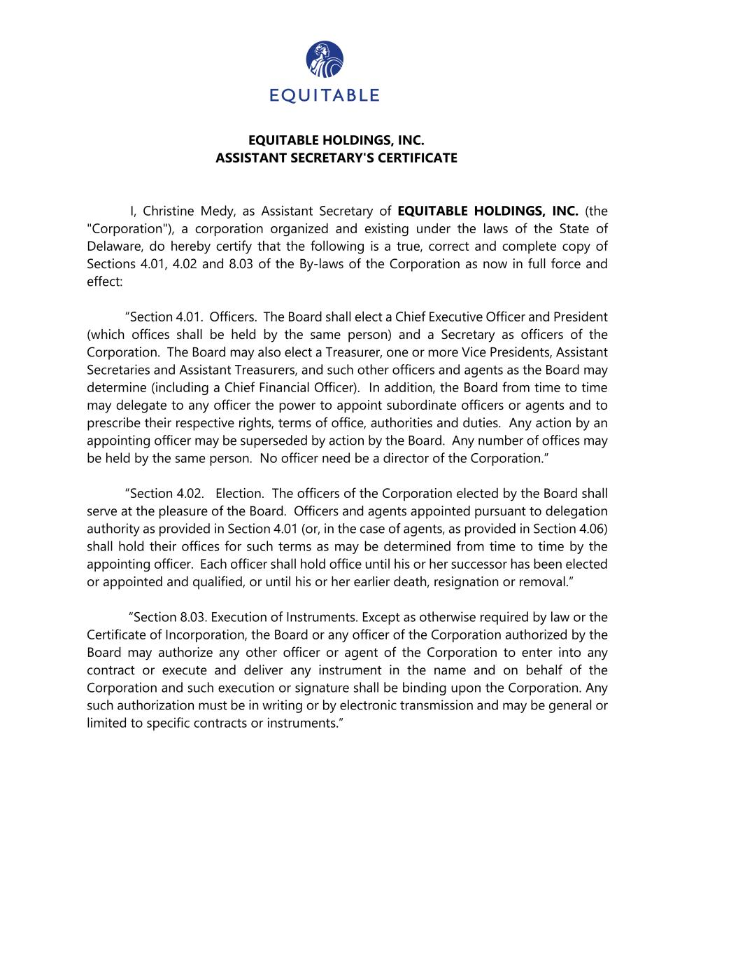
EQUITABLE HOLDINGS, INC. ASSISTANT SECRETARY'S CERTIFICATE I, Christine Medy, as Assistant Secretary of EQUITABLE HOLDINGS, INC. (the "Corporation"), a corporation organized and existing under the laws of the State of Delaware, do hereby certify that the following is a true, correct and complete copy of Sections 4.01, 4.02 and 8.03 of the By-laws of the Corporation as now in full force and effect: “Section 4.01. Officers. The Board shall elect a Chief Executive Officer and President (which offices shall be held by the same person) and a Secretary as officers of the Corporation. The Board may also elect a Treasurer, one or more Vice Presidents, Assistant Secretaries and Assistant Treasurers, and such other officers and agents as the Board may determine (including a Chief Financial Officer). In addition, the Board from time to time may delegate to any officer the power to appoint subordinate officers or agents and to prescribe their respective rights, terms of office, authorities and duties. Any action by an appointing officer may be superseded by action by the Board. Any number of offices may be held by the same person. No officer need be a director of the Corporation.” “Section 4.02. Election. The officers of the Corporation elected by the Board shall serve at the pleasure of the Board. Officers and agents appointed pursuant to delegation authority as provided in Section 4.01 (or, in the case of agents, as provided in Section 4.06) shall hold their offices for such terms as may be determined from time to time by the appointing officer. Each officer shall hold office until his or her successor has been elected or appointed and qualified, or until his or her earlier death, resignation or removal.” “Section 8.03. Execution of Instruments. Except as otherwise required by law or the Certificate of Incorporation, the Board or any officer of the Corporation authorized by the Board may authorize any other officer or agent of the Corporation to enter into any contract or execute and deliver any instrument in the name and on behalf of the Corporation and such execution or signature shall be binding upon the Corporation. Any such authorization must be in writing or by electronic transmission and may be general or limited to specific contracts or instruments.”

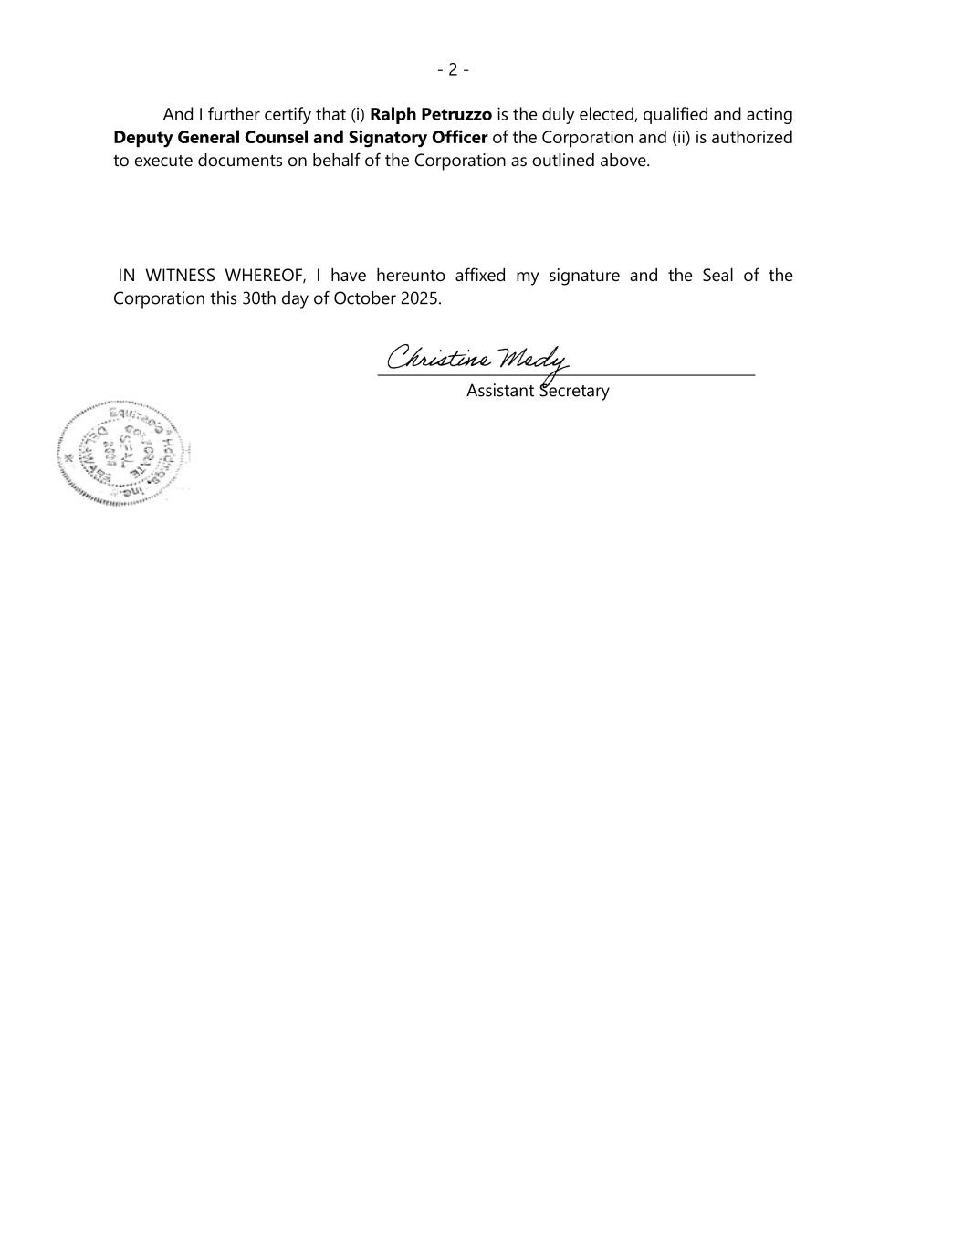
- 2 - And I further certify that (i) Ralph Petruzzo is the duly elected, qualified and acting Deputy General Counsel and Signatory Officer of the Corporation and (ii) is authorized to execute documents on behalf of the Corporation as outlined above. IN WITNESS WHEREOF, I have hereunto affixed my signature and the Seal of the Corporation this 30th day of October 2025. Assistant Secretary

